© 2024, King’s Printer for Ontario

Additional copies of this publication can be obtained from:

Environmental Registry of Ontario

ero.ontario.ca

Ontario.ca website

www.ontario.ca/page/provincial-park-management-direction

and / or

Port Burwell Provincial Park

9 Wilson Lane

Port Burwell, ON

N0J 1T0

Telephone: (519) 874-4691

**Opportunity to Comment**

**John E. Pearce Provincial Park Proposed Management Plan Amendment**

The Ministry of the Environment, Conservation and Parks is amending the management plan for John E. Pearce Provincial Park. After careful consideration of related planning information and review of input received thus far, this proposed amendment outlines proposed changes to site-specific management policies for the park. Administrative updates were made including new values information, current and relevant legislation and policy references and the outcomes of completed park projects. Sections have been reordered and new sections added to align with current park management plan format and content standards. For ease of review, this document is worded in the style of an approved management plan.

The release of this proposed amendment provides an opportunity for Indigenous communities, members of the public and stakeholders to be involved and provide comment. The Ministry of the Environment, Conservation and Parks will carefully consider all comments received and make changes as appropriate. Any revisions will be reflected in the approved management plan amendment. The approved management plan amendment will guide the management of the provincial park over a 10-year period.

The proposed amendment is available through the Environmental Registry of Ontario at ero.ontario.ca (number 019-7130) for 30 days to allow opportunity to review and provide input. Communities, groups, organizations, and individuals on the project mailing list have been notified.

To assist with our review of your comments, list the topic(s) you wish to discuss and briefly state your reasons for agreeing or disagreeing with the proposed management direction. You may also make suggestions or comments on other topics that are important to you. For further information on the proposed/preliminary management plan amendment or the planning process, please contact:

Katie Howard, Parks Planning Specialist

Ontario Parks, Southwest Zone

659 Exeter Road, 4th Floor, London, ON, N6E 1L3

E-mail address: Ontario.Parks.Southwest.Zone@ontario.ca

Comments should be submitted by **April 24th, 2024** through the Environmental Registry of Ontario at ero.ontario.ca (number 019-7130). Comments can also be sent to the individual identified above.

Thank you for your interest in the management of this provincial park.

Jason Travers,

Director, Ontario Parks Operations

The Ministry of the Environment, Conservation and Parks (MECP) is collecting your personal information and comments under the authority of section 29 of the *Provincial Parks and Conservation Reserves Act, 2006* for the purpose of public consultation on management planning. Your comments (not including personal information) will become part of the record of consultation and may be shared with the general public. Your personal information may be used by MECP to follow-up with you upon request or when required, and to send you information about future initiatives involving this park. Please indicate in your response if you do not wish to be notified of new initiatives. Any personal information you provide will be protected in accordance with the *Freedom of Information and Protection of Privacy Act* and will be handled in accordance with the government of Ontario’s Privacy Statement: www.ontario.ca/page/privacy-statement. If you have questions about the use of your personal information, please contact the individual identified above.

**Approval Statement**

September 28th, 1994

I am pleased to approve the John E. Pearce Provincial Nature Reserve Management Plan as official policy for the management and development of this park.

This management plan reflects this Ministry's intent to protect the natural features of John E. Pearce Provincial Nature Reserve and to maintain and develop high quality opportunities for heritage and nature appreciation for residents of Ontario and visitors to the province.



Contents

1 Introduction 1

1.1 Boundary 1

1.2 Indigenous communities 4

1.3 Planning context 5

1.4 Ecological integrity 5

2 Classification 5

3 Purpose, vision and objectives 6

3.1 Purpose 6

3.2 Vision 6

3.3 Objectives 6

3.3.1 Protection 7

3.3.2 Recreation 7

3.3.3 Heritage appreciation 7

3.3.4 Scientific research 7

4 Values 7

4.1 Natural heritage 7

4.2 Earth science 8

4.2.1 Lake Erie water levels 9

4.3 Cultural heritage 9

4.4 Outdoor recreation 9

4.4.1 Trails 9

4.4.2 Picnic area 10

4.4.3 Infrastructure 10

5 Pressures 10

5.1 Natural heritage 10

5.2 Earth science 11

6 Zoning 11

6.1 Nature reserve zone 11

6.1.1 NR-1: Nature reserve area (approximately 65 ha) 11

6.2 Access zone 12

6.2.1 A-1: Bluff picnic area (0.4 ha) 12

6.2.2 A-2: North parking area (0.6 ha) 12

6.3 Historical Zone 12

6.3.1 H-1: Historical facilities area (2.1 ha) 12

7 Policies 15

7.1 Resource management policies 15

7.1.1 Industrial activities 15

7.1.2 Wildlife 15

7.1.3 Vegetation 16

7.1.4 Tree removal 17

7.1.5 Species at risk 17

7.1.6 Non-native and invasive species 18

7.1.7 Fire management 18

7.1.8 Cultural heritage 19

7.1.9 Land management 20

7.1.10 Water Management 20

7.1.11 Shoreline bluffs and landform management 20

7.1.12 Collecting 21

7.1.13 Science and research 21

7.2 Recreation management policies 21

7.2.1 Hunting, trapping, fishing, harvesting and agriculture 21

7.2.2 Motorized vehicles 21

7.2.3 Hiking, picnicking, and bird watching 22

7.2.4 Horseback riding 22

7.3 Operations and development policies 22

7.3.1 Development 22

7.3.2 Visitor services 23

7.3.3 Information 23

7.3.4 Interpretive facilities 23

7.3.5 Partnerships 23

7.3.6 Special Events 24

8 Implementation priorities 24

9 Examination and adjustment of management plan 25

10 References 26

Appendix 1: Summary of Indigenous community, public and stakeholder involvement – Management Planning 1994 28

Appendix 2: Management planning history 28

**Figures**

**Figure 1: Regional Setting** 2

**Figure 2: Local Setting and Existing Development** 3

**Figure 3: Park Boundary and Zoning** 14

# Introduction

John E. Pearce Provincial Park is a 67.9 hectare (ha) nature reserve class park established in 1957. Located on the shores of Lake Erie, this day use destination receives approximately 12,000 visitors each year.

Development of the park began in 1956 when John E. Pearce donated 11.7 ha (28.88 acres) of land to the Province of Ontario. This property had been held by the Pearce family since it was first settled in 1809. Mr. Pearce’s vision for the donated woodlot was to preserve the property for future generations of Ontarians. An inscribed stone monument was erected in the park to commemorate this donation.

John E. Pearce Provincial Park is a reminder of Elgin County’s horticultural practices and distinct settlement heritage. The park’s shoreline is narrow and inaccessible because the bluffs along the lakeshore rise to approximately 30 metres in height.

The park protects provincially significant Carolinian ecological features, has a rich cultural history, and contains archaeological evidence of Indigenous activity dating back to approximately 1400 AD.

## Boundary

John E. Pearce is located on the shore of Lake Erie, two kilometres (km) south of Wallacetown (Figure 1). The park is situated in the geographic township of Dutton/Dunwich, in Elgin County (Figure 2). A network of provincial highways, county and municipal roads provide access to the park. The 67.9 ha provincial park is located in ecodistrict 7E-2. This county is a mixed landscape of rural, agricultural, forested and wetland areas.

Following John E. Pearce’s donation of 11.7 ha to the province, the park was created in 1957 by Ontario Regulation 144/57. With the subsequent acquisition of adjacent land in 1978, the area of the park was expanded to 67.9 ha (167.71 acres). The park is regulated under the *Provincial Parks and Conservation Reserves Act, 2006* (PPCRA).

Formerly, 22.3 ha of the park was used for agricultural purposes under a lease agreement. The County of Elgin purchased 0.4 ha along County Road #8.

**Figure 1: Regional setting**

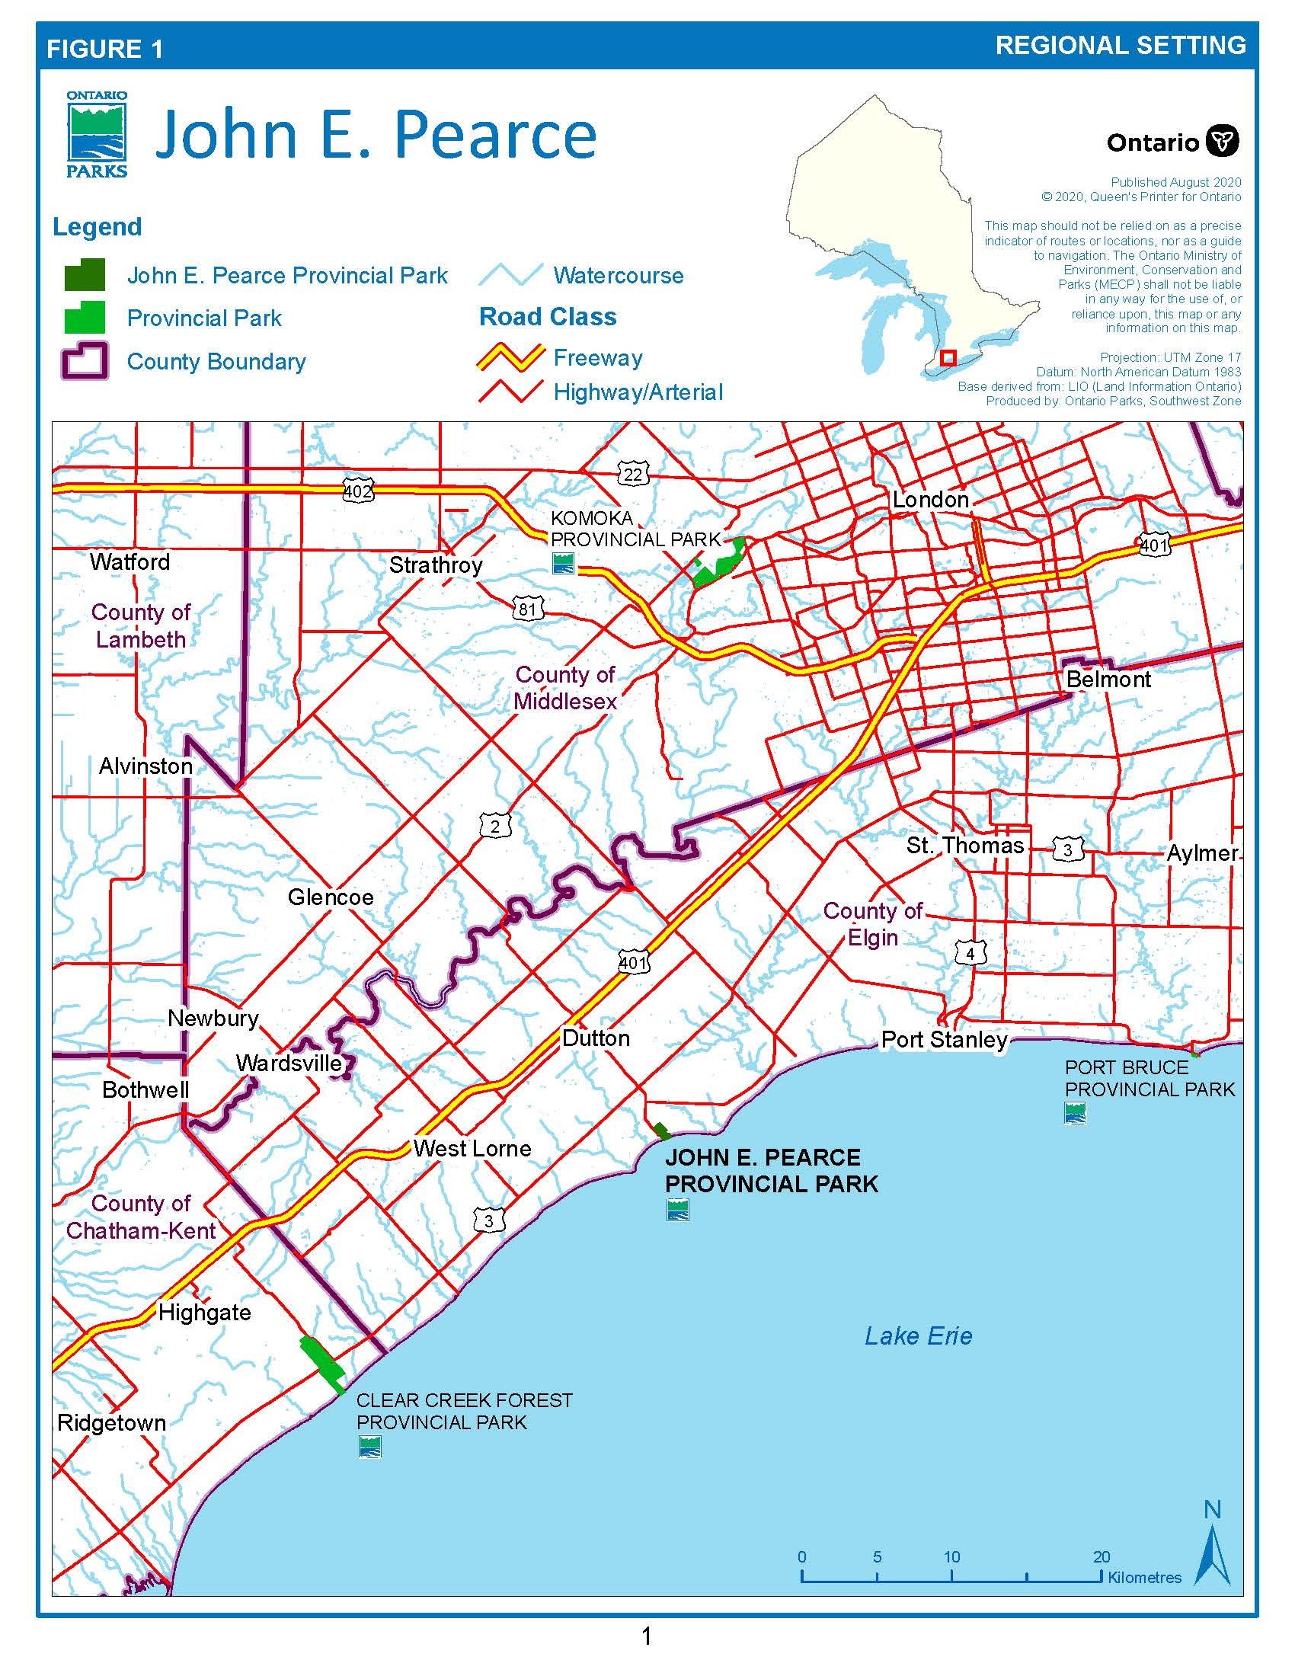

**Figure 2: Local setting and existing development**

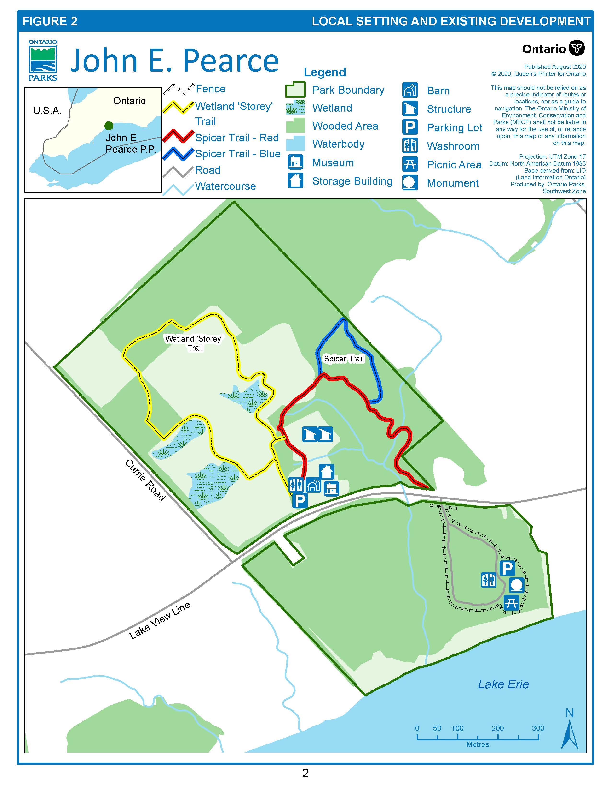

## Indigenous communities

Indigenous communities have lived on and relied upon the lands and waters within their traditional territories and treaty areas long before John E. Pearce Provincial Park was established, and continue to rely on these lands and waters to exercise their constitutionally protected Aboriginal and treaty rights. These include various practices, customs, and traditions integral to Indigenous communities’ distinctive cultures and ways of life, such as hunting, trapping, fishing, and gathering food for personal, social and ceremonial purposes; traditional teachings; and ceremonial and spiritual activities.

Many Aboriginal and treaty rights are connected to the natural environment and are primarily exercised on Crown lands in Ontario, including within provincial parks and conservation reserves.  The Ministry of the Environment, Conservation and Parks (MECP) is committed to meeting its constitutional obligations that may be owed to Indigenous communities, including the duty to consult and, where appropriate, accommodate.

Further, Ontario Parks is working to rebuild and renew relationships with Indigenous peoples based on trust and respect and to seek opportunities to protect, study and enjoy provincial parks and conservation reserves together with Indigenous communities while educating Ontarians and provincial park and conservation reserve visitors. The park is located within Treaty 2, 1790. There are five Indigenous communities associated with Treaty 2, listed in order of proximity to the park: Chippewas of the Thames First Nation, Chippewas of Kettle and Stony Point First Nation, Aamjiwnaang, Bkejwanong Territory (Walpole Island First Nation) and Caldwell First Nation.

The park also falls within the Haudenosaunee traditional territory referred to as The Beaver Hunting Grounds in the 1701 Albany Deed (also known as the Nanfan Treaty). The closest Haudenosaunee community is Oneida Nation of the Thames. Other communities associated with this treaty include Six Nations of the Grand River, Wahta Mohawks, Mohawks of Akwesasne, and Tyendinaga (Mohawks Bay of Quinte).

Munsee-Delaware Nation and Delaware Nation at Moraviantown (Eelünaapéewi Lahkéewiit) are both local Indigenous communities, however they are not associated with any Treaties that cover the park area. The Delaware, also known as Lenape (Lunaapeew), people arrived in the area in the late 1700’s and established these two communities. The Delaware exercise Aboriginal harvesting rights within a traditional territory that includes the park. In addition to these modern communities, there are historic communities that were in the area, notably the Attawandaron (The Neutrals).

## Planning context

The *Provincial Parks and Conservation Reserves Act, 2006* (PPCRA) states that a management plan must be prepared for each provincial park in Ontario. The purpose of this management plan is to establish detailed policy guidelines for the park’s long-term protection, development, and management. The plan will be reviewed in 10 years or sooner if required.

It will define the role and significance of the park in the Ontario’s protected areas system and provide statements of policy for the planning, management, and operation of the park. These policies must be responsive to public interest and compatible with the planning and management principles in the PPCRA.

All projects undertaken by Ontario Parks, or by partners on its behalf, will comply with all environmental impact assessment and evaluation processes, and other applicable provincial and federal legislation and policies. This may include further opportunities for consultation, as required.

## Ecological integrity

Planning and management principles in the PPCRA establish that maintenance of ecological integrity shall be the first priority, and restoration of ecological integrity shall be considered.

An ecosystem has ecological integrity when:

* it has all the parts (both living and non-living) that you would expect to find, and
* natural functions and rates of change are happening normally.

This management plan identifies site-specific management policies and actions intended to maintain or, where possible, restore ecological integrity.

# Classification

John E. Pearce Provincial Park is a nature reserve class park in recognition of the natural heritage values present.

Nature reserve class parks protect a variety of ecosystems and provincially significant elements of Ontario’s natural heritage, including special or rare natural habitats and landforms. These areas are protected for their natural value, to support scientific research and maintain biodiversity.

This park incorporates a sample of the eroding Lake Erie bluffs in association with deciduous forest. Representation of these features on Lake Erie does not occur elsewhere within the provincial park system. The park also provides a link with the history of the local area and permits limited day use recreational opportunities.

John E. Pearce Provincial Park was reclassified from a Natural Environment to Nature Reserve class park in 1994 to reflect a refocussing of priorities in the management of the park. The change in emphasis of park management was from maintenance of day use recreational features to long term stewardship and protection of a significant representative natural area.

# Purpose, vision and objectives

## Purpose

The purpose of John E. Pearce Provincial Park is to:

* protect the park’s natural heritage features, such as the characteristic bluffs of Lake Erie’s shoreline and representative Carolinian communities
* protect distinctive cultural heritage features, such as the locally significant Backus-Page house
* to provide ecologically sustainable recreational opportunities

## Vision

John E. Pearce Provincial Park is a place to increase knowledge of and foster a strong appreciation for local cultural and natural heritage through protecting, enhancing, and sharing park values and resources.

## Objectives

The PPCRA outlines four objectives for establishing and managing provincial parks which centre on protection, ecologically sustainable recreation, heritage knowledge and appreciation, and scientific research. John E. Pearce Provincial Park contributes to these objectives.

### **Protection**

John E. Pearce will protect provincially significant elements of the natural and cultural landscape of Ontario. The park contains distinct cultural heritage values and significant geomorphological and ecological features that will be protected through ecological restoration projects, ecologically sustainable park operations, and active reduction of impacts to park values.

### **Recreation**

The recreation objective is to provide provincial park day use recreation opportunities and to provide residents and out-of-province visitors with opportunities to discover and experience the distinctive environment of the park and surrounding area. The park provides ecologically sustainable recreation centered on picnicking, hiking and birdwatching.

### **Heritage appreciation**

The heritage appreciation objective is to provide opportunities for exploration and appreciation of the outdoor natural and cultural heritage of Ontario. The park has a rich cultural history and provides evidence of early agricultural practices as well as traditional land uses by Indigenous communities. Unique Carolinian species and habitats are also represented in the park.

### **Scientific research**

The scientific research objective for the Ontario Provincial Parks system is to facilitate scientific research and to provide points of reference to support monitoring of ecological change on the broader landscape.

# Values

## Natural heritage

The park is located in the Deciduous Forest Region and the Carolinian Zone of Southern Ontario in ecodistrict 7E-2. There is a diversity of ecological communities within the park, including upland and lowland deciduous forests, meadow communities with marsh inclusions, and open bluffs along the Lake Erie shoreline. Upland and lowland deciduous forests provide excellent examples of Carolinian deciduous forest communities.

Six vegetation types, including 15 community complexes, were identified in the park. Despite the relatively small size of the park, the diversity is considerable due to the variety of habitats and the location within the rich and temperate Carolinian Zone of Southern Ontario. Over 400 species of plants have been documented in the park, several of which are provincially rare, including some listed as species at risk under the *Endangered Species Act*, *2007*. The park also provides a variety of habitats for provincially rare and at risk species, including species of birds, bats, and reptiles.

The park’s most striking feature in summer is its greenery. The walkways meander through a rich mixed hardwood forest with some trees over 200 years old. Within the woodland, the predominant tree is the sugar maple with walnut, hickory, ironwood, and beech trees dispersed throughout the park. Ash was present prior to the spread of the emerald ash borer beetle (EAB). Ash near infrastructure, roads and trails were felled due to the potential hazards created by the EAB infestation. Covering the forest floor is a lush mat of plants and wildflowers including trilliums, hepaticas, jewelweed, violet, jack-in-the-pulpits and blood root. The habitat provided by the park and the proximity to Lake Erie makes the site valuable to migrating birds and butterflies, and visitors can witness the annual hawk migration as raptors travel south along the Lake Erie shoreline each fall.

In 2016, a multi-year project was initiated to rehabilitate 24 ha of land within John E. Pearce to enhance ecosystem function and integrity, reconnect fragmented habitat, and improve species biodiversity, ecosystem productivity and climate change resilience. Work included the retirement of agricultural fields and restoring these areas to wetland and tallgrass prairie habitat, tree planting, invasive species removal and strategically thinning the pine plantation to promote natural succession.

## Earth science

John E. Pearce Provincial Park’s shoreline is an excellent and regionally significant example of bluff erosion caused by repeated removal of moisture and wetting of the Lake Erie shoreline. The park provides an area to study this feature which is characteristic of this portion of the Lake Erie shoreline.

The Lake Erie shoreline between Port Talbot and Tyrconnell includes one of North America’s most impressive sequences of glacial sediments. The Port Stanley till is exposed in the 21 to 30 metre bluffs and gullies which occur in the park. It is a silty clay till, that is often interbedded with varved lacustrine silt and clay, and some water laid till that originated during the Port Bruce stadial, the last major thrust of the Erie ice lobe in this part of Ontario. Several intermittent streams cross the park following gullies present on the landscape

### Lake Erie water levels

Water levels on the Great Lakes are highly variable and can affect shoreline erosion rates and patterns. Since 1918, the highest lake levels recorded for Lake Erie was in 2019, while the lowest occurred in 1936. Lake Erie levels have risen steadily since 2013 and contribute to ongoing erosion of the entire shoreline.

## Cultural heritage

The park is rich with history. Evidence of Indigenous peoples inhabiting the area around the park dates back to the 1400s. Numerous middens have been discovered as well as evidence of several longhouses. Ceramics and artifacts have been unearthed on the property.

The area along the north shore of Lake Erie in Norfolk, Elgin and Kent counties known as the Talbot settlement is a historically significant settlement area. The park area was acquired from Colonel Talbot by a direct relative of the Pearce family in 1809. The farm property, which included a mid-nineteenth century Georgian style house called the Backus-Page House, was originally acquired to preserve the property for future generations of Ontarians.

The Backus-Page House was commissioned by Andrew and Mary Jane Backus and was one of the first brick homes built in what would eventually become Dunwich Township. Today, the house is a living history museum, restored to its 1850s state and provides information about agricultural practices and daily life during the 1800s in southern Ontario. In addition to the Backus-Page House, several cultural heritage sites are located within the park including a honey house, period barn, remnant foundation, replica carriage house, and heritage gardens.

## Outdoor recreation

### Trails

There are two trails within the park with a combined length of over 3 km: The Wetland ‘Storey’ Trail and the Spicer Trail are important recreational features and contribute significantly to visitor’s enjoyment of the park.

The Wetland 'Storey' Trail (1.5 km) meanders through rehabilitated habitat (previously agricultural fields) including wetlands, meadows, and a thinned pine plantation. Interpretive panels discuss the work accomplished through local partnerships, ecosystem function, invasive species, species at risk, as well as cultural and natural heritage values of the park.

The Spicer Trail consists of the red loop (1.26 km) and blue loop (0.45 km) providing park visitors with additional opportunities for hiking, bird watching and general nature appreciation. Interpretive panels discuss park history, Carolinian ecology, human influence, and biodiversity.

### Picnic area

The picnic area is a well-used recreational feature, enjoyed by many of the park’s visitors. Picnic tables are located in the south end of the park near the John E. Pearce monument and within a safe distance of the Lake Erie bluff.

### Infrastructure

Infrastructure that directly supports the park’s recreational and heritage appreciation mandates consists of parking areas, vault toilets, trails, viewing platforms, interpretive displays, and cultural heritage structures.

# Pressures

There are different pressures within and outside of the park that are negatively impacting park values. Pressures within the park will be addressed through actions such as restoring disturbed areas and developing infrastructure to support and limit the impact of increased recreational use. Pressures that originate outside of the park boundary such as non-native and invasive species, climate change and changing water levels will be addressed through mitigation and adaptation.

## Natural heritage

Previously, 22.3 ha of agricultural land within the park was farmed under a lease agreement. Intensive agriculture practices are not permitted in nature reserve class parks, and these fields have since been restored to wetland and tallgrass prairie habitat. The pressure of succession on these habitats will require management to maintain the function of the restored areas.

Unauthorized trails and increased recreational activities exhibit pressure on the natural heritage values of the park. Unauthorized trail creation and braiding creates surface compaction and introduces invasive species to previously undisturbed areas of the park. Non-native and invasive species have been identified in the park and threaten the viability of the park’s native species.

## Earth science

The constant erosion at the base of the bluff by wave action causes the bank to fall away and makes the top of the bluff unstable. Trespassing onto the eroding shoreline contributes to a higher rate of impact to the fragile bluff, and subsequently the access road and parking area has been closed to vehicle use. Climate change and changing of water levels exerts additional pressure on this sensitive earth science value.

# Zoning

Zones are established in provincial parks to guide protection and management based on sensitivity of natural and cultural values, potential for recreational uses, and desired degree of development. Different policies are applied to each type of zone to ensure they are managed appropriately.

John E. Pearce Provincial Park has been divided into 3 types of zones: nature reserve, historical, and access. These zones are shown on Figure 3 and described below.

## Nature reserve zone

The nature reserve zone covers most of the park, protecting significant earth and life science features with limited development.

### NR-1: Nature reserve area (approximately 65 ha)

**Description:** The nature reserve zone includes a representative portion of the eroding Lake Erie bluffs in association with deciduous forest. The restoration of previously used agricultural lands, the contrast between pine plantation and natural areas, Carolinian species, and the dynamic nature of the eroding Lake Erie shoreline, is noteworthy.

The forests are representative of the Deciduous Forest Region. Undisturbed climax forests, such as those found south of Lake Road in John E. Pearce Provincial Park are no longer common in southern Ontario.

**Management intent:** The nature reserve zone will be managed to retain, restore, and replace the undisturbed climax condition of these forests.

## Access zone

There are two access zones in the park geared towards supporting visitor entry, day use recreation, and access to heritage interpretation facilities and activities.

### A-1: Bluff picnic area (0.4 ha)

**Description:** This area covers the access road into the park (south of Lakeview Line), which now functions as a trail, and the day use area. The day use area includes a picnic area, vault toilets, small parking area, and the John E. Pearce monument.

**Management intent:** This zone provides space, infrastructure, and facilities to support the park’s natural and cultural heritage appreciation objectives and sustainable recreation.

### A-2: North parking area (0.6 ha)

Description: This area covers the two parking areas north of Lakeview Line and has vault toilets and signage.

Management intent: To provide parking and direct park visitors to hiking trails and interpretive facilities.

## Historical Zone

The park has one historical zone which encompasses most of the significant cultural heritage values of the park.

### H-1: Historical facilities area (2.1 ha)

***Description:*** This area covers a small section of the park north of Lakeview Line which has significant features including the Backus-Page House, outbuildings (e.g. honey house, replica barn, equipment barn, agricultural centre), groomed lawns, fields, orchards, and heritage gardens. The Backus-Page House was one of the first brick homes built in what would eventually become Dunwich Township. The property was part of the original Talbot Settlement. Programs led by the Tyrconnell Heritage Society provide insight into agricultural practices of the 19th century.

***Management intent:*** To provide space for culturally significant buildings and related interpretive activities provided through local partnerships. Management actions aim to preserve cultural heritage knowledge, historical features and associated landscapes while conforming to high standards of historical authenticity. Development will be limited to interpretive and/or educational facilities.

**Figure 3: Park Boundary and Zoning**

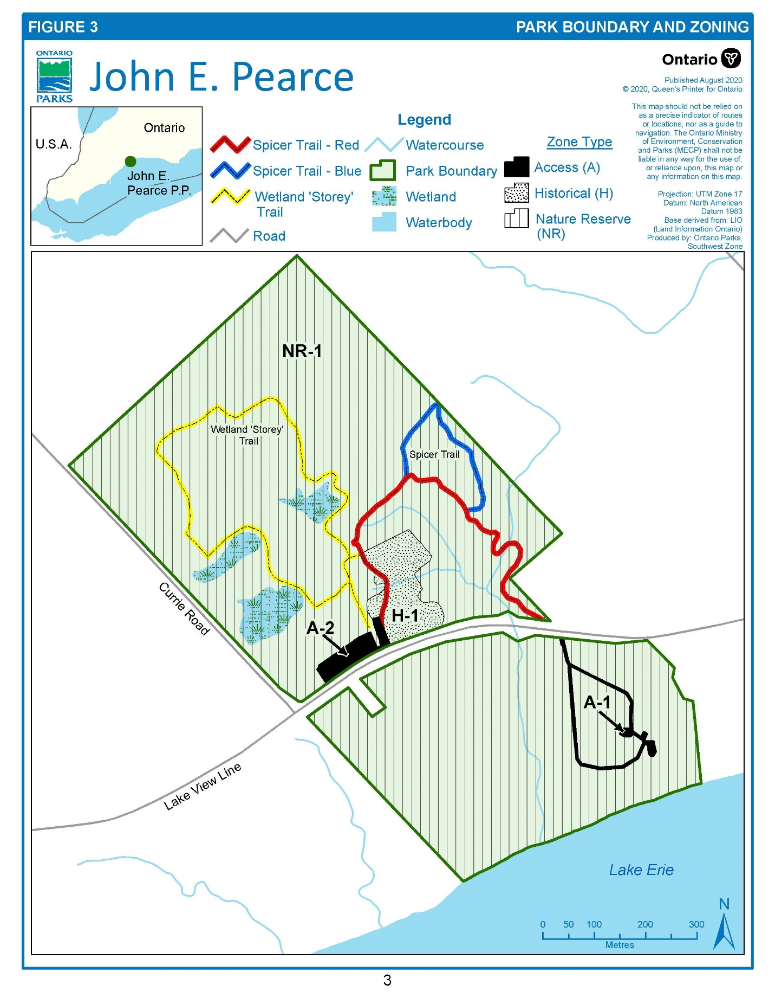

# Policies

## Resource management policies

Resource management policies have been established, consistent with applicable legislation and provincial park policies for nature reserve class parks while also recognizing the distinct cultural heritage features of John E. Pearce Provincial Park.

Planning and management of the park will recognize that these policies are interrelated and that an integrated approach will be required in order to achieve the objectives for this park.

### Industrial activities

The following activities are prohibited in John E. Pearce Provincial Park:

* commercial timber harvest
* generation of electricity (except for in-park use)
* extracting aggregate, topsoil or peat
* prospecting, staking mining claims, developing mineral interests or working mines
* other industrial uses

#### Utility corridors

There is one hydro corridor in the park entering from the east near the St. Peter’s Anglican Church, crossing the historical zone and exiting near the north parking area (A-2). There are also utility services (water) that run through, adjacent to, and/or near the park. Manual/mechanical tending will be encouraged in these corridors.

### Wildlife

Native wildlife populations, including species at risk, may be enhanced or species re-introduced where appropriate, feasible and desirable in terms of values for which the park was established.

Protection of the Carolinian vegetation will ensure continuation of wildlife species that inhabit the park.

Animal populations, including hyperabundant wildlife (e.g. white-tailed deer, wild turkey, raccoon), or individual nuisance or displaced animals may be controlled when necessary to protect park values. Techniques having minimal effects on other values will be used. If required, populations or individual animals will be controlled as quickly as possible through appropriate means which may include lethal methods.

Wildlife species or population management will be undertaken directly by Ontario Parks’ staff, or through partnerships with Ontario Parks.

### Vegetation

Management of vegetation within the park will be directed towards promoting the health and diversity of native vegetation communities to maintain or restore the park’s ecological integrity. Vegetation management for the purposes of supporting and maintaining existing or new heritage appreciation or recreational opportunities is permitted and will primarily occur in the historical and access zones.

Existing vegetation management practices (e.g. mowing, trimming, pruning, etc.) will not be expanded unless part of an approved development project. Generally, climax forests require very little management since they are self-sustaining if left undisturbed. For this reason, no active management is proposed for the nature reserve zone on the south side of the road. Successional vegetation management will be practiced.

Projects to enhance or restore native wildlife habitat and vegetation will be implemented where feasible and appropriate. Restoration projects will aim to maintain or improve habitat quality and connectivity, biodiversity, and ecosystem function.

Actions may include but are not limited to:

* restoring, naturalizing, or enhancing natural areas, habitats or wetlands (For example, native species planting or seeding, installing habitat structures)
* controlling access to areas with sensitive species
* creating ornamental or vegetation gardens with native species or historically accurate non-native species (restricted to historical zone)
* controlling plants and plant diseases / pests using chemical (For example,. herbicides, fungicides, insecticides), mechanical (e.g. removal, mowing) or cultural practices (e.g. burning) in accordance with applicable legislation and policy
* re-introducing native species or enhancing native species populations where appropriate and feasible

If visitor pressure within the nature reserve zones is causing trampling of areas containing rare species, then walking trails and sign systems may be established to mitigate such damage. Location of the trails will be guided by the report The Flora, Vegetation and Fauna of John E. Pearce Provincial Park prepared by Jocelyn M. Webber.

### Tree removal

Wherever possible, trees and brush cut in natural areas will be left to deteriorate in place. However, this may not be feasible in the historical zone or in the event of large-scale tree removal (e.g. as a result of emerald ash borer or other infestation). Where safe and feasible, trees will be trimmed or topped to leave snag habitat. Felled trees that are not left in place may be sold, disposed of or used in park operations if economical and feasible.

Wherever possible and appropriate, restoration or re-planting using native species will occur in areas where trees have been removed, particularly in areas affected by large scale tree removal.

The non-native species black locust (*Robinia pseudoacacia*) was planted in the gully at John E. Pearce. To remove these trees would probably cause further erosion of the gully and this would be more damaging than allowing them to remain. If future erosion problems persist in the gully, native species should be used to reduce substrate erosion. Native species on site, such as the shrub soapberry (*Shepherdia canadensis*), stiff gentian (*Gentiana quinquefolia*) and Canada bluegrass (*Poa compressa*) should be used for erosion control on exposed slopes.

### Species at risk and rare species

The park will be managed to protect species at risk and rare species. Species at risk and their habitats will be protected in a manner consistent with the *Endangered Species Act, 2007*, regulations and guidelines, and other relevant policy or best practices.

The park may undertake management actions for species at risk and rare species, as supported by research and directed through approved recovery strategies and government response statements or other species-specific management plans.

Existing populations may be augmented, and extirpated native species may be reintroduced, if biologically feasible and desirable for perpetuating park values and maintaining or enhancing ecological integrity.

### Non-native and invasive species

Non-native species are plants, animals and microorganisms introduced by human actions outside their natural past or present distribution. These species may originate from other continents, countries, or provinces, or from other parts of Ontario.

Invasive species are non-native species that are harming, or likely to harm, the natural environment. Non-native and invasive species will be addressed in a manner consistent with the *Invasive Species Act, 2015*, regulations and guidelines, Ontario’s Invasive Species Strategic Plan, and other relevant documents or best practices.

Where possible, Ontario Parks will work to eradicate or control invasive species in John E. Pearce Provincial Park. Invasive species control will aim to reduce or prevent impacts to native species, biodiversity, ecosystem function, and recreational opportunities. Control activities will be adapted based on the best available information.

### Fire management

Fire management in provincial parks is guided by the Fire Management Policy for Provincial Parks and Conservation Reserves (MECP and MNDMNRF 2021) and the associated guideline. The goal of fire management in provincial parks is to promote and encourage the use of fire as a natural ecological process for the maintenance and restoration of ecological integrity.

#### Forest fire management

All wildfires will be suppressed using standard methods and techniques where values in the park or on adjacent private lands are at risk.

#### Prescribed burning

Prescribed burning is the knowledgeable application of fire through deliberate human ignition to a specific area to accomplish predetermined resource management objectives (e.g. reducing fuel load which can help reduce the likelihood of large catastrophic fires, improving ecological health).

Prescribed burning may be undertaken in accordance with applicable policies and operational prescribed burn plans to reduce fuel loads, as well as enhance or restore certain vegetation communities, species habitats, natural disturbance patterns and ecosystem function.

### Cultural heritage

Cultural heritage values will be identified, assessed, and managed in accordance with existing applicable legislation and policies. During a preliminary archaeological survey of the park, locations were identified that contained early Indigenous artifacts. These sites will be protected by not identifying their locations in the park and by ensuring that no disturbance of the sites occur.

The Backus-Page House, a Georgian style home, is a living history museum which has been restored as closely as possible to its 1850s condition. It is managed under an agreement with the Tyrconnell Heritage Society who provides interpretive programming for park visitors.

The park may seek to co-operate with the local municipality, Indigenous communities, or other historic organizations, academic institutions, or museums to ensure the appropriate conservation or interpretation of artifacts and/or stories.

Cultural heritage initiatives may occur if they are consistent with relevant legislation, Ontario Parks’ policies and objectives, and are approved by the park superintendent.

#### Education and cultural heritage appreciation

John E. Pearce Provincial Park provides educational and heritage appreciation opportunities related to the area’s local history. Currently, these opportunities are provided through a local partnership. Guided opportunities offered by volunteers focus on the park’s historical agricultural practices and the lifestyle of an 1800s settler in the Talbot settlement.

Self-led opportunities are present in the form of exhibits and interpretive panels. These focus on a variety of topics including the park history, the work accomplished by the Tyrconnell Heritage Society, ecosystem function, Carolinian ecology, invasive species, species at risk, human influence, biodiversity, as well as cultural and natural heritage values of the park.

The Tyrconnell Heritage Society has developed an education and interpretation policy to help guide implementation of the park’s education, heritage appreciation and outreach initiatives. This document is reviewed and updated as required by the society.

### Land management

Ontario Parks supports the acquisition of land through sale or donation to enhance protection or park management. Adjacent lands with similar values, would be of highest priority. If lands are offered for sale or donation, Ontario Parks will evaluate how they contribute to park objectives. The acquisition of suitable properties would be subject to availability of financial and human resources.

Dispositions for municipal or other government purposes will not generally be allowed unless they contribute to the park’s purpose, vision, objectives, or operations. Dispositions include easements, authorizations, sales, transfers, and removal (deregulation) of land from the park. Dispositions for non-government purposes will not occur (e.g. for private or commercial purposes).

### Water Management

There are no water treatment facilities as the park is connected to Wallacetown’s water distribution services. The park has two sets of vault privies and a septic system which serves the carriage house. A future connection to municipal sewer infrastructure may be considered if feasible and practical.

### Shoreline bluffs and landform management

Landforms within the park will be managed for maintenance of natural processes and function, protection of significant cultural, natural, and recreational features, and visitor safety.

John E. Pearce Provincial Park is one of the few public protected areas between Port Stanley and Port Glasgow that contain Lake Erie shoreline bluffs, making this is a regionally significant park feature. The erosion of the bluffs will be left to continue through its natural process. Barrier fencing and warning signs along the bluff will be maintained for public safety and bluff protection. As erosion continues the fence will be moved inland with appropriate grassed areas maintained for picnicking.

### Collecting

Collecting or removing natural heritage items, cultural items or artifacts is not permitted unless authorized by the park superintendent. Other relevant collector authorizations or permits may also be required.

### Science and research

Ontario Parks may carry out inventories and monitoring to inform park management decisions. Scientific research by qualified individuals, which contributes to knowledge of natural and cultural values and to the management of the natural landscape, will be encouraged. Any external party who wishes to carry out research in John E. Pearce Provincial Park must obtain a research authorization letter from the park superintendent. Researchers may also need to obtain additional permits or approvals (e.g. ESA permits). Temporary facilities in support of approved research and monitoring activities may be permitted in Access and Historical Zones.

## Recreation management policies

### Hunting, trapping, fishing, harvesting and agriculture

The following activities are not permitted:

* sport hunting
* fur harvesting (e.g. trapping or trap lines)

sport and commercial fishing, including commercial baitfish harvesting

* vegetation harvesting (e.g. picking mushrooms, berries, fiddleheads)
* agricultural practices, unless undertaken for the purposes of educational or interpretive programs to highlight historical agricultural techniques

### Motorized vehicles

Use of motorized vehicles (e.g. passenger vehicles, motorcycles, gas or electric motor/power assisted bicycles) by park visitors is only permitted in parking areas in the access zone.

Park staff, emergency personnel or other persons with written authorization from the park superintendent may operate motorized vehicles, ATVs, or other off-road vehicles for operational, enforcement, emergency response, research, or resource management purposes. Snowmobiles are prohibited.

### Hiking, picnicking, and bird watching

The Wetland “Storey” Trail, Spicer Trail and park road will be maintained and monitored for degradation. If necessary, trails or sections of trails may be closed or relocated to prevent further erosion, trampling, rutting, widening or other degradation of park values. Additional trails will not be developed.

Walking, picnicking and nature appreciation will be encouraged. There are excellent opportunities for viewing migratory and breeding birds.

### Horseback riding

Horseback riding is not permitted.

## Operations and development policies

Ontario Parks will maintain a park operations plan to provide staff with the necessary direction to manage the park on a day-to-day basis. The park operations plan will include such topics as budget, staffing, maintenance schedules, enforcement and emergency management.

The provisions of the park operations plan will be consistent with park policy and Ontario Parks Operating Standards (MNRF 2018).

### Development

Infrastructure will be maintained, repaired, renovated, or replaced as required, or may be relocated, decommissioned, or demolished as necessary.

New infrastructure may be constructed at or transported to the park to support park operations, interpretation or research and may be focused on natural or cultural heritage values of the park. New construction will be limited to the access and historical zones.

The existing fence and warning signs along the bluff will be maintained for public safety, encouraging visitors to stay back from the edge of the bluff.

The walking trails in the park will be upgraded to allow visitors self-guided interpretive opportunities in the nature reserve. Walking trails on the north side of the Lake Road may be developed in the future, as funding permits. If this occurs, parking, access and visitor safety will be addressed at that time.

The road, parking area, and facilities such as the vault privies in the day use area of the park will be maintained for the convenience of park visitors. As funds become available the park boundary will be fenced along roadways.

There will be no campgrounds, campsites, or roofed accommodation within the park.

### Visitor services

The self-use visitor services program will provide an appreciation for the park as a nature reserve and an awareness of the park for its local cultural value.

A self-use information and interpretive sign system will be put in place to orient the park visitor to the facilities available and to inform the visitor about the natural and cultural values found in the nature reserve and surrounding area.

Two vault privies are located in the park. One is located near the parking area for the Backus-Page House and the other is near the picnic area and John E. Pearce monument.

### Information

Information will be provided by a park brochure, signs and exhibits. A park leaflet has been produced for general distribution through other parks, tourist information centres and other locations.

### Interpretive facilities

There are several buildings used for educational and interpretive purposes in the park including the Backus-Page House, honey house, barn, old barn foundation, carriage house, agricultural centre, vegetable gardens and orchards. Additional cultural heritage interpretive facilities may be constructed or added within the historical zone with approval from the park superintendent.

### Partnerships

Activities undertaken as part of a partnership or collaborative effort must be in keeping with the PPCRA, its regulations, Ontario Parks’ policies and all other applicable legislation. Partnerships or collaborative efforts will be subject to approval by Ontario Parks and may require the parties to enter into a legal agreement.

The Tyrconnell Heritage Society has a lease agreement to manage the Backus-Page House, effective 1997 to December 2046. This group has restored the building and operates it as a museum. The Tyrconnell Heritage Society is dedicated to promoting the history and heritage of the local area and educating the public on these topics which contributes to the objectives of the provincial park system.

### Special Events

A special event is an activity of limited time duration, occurring in designated areas, and organized and carried out by an individual, group, agency or association that is not sponsored by Ontario Parks.

Special events that relate directly to meeting park objectives may be permitted in keeping with the PPCRA, park operating standards and policies, and applicable government procurement processes. All special events must be approved by the park superintendent and require an agreement or authorization.

Special events may be permitted anywhere in the park outside of nature reserve zones provided that negative impacts to park values do not occur as a result of the activities. The location of special events will be influenced by a range of factors such as park values, infrastructure availability and operational considerations.

# Implementation priorities

Implementation of the actions identified in the management plan may be subject to:

* applicable legislation and provincial policy (e.g. environmental assessment)
* implementation and site planning
* the availability of financial and human resources

**Implementation Priorities**

* Ongoing habitat management and monitoring
  + Continued monitoring and management of non-native and native species is required to allow restored habitats to achieve desired ecological function.

**Long Term Implementation Priorities**

* Relocation or removal of infrastructure that is at risk due to the eroding bluff
  + If continued erosion of the Lake Erie bluff threatens public safety or park infrastructure, day use infrastructure will be relocated (e.g. picnic tables, vault privy, road/trail route, parking lot area, etc.).
  + Additional fencing or repairs to existing fencing will be completed when needed.
  + In areas where a significant risk to public safety is identified, signage will be erected to warn visitors of the dangers of accessing the eroding Lake Erie bluff beyond the fenced area.

# Examination and adjustment of management plan

This management plan will be examined in accordance with the provisions of the PPCRA to determine whether it is still relevant, effective and current, or if adjustments are needed. In circumstances where the plan/statement is not providing sufficient direction, or to address specific issues or pressures, it can be examined prior to the next scheduled examination.

# References

[Backus-Page House Museum](https://backuspagehouse.ca/).

[*Endangered Species Act, 2007, S.O. 2007, c. 6*](https://www.ontario.ca/laws/statute/07e06)

[*Invasive Species Act, 2015, S.O. 2015, c. 22*](https://www.ontario.ca/laws/statute/15i22)

Ministry of Natural Resources. 1992. Ontario Provincial Parks: Planning and Management Policies, 1992 Update. Provincial Parks and Natural Heritage Policy Branch. Toronto: Queen’s Printer for Ontario.

Ministry of Natural Resources. 2005. A Class Environmental Assessment for Provincial Parks and Conservation Reserves. Environmental Assessment Report Series. Peterborough: Queen’s Printer for Ontario.

Ministry of Natural Resources. 2006. A Technical Guide for Cultural Heritage Resources for Projects Planned Under the Class Environmental Assessment for Ministry of Natural Resources Resource Stewardship and Facility Development Projects and the Class Environmental Assessment for Provincial Parks and Conservation Reserves. Peterborough: Queen’s Printer for Ontario.

Ministry of Natural Resources and Forestry. 2014. [Ontario’s Protected Areas Planning Manual and Guidelines: 2014 Edition](https://www.ontario.ca/page/provincial-parks-and-conservation-reserves-planning). Peterborough: Queen’s Printer for Ontario. 33 pp.

Ministry of Natural Resources and Forestry. 2018. Ontario Parks Operating Standards. Peterborough.

Ministry of the Environment, Conservation and Parks and Ministry of Natural Resources and Forestry. 2021. Fire Management Policy for Provincial Parks and Conservation Reserves, PAM 7.02, (draft).

[*Ontario Heritage Act, R.S.O. 1990, c. O. 18*](https://www.ontario.ca/laws/statute/90o18)

[*Provincial Parks and Conservation Reserves Act, 2006, S.O. 2006, c. 12*](https://www.ontario.ca/laws/statute/06p12)

Harvey, E. T. 1977. John E. Pearce/Earth Science Inventory Checklist. Ontario Ministry

of Natural Resources, Southwestern Region. 4p.

Ontario Ministry of Natural Resources. 1978. Ontario Provincial Parks Planning and

Management Policies.

Webber, Jocelyn M. 1982. The Flora, Vegetation and Fauna of John E. Pearce

Provincial Park. Ontario Ministry of Natural Resources, Southwestern Region.

# Appendix 1: Summary of Indigenous community, public and stakeholder involvement – Management Planning 1994

The public in the local area have been notified that a management plan has been prepared for John E. Pearce Provincial Park. Additional copies of this plan are available at the Port Burwell Provincial Park office or [online](https://www.ontario.ca/page/provincial-park-management-direction)

Copies of the draft plan along with the invitation to comment on the plan was sent to the local municipalities, conservation authorities, adjacent landowners, interested organizations, groups and individuals.

A public open house was held on April 7, 1993. Approximately 50 people attended the session and over 20 written comments were submitted.

Many did not support the proposal in the preliminary plan to adjust the park boundary to exclude the house and farmland. The Ministry of Natural Resources has recognized that the farmland has the potential to contribute significantly to the value of the nature reserve. This land will be retained and progressively replanted. Vegetation Management Plans will be prepared as required.

The Ministry believes that removing the dwelling from the park by adjusting the park boundary is consistent with achieve park goals and objectives. A heritage easement will be arranged in order to afford the house the protection that it deserves.

# Appendix 2: Management planning history

| **Approval Date** | **Type of document and/or type of change** | **Document name** |
| --- | --- | --- |
| 09/28/1994 | Management Plan | John E Pearce Provincial Park Management Plan |
| 04/17/2012 | Examination   * Outcome: Amendment | Examination Report and Approval Statement |
| 03/26/2023 | 2023 Administrative Update | John E Pearce Provincial Park Management Plan – 2023 Administrative Update |
| XX/XX/2024 | 2024 Amendment | John E Pearce Provincial Park Management Plan – 2024 Amendment |