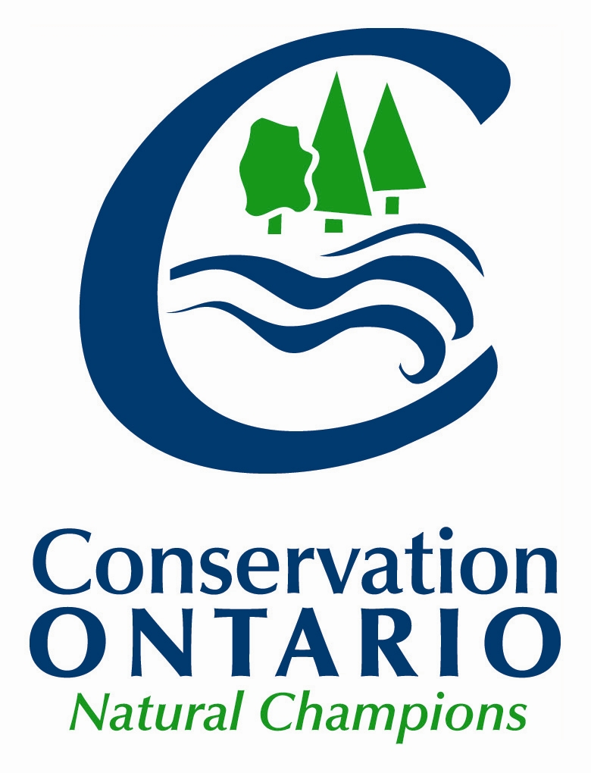

January 18, 2019

|  |  |
| --- | --- |
| Ken Petersen  Provincial Planning Policy Branch  777 Bay Street, 13th Floor  Toronto, ON M5G 2E5  [PlanningConsultation@ontario.ca](mailto:PlanningConsultation@ontario.ca) | Michael Helfinger  Intergovernmental Policy Coordination Unit  900 Bay Street, Hearst Block  7th Floor  Toronto, ON M6H 4L1  [Michael.helfinger@ontario.ca](mailto:Michael.helfinger@ontario.ca) |

Re: Conservation Ontario’s comments on Schedule 10 of Bill 66: Restoring Ontario’s Competitiveness Act, 2018 (ERO #013-4293); the Proposed open-for-business planning tool (ERO# 013-4125) and a New Regulation under the *Planning Act* for open-for-business planning tool (ERO# 013-4239)

Thank you for the opportunity to provide comments on Schedule 10 of “Bill 66: Restoring Ontario’s Competitiveness Act, 2019 (ERO#013-4293)”; the “Proposed open-for-business planning tool (ERO#013-4125) and a “New Regulation under the *Planning Act* for open-for-business planning tool (ERO#013-4239). Conservation Ontario is the network of Ontario’s 36 Conservation Authorities (CAs). These comments are not intended to limit consideration of comments shared individually by CAs through the Bill 66 consultation process.

Conservation authorities have considerable expertise in land use planning. Conservation authority roles in land use planning include: as a regulator under Section 28 of the *Conservation Authorities Act; as* a public commenting body under the *Planning Act* and *Environmental Assessment Act*; as source protection authorities under the *Clean Water Act* supporting policy implementation*;* as resource management agencies operating on a local watershed basis; as a body with delegated authority in plan review to represent the provincial interest for natural hazards; and as the province’s second largest landowners who may become involved in the planning and development process, either as an adjacent landowner or a proponent. In these roles, CAs endeavour to provide the best guidance to their municipal partners regarding how to balance multiple provincial and watershed priorities in a timely and cost-effective manner. Schedule 10 of the proposed Bill 66: *Restoring Ontario’s Competitiveness Act*, 2018 and the open-for-business planning tool appear to have significant implications for CAs in fulfilling their roles within the land use planning system.

Conservation authorities are concerned that the proposed open-for-business planning tool would have the effect of exempting applications under the *Planning Act* from having to be consistent with the Provincial Policy Statement and to conform to legislation including the *Clean Water Act,* the *Great Lakes Protection Act,* the *Greenbelt Act* andthe *Oak Ridges Moraine Conservation Act.* In addition, this tool proposes to override approved provincial plans which could result in new employment opportunities being located in unsuitable areas.

Good planning seeks to balance all of the provincial interests, including the economy, public health and safety and the environment. As guardians of public health and safety through their legislated and delegated roles, CAs have a responsibility to act in the provincial interest. Therefore, it is strongly recommended that any provisions in the proposed open-for-business planning tool which have the effect of circumventing necessary checks and balances for maintaining public health and safety be removed from the proposal.

It is noted that the proposed 34.1(8) of the *Planning Act* allows a local municipality to pass an open-for-business planning by-law that may impose conditions that are “reasonable for and related to the appropriate use of the land and that the municipality considers necessary for the protection of public health and safety”. It is recommended that ‘public health and safety’ be safeguarded as a provincial interest within the Provincial Policy Statement and the *Clean Water Act*.

**RECOMMENDATION:**

**Remove Section 3.0 (Protecting Public Health and Safety) of the Provincial Policy Statement and Section 39 of the *Clean Water Act* from the non-application of listed provisions in the proposed open-for-business planning tool as they represent necessary safeguards for public health and safety.**

Natural Hazards

The *Conservation Authorities Act* provides the legal basis for CAs’ mandate to undertake watershed planning and management programs that prevent, eliminate, or reduce the risk to life and property from flood hazards and erosion hazards, as well as encourage the conservation and restoration of natural resources. All new development has the potential to increase the risk of hazards to life and property from flooding and erosion and add to downstream cumulative impacts. Ensuring new development or redevelopment is not at risk from flooding or erosion is essential and must remain a basic principle in determining the feasibility of new development. Without proper evaluation of these potential impacts, maintenance and operation costs can lead to business uncertainty. In addition, there could be inadvertent and undesirable impacts on the site itself, as well as to adjacent and downstream properties, in the short term or over time. For example, these downstream properties could face increasing flood risks, with the attendant costs and liabilities attributed to the province and municipalities involved in their review and approval.

Proper evaluation and prevention measures avoid future costs; in fact, development in areas such as floodplains may result in huge costs that are better avoided. In this proposal, as posted, there is no requirement for pre-consultation, notice, review and appeal processes for an open-for-business by-law. Therefore, CAs are concerned that they do not have access to a planning process to ensure critical issues are raised, such as the presence of natural hazards (e.g. flooding, erosion). It is noted and agreed that the proposal does not preclude the proponent from receiving a building permit and a permit under Section 28 of the *Conservation Authorities Act.* As part of their commitment to providing high quality and timely decision-making on the Section 28 permit, CAs convey any concerns that they have regarding the establishment of the “principle of development” to the municipality/planning approval authority as early in the planning processes as possible, preferably at the pre-consultation stage. It is important for ensuring a streamlined development application that any public safety issue is raised during the preparation of a municipal Official Plan, secondary plan or Official Plan amendment, or as early as possible in the *Planning Act* approvals process and not through the *Conservation Authorities Act* S.28 permitting process. As concluded/agreed through the multi-stakeholder consultation process for the “Policies and Procedures for CA Plan Review and Permitting Activities” the Section 28 permitting process should serve as a technical approval process (similar to a building permit) rather than a reactionary measure to review and comment on applicable planning decisions that may not have been adequately informed with regard to natural hazards and public safety.

Clean Water Act

The *Clean Water Act* is the first step of Ontario’s multi-barrier approach to drinking water source protection. It provides the legislative basis for local Source Protection Plans which contain policies to protect municipal drinking water sources that 85% of Ontarians rely on. The plans include preventative land use planning policies to proactively address threats to our municipal drinking water sources, reducing the need for further/additional regulations.

Bill 66 proposes to override the need to conform to these land use planning policies in local source protection plans, within open-for-business by-law areas.Eliminating the ability to guide land use planning decisions in turn removes the preventative approach that was taken by local source protection committees to protect municipal drinking water sources.

Proposed Addition to the *Planning Act:* Section 34.1 Open-for-business planning by-law

The proposed Open-for-business planning by-law has been positioned as an opportunity to attract high quality jobs through a new major employment use. It is important to note, however, that the limitation on the use of the tool for an employment purpose would be established through regulation, rather than through amendments to the *Planning Act.* While it is unclear, it would appear that this would be a Ministerial level regulation.

Without placing limitations on the use of the tool directly into the *Planning Act*  this proposed amendment could be used in the future for a wide-range of business opportunities, which are not contemplated through this current consultation. For example, waste management facilities are notoriously difficult to site and yet, represent an opportunity for economic development for municipalities. Concern has been raised that this proposed change to the *Planning Act* could allow for a municipality, at the extreme, to site a waste management facility using one of these by-laws.

Therefore, it is recommended that amendments be made to Bill 66 to address the purpose and scope of Section 34.1 by-laws to employment-related development and that these be placed directly in the *Planning Act*. Furthermore, it is recommended that section 34.1(2)(2) be amended to requirethat the Minister create prescribed criteria for the use of the by-law. Conservation authorities would be pleased to advise on these criteria (see examples in the attachment) which presumably would be developed with input from the public.

The purpose of the proposed tool and regulation is unclear, as the *Planning Act* already contains an instrument to secure large-scale employment investments: the Minister’s Zoning Order. The distinct purpose of this new tool should be clarified.

Relationship to the ‘Made- in-Ontario Environment Plan’ and Other Provincial Consultations

Provincial land use planning policy and source protection policy supports the provincial government’s efforts in protecting the quality and quantity of water resources.  It is recommended that Bill 66, which suggests that the policies of the Provincial Policy Statement, Greenbelt Plan, Growth Plan and *Clean Water Act* / Source Protection Plans need not apply in certain circumstances, further align with the Made-in-Ontario Environment Plan to prevent any potential compromise to Ontario’s water resources and, in turn, Ontario’s economy.The plan states that the Province, “will protect these critical systems by using water more sustainably and keeping our water … clean while growing our economy."

The guiding principles for the government’s consultation on provincial planning approvals include: safeguarding public health and safety and continuing to protect provincial land use interests that are important to long-term economic, environmental and social well-being, including protecting the Greenbelt and the environment. These guiding principles are supported and it is recommended that these guiding principles be adopted for the proposed open-for-business planning tool and accompanying regulation under the *Planning Act*.

Specific Comments on the Non-application of listed provisions and the Proposed Regulation

In addition to the recommendations within this letter, further specific comments on the Non-application of listed provisions and the Proposed Regulation have been provided in Attachment 1. These comments are intended to outline the need for further clarity when defining the scope of use for the open-for-business tool by municipalities. They include considerations that could be helpful in crafting explanatory notes both with regard to scope and with regard to what constitutes the Minister’s review.

Conclusions

Conservation authorities are solution-oriented agencies, who represent aspects of the provincial interest in protecting public health and safety and work closely with their municipal partners to ensure development proposals uphold these interests. To better ensure consistent safeguards for public health and safety, Conservation Ontario recommends the removal of Section 3.0 (Protecting Public Health and Safety) of the Provincial Policy Statement and Section 39 of the Clean Water Act from the non-application of listed provisions in the proposed open-for-business planning tool. CAs continue to be committed to streamlining planning processes and to providing the best guidance to their municipal partners in a timely and cost-effective manner. Conservation authorities are prepared to assist the Province with identifying those streamlining opportunities as well.

Thank you for the opportunity to review this proposal, should you have any questions about this letter, please feel free to contact myself at extension 223 or, for specific clarifications on: natural hazards, please contact Leslie Rich, Policy and Planning Liaison (ext 226); and, *Clean Water Act*, please contact Chitra Gowda, Source Water Protection Lead (ext 225).

Sincerely,

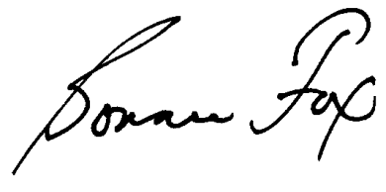

Bonnie Fox

Manager, Policy and Planning

c.c. All CA CAOs/GMs

Encl.

**Attachment 1**

**Specific Comments on the Non-application of listed provisions and the Proposed New Regulation under the Planning Act for Open-for-Business Planning Tool**

**Non-Application of Listed Provisions – Proposed 34.1(6) of the *Planning Act***

|  |  |
| --- | --- |
| ***Subsection*** | **Commentary** |
| *Non-application of listed provisions* | * It is recommended that Bill 66 be amended to remove the ‘non-application of listed provisions’ that may compromise public health and safety * Should the non-application of listed provisions remain in its current form, the following criteria should be added:  1. Municipalities identify specific lands to which the by-law would apply 2. Municipalities demonstrate there are no other feasible employment lands outside of the areas protected under the non-application of listed provisions 3. Municipalities assess the nature and extent of matters which may affect public health and safety (on site and sub-watershed basis) 4. Municipalities consult with public agencies (CAs) and include any responses from these agencies in their request to the Province.   (i.e. Checks and balances be put in place to ensure by-laws are not being passed when there is available land already identified for employment development in OPs) |
| 1. Subsection 3 (5) of the *Planning Act* | * Subsection 3(5) of the Planning Act ensures conformity with the PPS. Conformity with the PPS requires land use planning decisions to be made in the public interest and that health and safety of the public is protected. Conformity with Section 3 of the PPS should remain to ensure land use planning decisions are made in the public interest while ensuring the health and safety of the public is protected. * Further, with regard to the health and safety section of the PPS, its application is important with Climate Change posing increasing risks to communities (e.g. flooding). * The PPS (2014) Section 2.2 ‘Water’ specifies that planning authorities shall protect, improve or restore the quality and quantity of water. This includes the protection of designated vulnerable areas around municipal drinking water sources, and sensitive surface water and groundwater features as well as related hydrology. The proposed Bill 66 schedule 10 can circumvent restrictions on development and site alteration and mitigation measures, thus potentially impacting public health, and sensitive water features including groundwater recharge areas and vulnerable aquifers that may supply local private and communal wells. |
| 1. Section 24 of the *Planning Act* | * Municipal Official plans (OP) identify and designate employment lands based on full servicing. There is a need for the OFBPBL to conform with all OPs as these documents are the guide for all local planning decisions. Excluding Section 24 of the Planning Act could allow for development to occur which doesn’t particularly comply with OP policies * The OFBPBL could be used to accelerate development approvals for employment lands (for lands currently serviced) in areas already approved as employment lands in OPs |
| 1. Section 34 (10.0.0.1) to (34) of the *Planning Act* | * Removal for the requirement for public meetings (12) and the right of appeal to the LPAT limits the ability of municipal and planning agencies to ensure development will not have negative impacts on the surrounding public, properties or environment. Based on the published information, this challenges the importance of the role that community plays in the Land Use Planning process. This, plus the limited amount of time for the public to voice their opinions during which the by-law can be passed, effectively removes the relevant public and private interests from the process. * Removal of public meetings and the right of appeal also has the potential to create a situation where one private interest could benefit at the expense of many public interests * Not providing notice (Section 15) to CAs could present a risk to public safety in cases where development is proposed in or adjacent to hazard lands. CAs utilize this consultation to provide policy and technical input into the passage of zoning by-laws |
| 1. Section 36 of the *Planning Act* | * Holding provisions are useful tools that ensure all technical matters are addressed prior to zoning coming into force. For CAs, these provisions allow technical matters related to CA roles to be addressed prior to zoning coming into force (ie. CA permits) |
| 1. Section 37 of the *Planning Act* | No comment. |
| 1. Section 39 of the *Clean Water Act, 2006* | * It is recommended that Bill 66 be amended to remove the Clean Water Act (2006) from the list of non-applicable provisions. The Clean Water Act is an essential law necessary to avoid another tragic contaminated water incident such as that of Walkerton in 2000, which led to multiple deaths and long-term illnesses for many people. The Clean Water Act is the first step of Ontario’s multi-barrier approach to drinking water source protection. Without this first step, the protection of drinking water in Ontario is incomplete. * The Clean Water Act provides the legislative basis for local source protection plans that contain policies to address significant, moderate and low level threats to our municipal drinking water sources. These policies were developed by local committees (that include municipal representatives) who already considered factors such as growth and economy. These legally binding policies were approved by the Province of Ontario to proactively address risks to the quality and quantity of municipal drinking water sources on a watershed basis. * Bill 66 proposes to circumvent the requirement for municipalities to conform to source protection plan policies that rely on Planning Act decisions, within proposed open for business by law areas. * The use of the proposed open for business by law has the potential to lead to cross – boundary issues, where an open for business by law area could impact public in adjacent municipalities. Connections of surface water and groundwater systems that are drinking water sources extend far beyond municipal boundaries - and should be considered through a watershed based approach. * Source protection plan policies using decisions under the *Planning Act* are proactive, by ensuring that development does not create risks to drinking water sources. Proactive planning prevents impacts early on in the process and also significantly reduces any further regulatory burden. Eliminating the ability to guide land use planning decisions can cause a risk to public health due to the potential for water contamination, as well as overuse. * If Bill 66 is passed, the local source protection committees may have to determine and consult on alternate policy approaches to ensure that the committees meet their mandate under the *Clean Water Act*, which is to protect municipal drinking water sources. Further, other regulatory tools may not offer the same proactive and preventative approach as land use planning policy tools. * The land and water areas which Source Protection Plans have designated as “vulnerable to significant threats” are typically small in comparison to the area of land to which development could be attracted. Applying the proposed Bill 66 to these vulnerable lands will not appreciably increase the area to which municipalities will wish to attract development, but may well place risks to drinking water safety and therefore public health. The costs involved, if such is the case, would far out strip the benefits from any development. * Clean and sustainable municipal drinking water sources are also the backbone to supporting a strong and sustainable local economy and healthy communities. Smart growth is achieved through its three pillars of environment, economy and society functioning together and not separately. Rather than removing the requirement for land use planning policies within open for business by law areas, the Province is encouraged to utilize the significant science and policy work completed under the *Clean Water Act* for responsibly siting manufacturing or research and development facilities. For example, the location of water quantity stressed areas (determined through assessments conducted under the Clean Water Act) is one of many factors to be considered while siting a manufacturing or research and development facility, to help avoid water supply problems to the public and to the facility. Utilizing the strong science and policy work completed will firmly support the proposed Environment Plan by the Province, which states that, "We will protect these critical systems by using water more sustainably and keeping our water and air clean while growing our economy”. |
| 1. Section 20 of the *Great Lakes Protection Act, 2008* | * Not requiring a shoreline project to conform to any protection initiative could result in less environmental protection for the Great Lakes. It is suggested that planning decisions should conform to the *Great Lakes Protection Act* to help combat climate change, reduce algal blooms and protect wetlands and coastal areas. The Great Lakes are a significant contributor to the overall provincial economy. |
| 1. Section 7 of the *Greenbelt Act, 2005* | * Planning decisions (including by-laws) should conform to the *Greenbelt Act* to help protect the agricultural system and well as ecological and hydrological features and systems. These systems provide enormous benefits to the public (ie. access to clean water, agricultural productivity, avoided flood costs, avoided social costs of climate change, etc.). It is recommended that the value of natural capital be considered when making revisions to the OFBPBL tool. * Approval of Bill 66 could potentially allow large-scale development in the protected countryside and/or Greenbelt Natural Heritage System |
| 1. Section 6 of the *Lake Simcoe Protection Act, 2008* | * It is recommended that the value of natural capital be considered when making revisions to the OFBPBL tool. |
| 1. Subsection 31.1 (4) of the *Metrolinx Act, 2006* | No comment. |
| 1. Section 7 of the *Oak Ridges Moraine Conservation Act, 2001* | * Approval of Bill 66 would allow development to disregard the requirements of the ORMCP and potentially adversely impact the moraine’s environmental resources. |
| 1. Section 13 of the *Ontario Planning and Development Act, 1994* | * No comment. |
| 1. Subsection 14 (1) of the *Places to Grow Act, 2005* | * Section 14 requires a decision under the *Planning Act* to conform to the Growth Plan for the Greater Golden Horseshoe. This contains environmental protections and directs development to rural and urban settlement areas (properly serviced areas). Non-application of this section of the *Places to Grow Act* could result in a more costly and environmentally impactful piecemeal approach to servicing and stormwater management. * Consideration should be given to the availability of waste water treatment capacity and availability of water supply while minimizing impacts to the local watershed * Potential development sites located outside of established settlement areas would be subject to rural servicing. This would result in costly development requiring the establishment of private services on such a large scale. It is recommended that servicing criteria be included in the list of criteria to be met in consideration of the use of the planning tool |
| 1. Section 12 of the *Resource Recovery and Circular Economy Act, 2016* | No comment. |
| 1. Any prescribed provision | * Additional non-applicable provisions should only be considered through future legislative amendments to the Planning Act and not prescribed through regulation. |
| *Application of site plan control* | * From a development review perspective, removing site plan approval by a municipality presents some concern, as without site plan approval, design proposals made at earlier stages will potentially not be followed through to construction and implementation. * Through waiving the site plan control circulation process there is a risk that CA permitting requirements will be missed early in the approval process, resulting in undue strain on the existing regulatory process with regard to Section 28 approvals. |
| *Conditions that may be imposed* | * To provide comments, more information is needed on what is meant by the manner of construction and construction standards not being subject to a condition. |
| *Notice* | * CAs have long-established working relationships with municipalities and local municipalities typically consult CA staff, especially when development is proposed to occur in a regulated area. Through the OFBPBL tool, municipalities could bypass regular notice requirements which could result in unintended consequences for public health and safety. |

**New Regulation under the Planning Act for Open-for-Business Planning Tool**

| **Section** | **Commentary** |
| --- | --- |
| A municipality’s request to use an open-for-business planning by-law would need to be accompanied by information that would be prescribed in a proposed new regulation, such as a description of the subject lands, land use planning information, and open-for-business information, including details about the proposed employment opportunity. | * Should the non-application of listed provisions remain in its current form, the following requirements should be added:  1. to identify if the lands outlined in the OFBPBL are located in environmentally sensitive (hazard/designated drinking water vulnerable) areas 2. to work closely with their local CAs and meet requirements to mitigate risks and protect downstream communities from flooding and erosion hazards  * In order for timely approach to approving major employment uses, the regulation should specify the timing for Minister review/approval * Residential uses, even as a secondary use should not be included under OFB by-laws. As currently proposed, it could present a serious risk to the public in the event that development is placed in hazard lands. |
| Require confirmation that the proposal is for a new major employment use | * A definition is needed to ‘new major employment use’ to clearly distinguish this tool from a Minister Zoning Order |
| Identify the uses of land, buildings or structures that may be authorized by the tool, such as manufacturing and research and development, but not residential, commercial or retail as the primary use | * New uses should be located out of hazard lands and should have safe access to ensure public safety * New uses should not cause or contribute to offsite impacts / downstream cumulative impacts. It is recommended that the municipality work with the CA to ensure development or redevelopment is not at risk of flooding or erosion and that the quality and supply of drinking water sources are not impacted. Without consideration for these potential impacts, maintenance and operational costs could increase depending on risks. |
| Prescribe how notice is to be given to the Minister of Municipal Affairs and Housing following the passing of an open-for-business by-law (similar to how the Minister is notified following the passing of a zoning by-law – e.g. email and personal service). | * Should the non-application of listed provisions remain in its current form, the following should be added:   1. Require the province to report on performance outcomes of the tool (e.g. number of times the OFBPBL has been used, amount of approved OFBPBL lands in hazard areas and drinking water vulnerable areas and number of jobs / employment uses created through its application) |