February 22, 2019

Greg DeVos

Ontario Ministry of Agriculture, Food and Rural Affairs

Food Safety and Environmental Policy Branch

1 Stone Road West

Ontario Government Building, 2nd floor,

Guelph ON N1G 4Y2

Dear Mr. DeVos,

**RE: ERO 013-4388 Proposed regulatory amendments to Ontario Regulation 267/03 under the Nutrient Management Act**

The Christian Farmers Federation of Ontario (CFFO) is an Accredited Farm Organization representing the interests of over 4,000 farm families in Ontario who are called to the vocation of farming. CFFO policy promotes economically, socially, and environmentally sustainable farming, advocating that farmers receive fair return for their production and stewardship efforts.

The elimination of unnecessary red-tape is an important step towards creating a more efficient environment conducive to good business operations. The two proposed regulatory amendments to the Nutrient Act are beneficial to farmers since both successfully target policies that should be considered unnecessary.

The first amendment, which eliminates mandatory renewal of nutrient management strategies (NMS) every five years, regardless of any relevant changes to farm operations regarding nutrient generation or application, is a move in the right direction. It will save farmers possibly thousands of dollars from unnecessary renewals without compromising responsible nutrient management.

The second amendment, which recategorizes zebra, elephant, and kangaroo manure as category 1 non-agricultural source material (NASM), also benefits farmers who would use these manure types. Being that these three species are all herbivores, the nutrient content of the low-nitrogen manure they generate bears close resemblance to those of traditional farm animals. Since these three NASMs share many of the same properties as traditional manures, it would be beneficial to regulate them in a similar fashion so that farmers no longer need to spend time and money on government approvals or the creation of an NASM plan for these materials.

Nutrient management is an important aspect of farming operations, and it is also important that it be regulated adequately to ensure the responsible use of these materials. This amendment to the Nutrient Management Act cuts regulations around nutrient management in a way that makes agricultural operations easier for farmers without undermining the policies that ensure this responsible use.

Thank you for your consideration of these comments.

Sincerely,

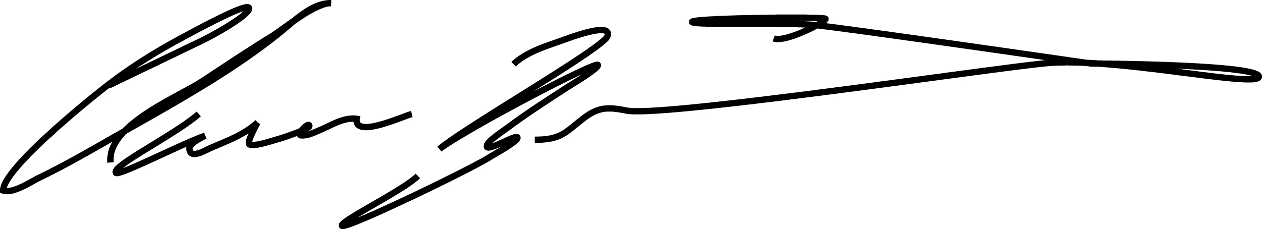

Clarence Nywening, President

Christian Farmers Federation of Ontario

JK