**Environmental Site Assessments---The Consultant’s Dilemma**

Buying and selling commercial/industrial properties in Canada generally requires an Environmental Site Assessment (ESA) to see if the property has any issues stemming from its previouse uses or current condition. They also include a review of the surrounding properties for any possible impact to the site with a particular emphasis on “red-flag” operations such as gas stations and dry cleaners or industrial manufacturers. Demand for ESAs began in the late 1980’s when new environmental standards were introduced placing limits on the levels of contaminants in soil and ground water. This prompted buyers and sellers, bankers and lawyers to seek the help of environmental consultants to examine their properties and report back on any environmental issues found with recommendations on what to do about them. At the beginning, the new rules were mostly ignored because those involved really didn’t understand what the fuss was all about and didn’t see the need for another layer of bureaucrasy in an already expensive real estate process. Also, the new rules were in the form of voluntary guidelines rather than Regulations, so there was no pressing reason to take on the increased costs and time delays of applying them to property purchases. This changed, slowly at first, then with increasing rapidity as news spread of property values collapsing as a result of applying the new rules after finding the site was contaminated. Sites and businesses which had seen their cash value continue to soar over the previous decades were suddenly blind-sided by an environmental report showing their real estate was contaminated and its value worthless or catastrophically reduced. Particularly troublesome for some was the news that the contaminants had been there long before they purchased the property. So, it is true to say that on the day the new rules were introduced, billions of dollars in property values disappeared and most of us didn’t know it, especially the countless mom-and-pop businesses built on old industrial land or over or near old leaky gas stations, fuel depots, dry cleaners and so on! For them, the business was their retirement nest-egg and their anger at the government and the environmentalists for penalising them for something they didn’t know about was palpable. The outcome thoughout the 1990’s was a landscape dotted with derelict gas stations, shuttered buildings and abandoned industrial lands which were given a new name---brownfields!

The banks were quick to realise that a property’s cash value was very much tied to its environmental condition---that is, whether or not the property’s soil and ground water met the new contamination limits so they quickly made ESA’s a prerequisite for loan approval. The new millenium brought more changes and new headaches. Guidelines were replaced with Regulations and the Regulations greatly expanded the list of contaminants while at the same time lowering the allowable limits for most of them, thereby converting more properties from assets to serious liabilities---including some that had already been shown to be clean under the previous limits. By lowering the allowable limits these “clean” properties were now “contaminated” again despite the fact that the owners had done nothing to cause this! This situation continues every time the Regulations are revised and an allowable limit is lowered.

**The Consultant’s Role**

ESA’s are now common practice in the buying and selling of commercial/industrial real estate and the role of the environmental consultant is now firmly established in the process. (Surprisingly, although the same rules also apply in large part to the residential real estate market, there has been much less interest from home buyers in establishing the environmental condition of their properties.) The consultant is tasked with the job of recording a site’s previous history from an environmental viewpoint to see if there is any chance that it may now exceed a regulatory limit in its soil and ground water. This involves a walk-through site inspection, including the interior of any buildings, to look for actual or potential environmental issues but does not include any soil or ground water sampling. The surrounding properties are also scanned for any possible impact to the subject property and the whole exercise is presented to the client in the form of a *Phase 1 Environmental Site Assessment* report. If any contamination is known or suspected, a *Phase 2 Environmental Site Assessment* is then recommended and this involves borehole drilling or excavating test-pits to examine the soil and ground water on site to see if it complies with the regulatory limits (“Site Condition Standards” in Ontario). If contaminants exceeding the limits are found, further investigation is required to define the horizontal and vertical extent of this followed by a cleanup of the impacted zone. After the cleanup, additional samples are gathered to verify the contaminants have been removed. Costs for phase 2 ESAs range from low five to six-figures and cleanup costs can take this into seven figures, well beyond the means of most mom-and-pops.

**The Consultant’s First Dilemma**

Phase 2 ESAs present a series of challenges to the consultant which are not easily met and some of which are just not met at all. Following the completion of the phase 1 report, a phase 2 sampling and analysis plan is prepared which defines the number of boreholes and monitoring wells to be installed and the number and depths of samples to be retrieved. However, phase 1 reports are often sketchy at best with much missing information such as what chemicals, if any, were used on site, where were they used and how were they disposed of. Did they have any spills? What were the neighbours up to at that time? Did they have any spills?... and on it goes. These questions are hard to answer especially when it relates to activities that happened 50 or more years ago and there’s no one around to ask. Even if your lucky enough to find someone, memories fade and environmental issues were not on the radar screen at that time.

Before starting a phase 2 ESA, the consultant must prepare a “Sampling Plan” which defines the number of boreholes and monitoring wells to be installed and the number of samples to be gathered. How many boreholes?, how many samples?, all the Regulation says is “a sufficient number” and what that number is is up to the consultant to decide and here’s the dilemma: the science and common-sense says when you don’t have answers to the above questions, a “sufficient number of samples” is to drill closely-spaced boreholes all across the site and analyse samples from multiple depths beneath the surface to cover all possible contaminants. Opposing this scientific approach is the client whose pockets are not deep enough to cover the drilling and lab costs and the consultant’s marketplace where the lowest bid wins and padding a project with expensive drilling and lab costs is not a recipe for success. So where do you strike the balance? Current practice is to define “Areas of Potential Environmental Concern” (APEC) on the site based on the findings of the phase 1 investigation and then concentrate on these areas in the phase 2 investigation but this is a hit-and-miss process given the amount of missing information and even here there is no guidance on how many boreholes and how many samples are required.

**For Example..**

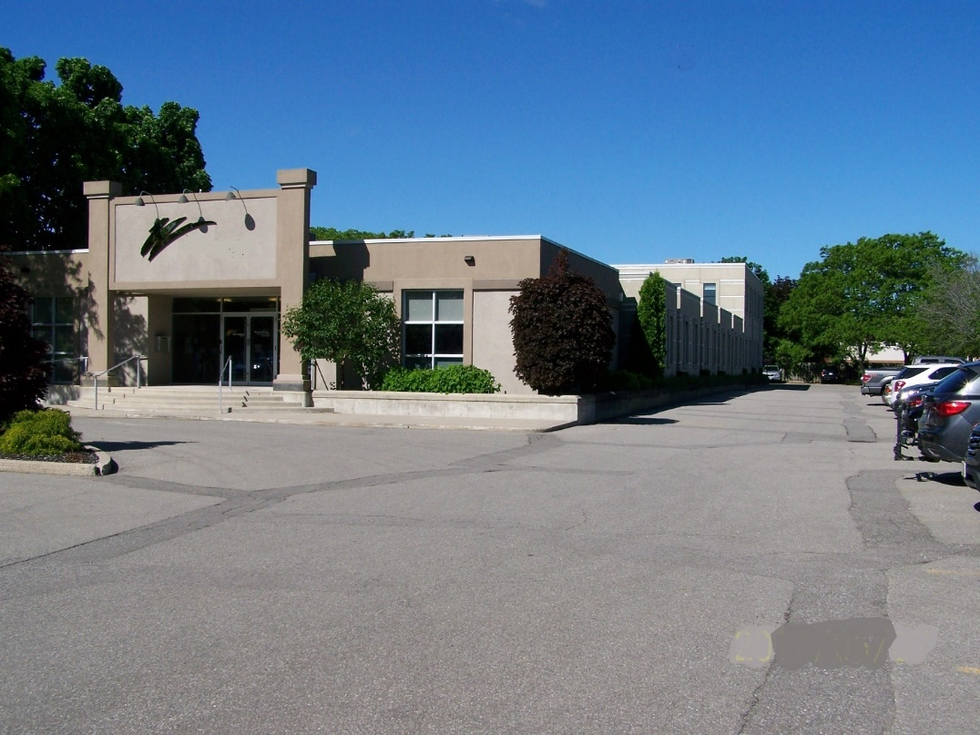

Take, for example, a 1 hectare downtown site currently used as a commercial office building with parking lot. The phase 1 report shows that back in the late 1800’s there was a leather tannery on site heated by coal which closed in the 1920’s. This was followed by a widget manufacturer who made widgets that are no longer used but no one is quite sure what chemicals or processes were involved or where and how these were stored. Did they spray-paint them with lead-based primer and if so, where was the exhaust outlet from the paint booth? However, they closed up in the 1940’s and were replaced with a welding shop which used a sand-blasting process to clean the rust prior to painting. From the 1940’s to the 1970’s the site was used as a gas station and auto garage with underground fuel tanks whose location is uncertain then the garage building with its underground hydraulic lifts was demolished to make way for the new office building now on site. There’s no record of any cleanup being performed. Accurately defining APECs on this type of site *before any drilling is done* is very difficult and the list of possible contaminants is long given the different types of operations on the site so, it means completing the phase 2 ESA in two parts: preliminary and final. The preliminary phase 2 examination of the site drills a few boreholes in each identified APEC to check the soil and ground water for the “contaminants of potential concern” in the hope that these are “sufficient” to indicate if the site is contaminated or not. If nothing amiss is found, the site is declared to “show no evidence of any exceedances of a regulatory limit for the contaminants examined” and nothing more is done. If exceedances are found, further drilling and sampling is done to define the horizontal and vertical extent followed by a site cleanup or risk assessment, the latter being used to see if the contaminants can be left in place. Remember, all of this is based on the sketchy information in the phase 1 report and the best guess at where any contaminants might be.

The Consultant’s Second Dilemma

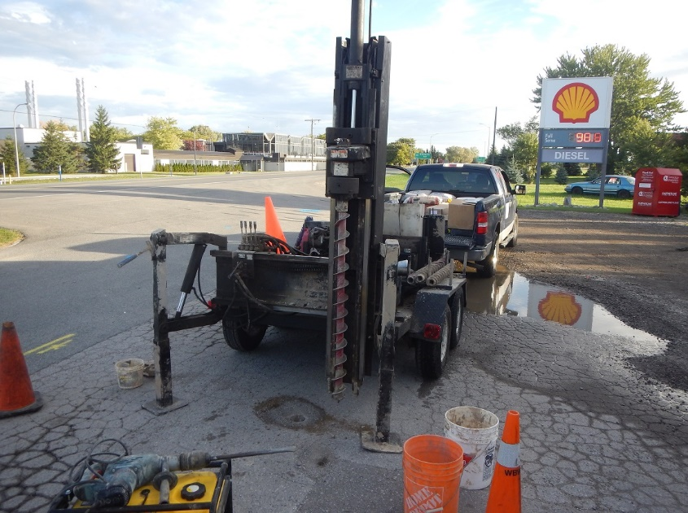

The Regulations specify that “representative samples” must be submitted for analysis but once again they do not define how to achieve this--what size of sample and how many should be collected. This decisionn is left to the consultant who is already under intense pressure from two conflicting sources: the client who demands costs be kept to a minimum and the same client who later finds out that you failed to detect contaminants that someone else has discovered and is now threatening to sue you! Worse still, it really doesn’t matter what size of sample you send to the lab (typically around 100 – 200 grams), *the laboratory only uses about one gram (< 1%) of the sample to complete the analysis. The other 99% stays in the bottle!* This is less of an issue when sampling groundwater which is much more homogeneous because the contaminants are in a dissolved state but it is often an insurmountable issue when sampling soil, especially when you have no prior knowledge how the contaminant is dispersed within the soil. Yes, your nose and eyeballs and vapour meters can help but only with contaminants you can see and smell and volatilise but if the allowable limit for the contaminant in question is in the low to sub-parts per million level---and many of them are---and you can’t see it or smell it or meter it, none of these three avenues are any help. It makes no sense to argue that a one gram sample analysed at the laboratory is representative of the millions and millions of grams at the site unless the contaminant particles in the soil are evenly dispersed and in sufficient numbers to allow 1 gram of soil (typically a few thousand particles) to contain an average number of contaminant particles. This never happens in reality and is especially troublesome when dealing with toxic metals (antimony, beryllium, cadmium, mercury, etc.) and polycyclic aromtaic hydrocarbons (PAHs) where it only takes a few contaminat particles per million soil particles to exceed the limit. A site which shows an exceedance of *any* contaminants must be cleaned up or risk assessed. In these and many other cases, one gram samples simply cannot be representative because the lab takes only a couple of thousand particles from the sample bottle for analysis. Statiscally, the chances of the 1 gram lab sample containing *any* contaminant particles is close to zero but if it does happen to include one, the lab certificate will show a result far above the true value (1 particle in 2000 particles = 500 ppm).

**What are the Consequences?**

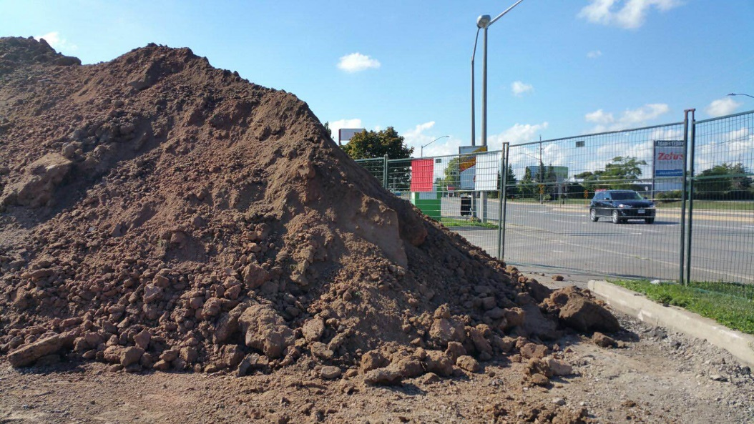At the core of every phase 2 ESA is the laboratory certificate of analysis showing whether a site needs an expensive cleanup or a pat on the back to the site owner. Consultants place great reliance on these certificates because they come with several pages of quality control showing how precise and accurate the results are but they miss the point that the result is only as reliable as the sample is representative and no one has yet defined what representative means. It is troubling to think that many a site has been declared “clean” on the basis of lab certificates showing no exceedances when, in fact, the lab sample was simply not large enough to contain anywhere near a representative number of contaminant particles and the site is in fact “contaminated”. Equally troubling it is to think that many a site has undergone an expensive cleanup based on a reported exceedance in a one gram sample that was never representative in the first place. A very common occurrence is to find a slight exceedance in one or more metals or PAHs on a site which prompts further investigation only to find these metals or PAHs have “disappeared” but are now replaced with other members in the analytical package that weren’t there first time around. The problem here is not with exceedances but with statistics.

**What is the Solution?**

The Ontario Ministry of the Environment, Conservation and Parks has just announced proposed changes to the Brownfileds Regulation and introduced a new Excess Soil Management regulation which once again fails to address the serious sampling issues. Indeed, it carries instructions that at least three samples from a 150 cubic metres pile of soil be analysed before it can be disposed of?? That’s approximately eight big truckloads and the1.5 grams of soil analysed for metals (0.5 g/sample) is supposed to tell me something about the soil quality. This is meaningless. Finding a solution to these issues is not going to be easy because the answer is either to increase the sample size at least a 100-fold or greatly increase the number of smaller samples. The labs currently cannot handle the former and the client will refuse to pay for the latter so we are left with lab results and cleanups based on very unrepresentative data.

**Dr. George Duncan, M.Sc., Ph.D., P.Geo. (Limited), C. Chem., Q.P.ESA**

**Senior Consultant,**

**A & A Environmental Consultants Inc.**

Dr. George Duncan is a Principal Consultant with A & A Environmental Consultants, Inc. He is an environmental analytical chemist with over thirty years’ experience in his field and has conducted over two thousand site investigations and cleanups. He holds a Master’s and a Doctorate degree in Analytical Chemistry from the University of Salford in England and is a “Qualified Person” under Ontario Regulation 153-04 for the performance of Phase I & 2 Environmental Site Assessments. He is registered as a Professional Geoscientist (limited) with the Association of Professional Geoscientists of Ontario (APGO) and as a Chartered Chemist with the Association of the Chemical Profession of Ontario (ACPO) and the Royal Society of Chemistry in the UK. For a full description of the author’s background visit the company web-site at [www.aaenvironmental.ca/](http://www.aandaenv.com).