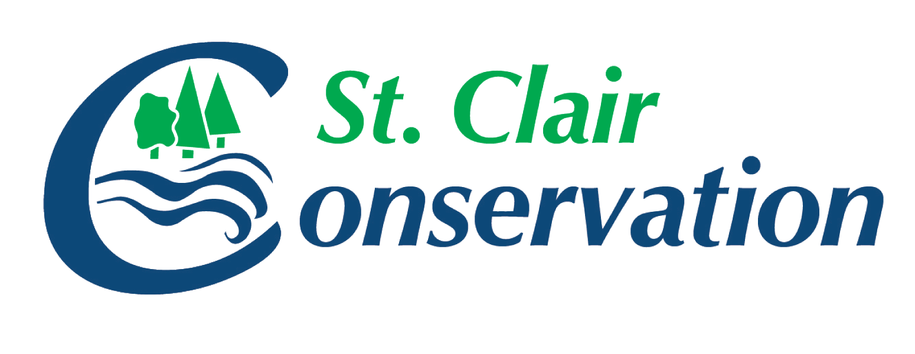 |  | St. Clair Region Conservation Authority  205 Mill Pond Crescent, Strathroy, ON,N7G 3P9  Ph: 519-245-3710 Fx: 519-245-3348  E-Mail: stclair@scrca.on.ca  Website: www.scrca.on.ca

Comments regarding Environmental Registry of Ontario posting Modernizing conservation authority operations – Conservation Authorities Act
Posted by Ministry of Environment, Conservation and Parks on April 5, 2019 #013-5018

In April 2019, the Ministry of Environment, Conservation and Parks (MECP) posted the above noted document on the Environmental Registry of Ontario (ERO) for comment.

The following details the comments formally submitted by the St. Clair Region Conservation Authority (SCRCA) in the response to the above noted posting.

The Conservation Authorities Act, an Act introduced in 1946, enables programs and services that further the conservation, restoration, development and management of natural resources throughout watersheds in Ontario. Under the Act, 36 Conservation Authorities (CAs) were created at the request of municipalities. They are governed by municipally appointed representatives to deliver local resource management programs at a watershed scale for both provincial and municipal interests. The initial focus of Conservation Authorities was to prevent flooding, erosion, drought, and deforestation through improved land, water and forestry management practices. As extreme weather, particularly heavy rains and flooding becomes more frequent due to climate change, the core frontline role that Conservation Authorities play in our communities is becoming increasingly important. Since the 1940s when the Act was established, the programs and services delivered by Conservation Authorities have expanded. Conservation Authorities are the second largest landowners in Ontario, next to the Province; collectively they own and manage 146,000 hectares of land in Ontario.

Through Preserving and Protecting our Environment for Future Generations: A Made-In-Ontario Environment Plan, released in November of 2018, this government committed to “work in collaboration with municipalities and stakeholders to ensure that conservation authorities focus and deliver on their core mandate of protecting people and property from flooding and other natural hazards and conserving natural resources.”

Proposed Changes | SCRCA Response
Clearly define the core mandatory programs and services provided by conservation authorities to be:  - Natural Hazard Protection and Management  - Conservation and Management of conservation authority lands  - Drinking water source protection (as prescribed under the Clean Water Act)  - Protection of the Lake Simcoe watershed (as prescribed under the Lake Simcoe Protection Act) | It is our understanding that these 4 core mandatory programs and services are to be placed in the legislation and then standards and requirements would be described in regulation, making them a legal requirement. With regard to 3 and 4, reference to “as prescribed” under the respective Acts, fails to clearly describe implications to all Conservation Authorities. Under the Clean Water Act, Lead Conservation Authorities have different requirements than non-lead Authorities.  CAs currently receive provincial transfer payments to provide programs and services for core mandates #1 and #3. The recognition, by the Province, that CAs play an important role in the protection of the Province’s interest in local resource management must be supported financially in order to ensure that Authorities are able to implement the role. SCRCA supports the need for clarity in defining the role of Conservation Authorities but cannot support the proposed 4 ‘core mandatory’ programs as outlined as they do not recognize the value and importance of the broader landscape understanding. Specifically, Conservation Authorities promote an integrated watershed management approach to deliver services and programs to protect and manage impacts on water and other natural resources. We recommend that this be identified in core mandate #1

Increase transparency in how conservation authorities levy municipalities for mandatory and non-mandatory programs and services. Update the Conservation Authorities Act an Act introduced in 1946, to conform with modern transparency standards by ensuring that municipalities and conservation authorities review levies for non-core programs after a certain period of time (e.g., 4 to 8 years) | Section 39 programs are clearly outlined under the existing legislation. Conservation Authorities have received financial support at a static level from the Province to support these program areas since 1996. While Provincial support has been flatlined fot 23 years, Municipalities have provided funding to match Provincial Section 39 funds and further financial support necessary to cover the remaining costs for Section 39 programs, as well as funding to support locally supported programs, has been provided by Municipalities through ‘non-matching and special levies’. Support for these programs and the associated cost of these programs is obtained annually through a budgetary process that provides multiple opportunities for municipalities or their representatives on the Board of Directors to seek or request further information or to voice their support or concern for these budget components. SCRCA supports the need for transparency, however, the existing budget process provides ample transparency and further SCRCA does not support the requirement for a review requirement within a set timeframe as these actions are already undertaken annually.
Establish a transition period (e.g. 18 to 24 months) and process for conservation authorities and municipalities to enter into agreements for the delivery of non-mandatory programs and services and meet these transparency standards | Further clarity on provincial plans to legislate agreements with municipalities is required for SCRCA to understand the terms of the agreements. There is a need for Conservation Authorities to contribute to the design of the agreements, to ensure support and capacity for the programs and services included. Should such agreements be required SCRCA supports a transition period of 24 months to ensure that agreements can be executed and implemented. SCRCA supports the transparency of these agreements and any standards that may be contained within. Conservation Ontario is addressing these agreements as part of the Client Service and Streamlining Initiative – Improving Client Service and Accountability.
Enable the Minister to appoint an investigator to investigate or undertake an audit and report on a conservation authority | SCRCA has no concern with the proposed additional power being provided to the Minister.
Clarify that the duty of conservation authority board members is to act in the best interest of the conservation authority, similar to not-for profit organizations | SCRCA supports the provision of further clarity regarding the duties of Authority Board members.
General Comments
Modernizing conservation authority operations – Conservation Authorities Act | A webinar hosted by MECP for all Conservation Authorities held on April 4, 2019, provided background to this proposed modernization of Conservation Authority operations. Citing climate change and flooding, land use planning, environmental protection and drinking water protection, it was explained that the Province was consulting on ‘how CAs can improve delivery of core programs and services’. Ministry staff went on to identify the drivers behind the modernization of CA operations. The first two drivers listed were specific to CA member municipalities regarding the costs of funding CAs and the municipalities’ lack of control over CA budgets. SCRCA undertakes a lengthy budget process offering multiple opportunities for municipal comment and further offers to present the proposed budget to Councils at the municipalities’ request. The Board members who approve the CAs annual budgets and therefore they have ultimate control of all CA budgets are appointed by their local municipalities. Municipalities concerned about the costs to fund CAs have concurrently voiced concerns that the Province is not living up to their commitment to provide 50% financial support to the Section 39 programs as outlined in 1996. These issues are then further compounded by the Ministry of Natural Resources and Forestry decision to cut transfer payments for Section 39 programs by almost 50% in last month’s budget. The third driver identified was the 2012 report from the Commission on the Reform of Ontario Public Services, which identified jurisdictional crowding as an issue in the development sector. This issue was addressed with the review of the Conservation Authorities Act and the passage of Bill 139 in 2017. The final driver identified was the Ontario Auditor General’s 2018 Special Audit of the Niagara Peninsula Conservation Authority and several key recommendations included. Ministry staff brought forward issues regarding clarity of board member accountability, board member training and mechanisms for Ministry intervention. Unfortunately, other key messages from that same report were not brought forward. In particular, Ontario’s Auditor General also recommended a ‘review of current funding levels to CAs to determine how floodplain mapping can be completed in a timely manner’.

