**F**EDERATION OF

**U**RBAN

**N**EIGHBOURHOODS

OF **O**NTARIO

www.urbanneighbourhoods.ca

An Umbrella Group of   
Community Associations throughout Ontario

*Communities count.    
Civic matters.*

##### Cambridge

##### Brampton

##### Guelph

*Hamilton*

*Kingston*

*Kitchener*

*London*

*Ottawa*

### Markham

### Mississauga

### Oakville

### Toronto

*Vaughan*

*Waterloo*

*Sudbury*

*Thunder Bay*

*Unionville*

*Windsor*

Contact email

[funontario@rogers.com](mailto:funontario@rogers.com)

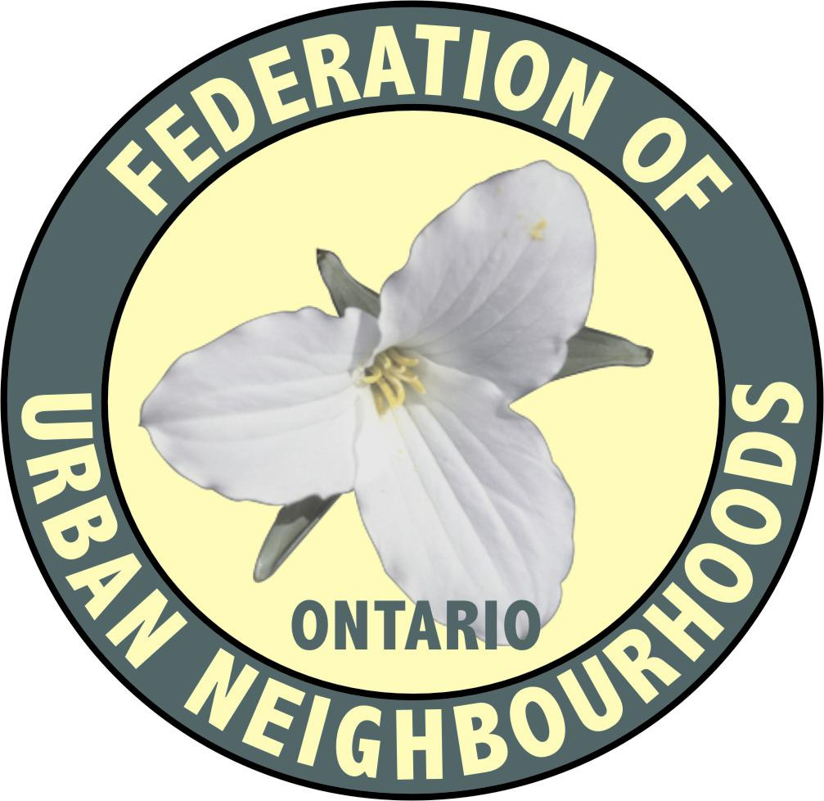

* that housing option policies will not be misused to direct growth to where it is not needed.

Unfortunately these assumptions are unproven, and frankly are likely false.

FUN represents resident associations in Ontario’s largest cities, some of which have designated Urban Growth Centres under the Growth Plan where the targets of the Growth Plan have not only been met but exceeded. Today, in 2019, the City of Toronto as a whole has already achieved 96% of the residential units needed to meet the provincial population targets of 2041. And yet, the Minister found it necessary to intervene in the municipal planning processes related to the Secondary Plans for these Growth Centres and to also specify minimum density targets for Major Transit Station Areas (MTSAs) in the recently revised Growth Plan that have no realistic relationships to Toronto’s actual growth targets of the same Plan.

FUN appreciates the opportunity to comment on the revised Policies prior to their finalization and looks forward to the government’s response to the public input.

Respectfully submitted,

Geoff Kettel,

President

c.c. Premier Doug Ford

John Fraser, Interim Leader, Liberal Party

Andrea Horwath, Leader, New Democratic Party

Ontario MPPs

Federation of Urban Neighbourhoods