

**Comments on Proposed Policy Changes – Provincial Policy Statement**

***Submission to the Ontario Provincial Policy Statement Review***

**October 21, 2019**

**FCM/RAC Proximity Initiative**

**Introduction**

The FCM-RAC Proximity Initiative appreciates the opportunity to provide this submission to the *Ontario Provincial Policy Statement Review*. The Federation of Canadian Municipalities (FCM) – Railway Association of Canada (RAC) Proximity Initiative advocates that municipalities, railways and governments can work together to address proximity issues and improve rail safety. This review provides an important opportunity to proactively address proximity issues and sensitive land uses in Ontario.

The changes brought forward in the 2014 Ontario Provincial Policy Statement Review demonstrated the leadership position of the province with regards to rail proximity issues and safety. This review provides the opportunity for the province to build on this foundation.

The push to intensify urban development to avoid urban sprawl has led to increased development on lands in close proximity to rail operations which can result encroachment on railway property. New developments include converting industrial or commercial property into residential developments, sometimes built without any mitigation measures and sited next to major railway corridors. The absence of mitigation measures creates serious safety and quality of life issues for residents due to the lack of crash walls, noise and vibration mitigation and proper separation barriers to prevent trespassing. When proximity issues arising from the growth and expansion of rail facilities or communities are not understood and addressed, problems can often be intractable and long lasting.

Initially produced in 2004 and revised in 2013, the *Guidelines for New Development in Proximity to Railway Operations* include a number of important standards and measures for the Ontario government to address and translate into policy as a means to proactively addressing proximity and rail safety issues in municipalities across the province.

**Overview of the FCM-RAC Proximity Initiative**

The Federation of Canadian Municipalities (FCM) and the Railway Association of Canada (RAC) have a longstanding commitment to the prevention and resolution of issues that may arise when people live and work in close proximity to railway operations.

Building on back-to-back memorandums of understanding (MOU) since 2003, both organizations continue to work together under open-ended MOU signed in September 2016. The FCM–RAC Proximity Initiative Steering Committee includes equal representation from the FCM (elected officials) and railway sector (senior railway representatives) as well as observers from Transport Canada and the Canadian Transportation Agency (CTA).

Accomplishments to date include developing a dispute resolution model that is included in the *CTA Guidelines for the Resolution of Complaints over Railway Noise and Vibration* and developing and publishing Proximity Guidelines and Best Practices in 2004. These initial guidelines were reviewed, edited and revised to include conversion and infill projects and launched in May 2013 at the FCM Annual Conference as the *Guidelines for New Development in Proximity to Railway Operations*.[1]

At the municipal level, of the top 15 cities in Canada (by population), two Cities - Montreal and Calgary - have adopted or created proximity guidelines, and London and Windsor have adopted portions of guidelines. Three of the other top 15 cities - Toronto, Edmonton and Winnipeg - are in the process of considering proximity guidelines.

Another 122 municipalities have adopted all or parts of the Guidelines and 118 municipalities have sought railway commenting for setbacks and safety barriers as potential conditions of approval.

It should be noted that ‘adoption’ does not necessarily mean that the FCM-RAC Proximity Guidelines have been fully accepted. Rather, it can mean that the municipalities have used the FCM-RAC Proximity Guidelines as a starting point, or have used them to build a business case, to adapt and customize the concepts to their own context.

**FCM-RAC Guidelines for New Development in Proximity to Railway Operations**

The *Guidelines for New Development in Proximity to Railway Operations* are intended to assist municipal governments and railways in reviewing and determining general planning policies when developing on lands in proximity to railway facilities, as well as to establish a process for making site-specific recommendations and decisions to reduce land-use incompatibilities for developments in proximity to railway operations, addressing such issues as safety, noise and vibration. A key component is a model review process for new residential development, infill, and conversions in proximity to railways. Adoption of these guidelines into municipal land use regulations can provide greater assurance that our communities of the future are safe and sustainable.

The desire to ensure safety and promote a high quality of life for people living and working in close proximity to railway corridors is a principle objective of the Guidelines. Mitigation in the form of a standard setback and berm or crash wall are measures that have been developed by the railways based on a detailed analysis of past incidents and derailments.

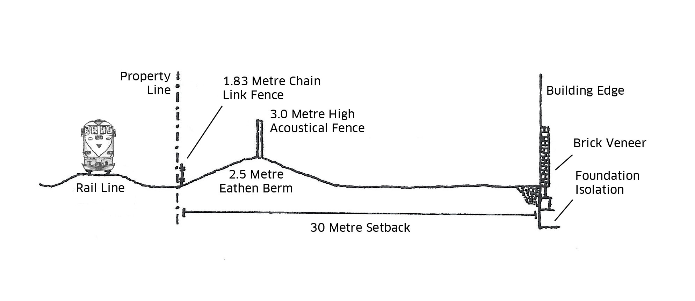

Figure 1 -Standard mitigation for a new residential development in proximity to a main line railway. Source: FCM-RAC Guidelines for New Development in Proximity to Railway Operations, P.19.

*Greenfield Developments*

Standard mitigation (Figure 1) measures serve as a minimum requirement to reduce incompatibility issues associated with locating new development in proximity to railway corridors. These measures are most easily implemented in new green field developments.

The setback contributes to the mitigation against potential impact of railway incidents as well as noise and vibration through distance separation. The earthen berm in conjunction with the setback can protect against the physical components of a derailment and provides mitigation of wheel and rail noise. It also reduces the overall noise barrier height and cost, and offers a productive use of foundation excavations as recommended in “ **section 3.2.3 Planning authorities should support, where feasible, on-site and local re-use of excess soil through planning and development approvals while protecting human health and the environment.”**

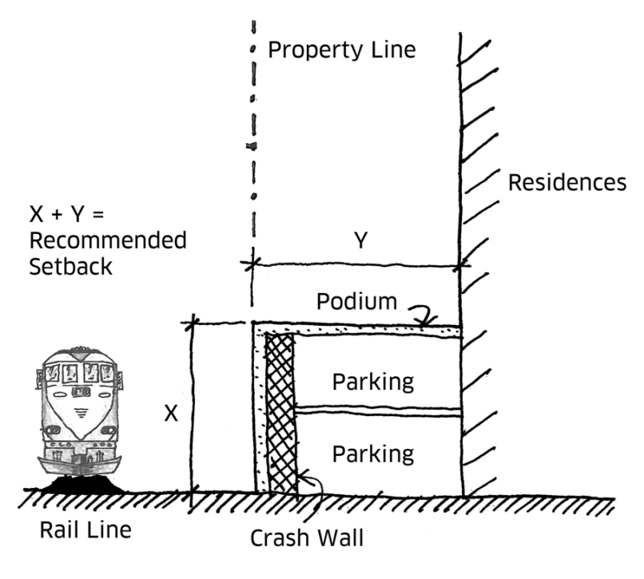

Source: FCM-RAC Guidelines for New Development in Proximity to Railway Operations, P.27.

*Infill and Conversions*

Today we often see conversion and infill projects in urban areas that are located next to railway corridors without crash walls or site-specific mitigation measures leading to more noise, vibration and safety issues for municipalities and railways.

Conversions and infill developments (Figure 2) are a good way to intensify and bring residents back to city centers, but these constructions must address safety, noise, vibration and other proximity issues. Many of the adverse impacts of railway noise can be avoided or minimized through good design practices and safety issues and can be addressed through the incorporation of crash walls.

In an infill or conversion development, the noise sensitive rooms, such as bedrooms, should be located on the “quiet side” of the building. Building on a podium and locating the gym or garage spaces on these ground floors – moves the residents further from the noise and vibration source and provides an additional safety setback. The Guidelines also provide a Development Viability Assessment process for identifying alternative solutions where the standard measures are not workable.

The intent of the Guidelines is to:

* Promote awareness around the safety, noise and vibration issues and mitigation measures associated with development near railway operations;
* Establish effective approvals processes for new residential development, infill and conversions from industrial or commercial uses that allows municipal planners to effectively evaluate such proposals while ensuring that appropriate safety, noise and vibration mitigation measures are included; and
* Promote greater consistency in the application of relevant standards across the country.

In Ontario, 5 municipalities have adopted the Guidelines in part or in full while approximately 70 municipalities have sought railway commenting for setbacks and safety barriers as conditions of approval[2].

Under the *Planning Act*, municipalities must revise and update their official plan every five years to ensure that it conforms to provincial plans and is consistent with the PPS: “*All municipal official plans and decisions affecting a planning matter in Ontario are required to be consistent with the policies set out in the PPS. The PPS provides policy direction on matters of provincial interest related to land use planning and development, including providing specific direction on freight-supportive land use patterns, protection of major-goods movement facilities and corridors and planning in vicinity of major facilities*.”[3]

The Ontario Ministry of Transportation’s *Freight Supportive Guidelines* are intended to “*help municipalities, planners, engineers, developers and other practitioners create safe and efficient freight-supportive communities. By coordinating land use planning and freight mobility planning, the Guidelines help to respond to industry needs for freight movement in Ontario, as well as provide linkages between freight movement and land use planning policy and practice*.”[4] The *Freight Supportive Guidelines* are intended to complement and be in accordance with the existing provincial policy framework by providing strategies, information and knowledge to assist municipalities in implementing *freight-supportive* policies in their official plans.

Regulations under Ontario’s *Planning Act* also require railways to be notified of official plans (and amendments), subdivision plans, zoning bylaws and consents to sever lands, if the proposal involves any land within 300 metres of a railway line. This allows the railways to review proposed developments and submit recommendations regarding incompatibility or safety issues. Disputes can be brought to the Ontario Municipal Board for adjudication. [5]

**Proximity Issues - Efficient use and management of land and Infrastructure**

Most of Canada’s municipalities have evolved around railway lines and the services they deliver to the community. While rail operations in communities have been mutually beneficial, their proximity can sometimes lead to issues between people and trains.

Canadians are living and working around trains and their lines. They are also opting to leave their car at home in favour of commuting by train. In Ontario, commuter railways complete approximately 60million passenger-trips per year[6].

But as Ontario becomes more urbanized and cities try to minimize urban sprawl, many new residential developments are being built on sites in close proximity to rail facilities in both urban and rural communities, creating challenges for these communities and railways to co-exist. Both parties' goals are the same. Railways and communities both want to reduce pollution, congestion and costs while prioritizing safety and convenience.

The Proximity Initiative believes that the language put forward in section 1.1.3.4 of the proposed draft policy statement should be strengthened to include a requirement for specific mitigation measures to address public health and safety, noise and vibration.

The existing reference to “should be promoted” does not ensure that risks to public health and safety will be mitigated.

*1.1.3.4 Appropriate development standards* ***should be promoted*** *which facilitate intensification, redevelopment and compact form, while avoiding or mitigating risks to public health and safety.*

The Proximity Initiative recommends that 1.1.3.4 should be revised to: Appropriate development standards should be adopted that facilitate intensification, redevelopment and compact form, while avoiding or mitigating risks to public health and safety.

As with any other transport mode's infrastructure (e.g. airports, truck depots), rail facilities are located across Ontario and operate 24/7, often in the proximity of highly populated communities. As Ontario becomes increasingly urbanized, railroads and people are living closer together as development grows around rail facilities. People living and working near these facilities (such as rail tracks or yards) can be impacted by noise and vibration from train operations. This may include train whistling, wheel squeal, idling of locomotives, and shunting of cars in yards. In addition, the construction and maintenance of rail infrastructure such as rail bridges, signals, track and buildings can further complicate noise and vibration issues. Construction and maintenance related to highway-railway crossings can be disruptive to public convenience.

The issue of safety is also sometimes not fully considered in new development projects in proximity to existing railway operations. This includes the danger of train derailments impacting homes and lives, the construction of new grade crossings, and adjacent land uses that create trespassing issues across railways.

**Land Use Compatibility**

The proposed changes to 1.2.6.1 and the addition of section 1.2.6.2 have the potential to increase safety, noise and vibration issues by being more permissive in allowing sensitive uses. The language used in 1.6.9.1 is stronger but refers to 1.2.6 – hence again reducing the potential safety, noise and vibration issues for sensitive land uses in proximity to rail lines and yards. What are the provincial guidelines, standards and procedures referenced?

1.2.6.1 Major facilities and sensitive land uses **shall (** *removed -should*)be planned (*removed-to ensure they are appropriately designed, buffered and/or separated from each other)***and developed** to **avoid** (*removed – prevent*), **or if avoidance is not possible, minimize and** mitigate **any potential** adverse effects from odour, noise and other contaminants, minimize risk to public health and safety, and to ensure the **long-term operational and economic viability** of major facilities **in accordance with provincial guidelines, standards and procedures.**

**1.2.6.2 Where avoidance is not possible in accordance with policy 1.2.6.1, planning authorities shall ensure that the planning and development of sensitive land uses adjacent to existing or planned industrial, manufacturing, or other uses that are particularly vulnerable to encroachment are only permitted if: a) alternative locations for the proposed sensitive land uses have been evaluated and there are no reasonable alternative locations; and b) potential impacts of these uses are minimized and mitigated in accordance with provincial guidelines, standards and procedures. (new)**

1.6.9.1 Planning for land uses in the vicinity of airports, rail facilities and marine facilities shall be undertaken so that: a) their long-term operation and economic role is protected; and b) airports, rail facilities and marine facilities and sensitive land uses are appropriately designed, buffered and/or separated from each other, in accordance with policy 1.2.6

1.6.7 Transportation Systems

The Proximity Initiative recommends the following words be added to the 1.6.7.3 and 1.6.8.2:

1.6.7.3 As part of a multimodal transportation system, connectivity within and among transportation systems and modes should be maintained and, where possible, improved including connections which cross jurisdictional boundaries.

1.6.7.3 As part of a multimodal transportation system, connectivity, intermodality and interoperability within and among transportation systems and modes should be maintained and, where possible, improved including connections which cross jurisdictional boundaries

1.6.8.2 Major goods movement facilities and corridors shall be protected for the long term.

1.6.8.2 Major goods and passenger movement facilities and corridors shall be protected for the long term.

**Canadian Transportation Agency Decision 69-R-2014**

The Canada Transportation Act authorizes the Canadian Transportation Agency (the Agency) to resolve complaints about noise or vibration related to construction or operations by federal freight railways and public passenger service providers including urban transit authorities.

The Agency cited the Proximity Initiative’s first Guidelines and Best Practices (2004) in Decision No. 69-R-2014 in February 2014. The noise and vibration complaint was from a resident of Vaudreuil-Dorion, Quebec. The complaint was dismissed based on the following determination:

*[55] The Agency notes that despite the close proximity to the busy main line track, no evidence was presented that the residential developer assessed the impacts of the railway noise and vibration on the residential development. No evidence was presented that the developer incorporated mitigation measures in the construction of the house to lessen the exposure to noise and vibration.[7]*

*[56] Furthermore, beyond a post facto municipal council resolution expressing concern about noise and vibration and affirming that the Municipality aims to ensure that its citizens get the best possible quality of life, there is no evidence before the Agency indicating that when approvals were sought for the housing development, any consideration was given by the Municipality to issues of noise and vibration or to the proximity of residences to CP’s main line, notwithstanding the Federation of Canadian Municipalities and Railway Association of Canada’s Proximity Guidelines and Best Practices, which pre‑date the Municipality’s decision to approve the construction and of which the Municipality should have been aware.[8]*

*57] A Municipality takes a risk when deciding to allow housing development in close proximity to a railway right of way and the Agency is of the opinion that Municipalities have a responsibility to assess compatibility issues before approving a housing development along a railway right of way, and if they approve a development, to ensure that the necessary mitigation measures are implemented. The Agency notes that the Municipality apparently authorized the residential construction along CP’s main east-west rail transportation corridor. However, there was no evidence presented to the Agency of any mitigation measures having been implemented. In fact, CP draws attention to the fact that no berm or noise wall was constructed.[9]*

The Proximity Initiative was pleased that the Agency recognized the important contribution of the Guidelines in reducing proximity issues. This decision also illustrates the fundamental need for planning regulations to formally address development in proximity to railway facilities to ensure that safety and livability are addressed before developments are completed.

**Railway Safety Act Review**

On May 31, 2018, the Minister of Transport tabled the final report of; the 2017-18 Railway Safety Act Review Panel, in the House of Commons. This report, completed by a credible and independent Chair and Panel, recognized the continued need and ongoing role for government to proactively address land-use planning in proximity to railway operations. With regards to proximity issues the report states:

“Recommendation 8 - It is recommended that the federal government provide leadership in addressing incompatible land use around rail operations by driving a substantive dialogue between all jurisdictions and stakeholders, with a view to developing a solution to land use near rail operations on a national scale. Measures to this effect should include:

launching a senior government-level dialogue with the provincial/territorial governments to promote the formal adoption of measures equivalent to the "Guidelines for New Development in Proximity to Railway Operations", developed jointly by the Federation of Canadian Municipalities and the Railway Association of Canada, in land use planning policies that apply to municipalities;

amendments to Part III (Non-Railway Operations Affecting Railway Safety) of the Railway Safety Act be made to provide the Governor in Council with the authority to make regulations requiring land use planning authorities to provide pre-notice to affected railway companies before authorizing land use or zoning changes, as well as construction within a prescribed distance (e.g., 300 meters) of a railway corridor; and

amendments to Part III (Non-Railway Operations Affecting Railway Safety) of the Railway Safety Act to provide the Governor in Council with the authority to make regulations that define safety criteria for construction and activity within a prescribed distance (e.g., 30 meters) of a railway operation. Regulations should be developed in consultation with relevant provinces/territories, Indigenous groups, municipalities, railways, associations, and citizen groups.

In response to the Panel’s recommendations, Transport Canada committed to:

Continue to encourage provinces, territories and municipalities to adopt the Guidelines for New Development in Proximity to Railway Operations in their land use planning policies[10].

**Conclusion**

In conclusion, the Provincial Policy Statement has an important role to play in proximity issues management by ensuring responsible land use planning policies, guidelines and regulatory frameworks are in place - that reduce risk and ensure new sensitive developments in proximity to railway operations provide safe, livable homes.

The Guidelines provide the necessary tools required to mitigate for risk in proximity to railway operations and should be included in the Provincial Policy Statement.

Thank you,



Project Manager, FCM-RAC Proximity Initiative, clulham@sympatico.ca

1. <http://www.proximityissues.ca>
2. A full list of municipalities can be viewed at: https://www.proximityissues.ca/guidelines-adoption/
3. Ontario Ministry of Transportation(2016) *Freight Supportive Guidelines*, P8 <http://www.mto.gov.on.ca>
4. Ibid P3
5. RSO 1990, c P19 [*Planning Act*]. *Official Plans and Plan Amendments*, O Reg 545/06, cl 5 (9)11.
6. Railway Association of Canada (2019). Rail Trends database.
7. <http://ww.otc-cta.gc.ca>, *Decisions and determinations,* Rail 2014, Decision No.69-R-2014
8. Ibid
9. Ibid
10. <https://www.tc.gc.ca/en/reviews/transport-canada-response-2017-2018-railway-safety-act-review-report.html#Improving-rail>