

January 14, 2020

Troy Anthony

Ministry of Natural Resources and Forestry

70 Foster Drive

Sault Ste. Marie, Ontario P6A 6V5

Submitted Online Via the [Environmental Registry of Ontario](https://ero.ontario.ca/notice/019-1020)

**RE: Overwhelming Support for ERO# 019-1020, *Proposed Changes to the Crown Forest Sustainability Act, 1994***

Dear Mr. Anthony:

As the owner of MITIG Forestry Services Ltd, thank you for the opportunity to comment on the *Proposed Changes to the Crown Forest Sustainability Act (CFSA),* Environmental Registry of Ontario number 019-1020. I am writing to you today to express overwhelming support for this proposal. Given that the current regulation under the ESA expires this year, I ask that this proposal be approved and finalized as soon as possible. There can be no further delay on this item.

My support for these changes is contingent on the finalized language containing no additional conditions, restrictions, or requirements, beyond what is already contained within the CFSA or O. Reg. 242/08 under the Endangered Species Act (ESA). While removing this duplication is a critical and essential first step, species at risk prescriptions contained within existing forest management guidance continues to limit access to a renewable and sustainable supply of timber.

The CFSA already provides landscape, stand, and site-level direction for managing, conserving, and protecting species at risk. Having two acts attempting to accomplish the same outcome represents the single greatest piece of red tape and duplication to this sector. While a permanent, legislative change to the CFSA is an essential and important first step; in order to unleash the full potential of the sector, improvements need to be made to forest management guidance (e.g. landscape guides and the Forest Management Guide for Conserving Biodiversity at the Stand and Site Scales) delivered under the CFSA.

I understand that MNRF is currently undertaking a review of forest management guidance and manuals and expect the finalized products to:

1. Consider the impacts of climate change on species at risk habitat.
2. Evaluate the cumulative impacts of species at risk policy on a healthy economy.
3. Contribute to functioning ecosystems and working landscapes.
4. Undertake, share, and consider socio-economic impact analysis.

This change to the CFSA has the potential to significantly reduce administrative burden, costs, and business uncertainty while ensuring a continued commitment to the highest standards of sustainable forest management.

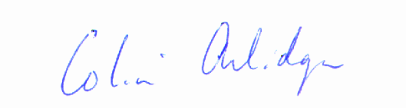Sincerely,

Colin Arlidge R.P.F.

CC Minister John Yakabuski, Ministry of Natural Resources and Forestry

Minister Jeff Yurek, Ministry of Environment, Conservation and Parks

Jamie Lim, President & CEO, Ontario Forest Industries Association