RE: Drainage Act Discussion Paper Comments (ERO #019-1187)

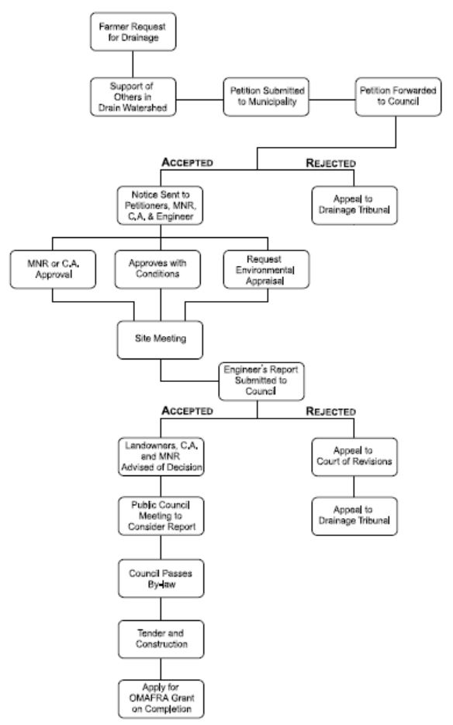

Figure 1 Drainage Scheme Approval Process (Walters and Shrubsole, 2003)