**IKEA Canada Response to Ontario’s Proposed Regulation, and Amendments, to make Producers Responsible for Operating Blue Box Programs**

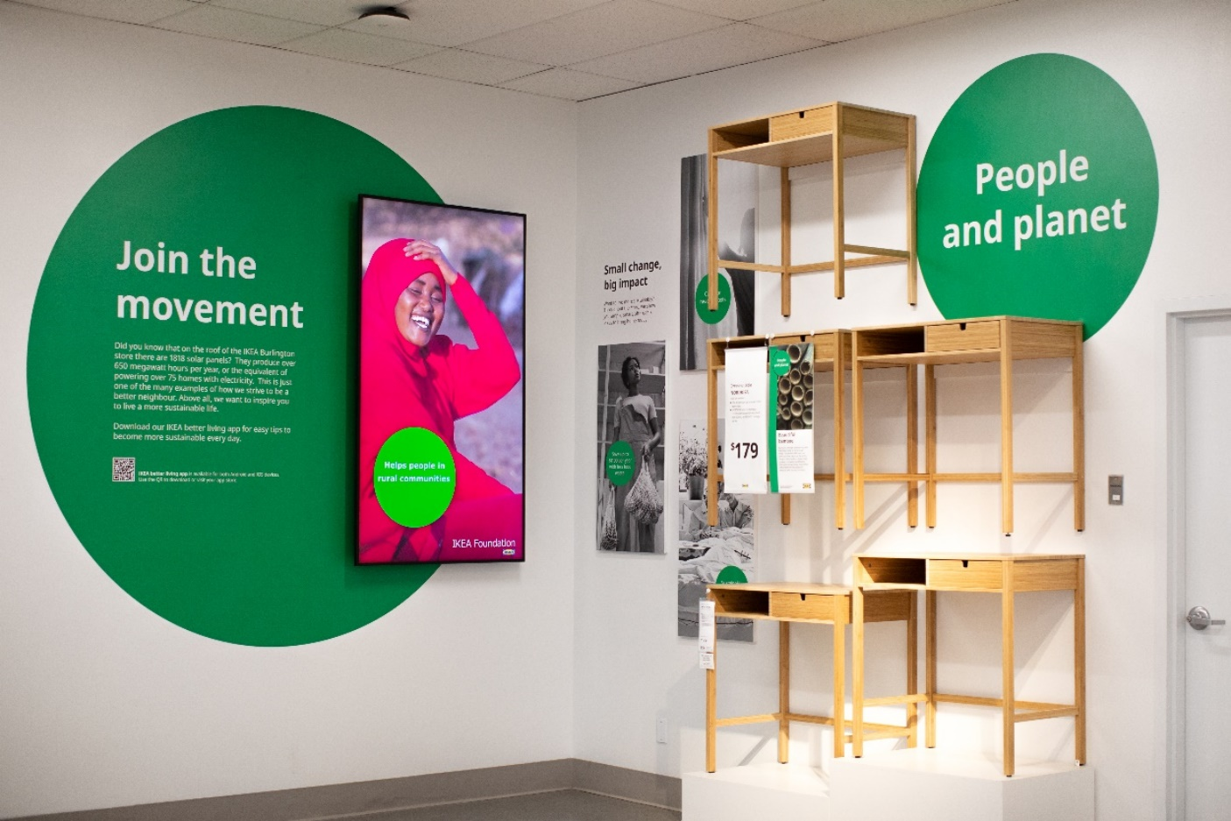

**Introduction**

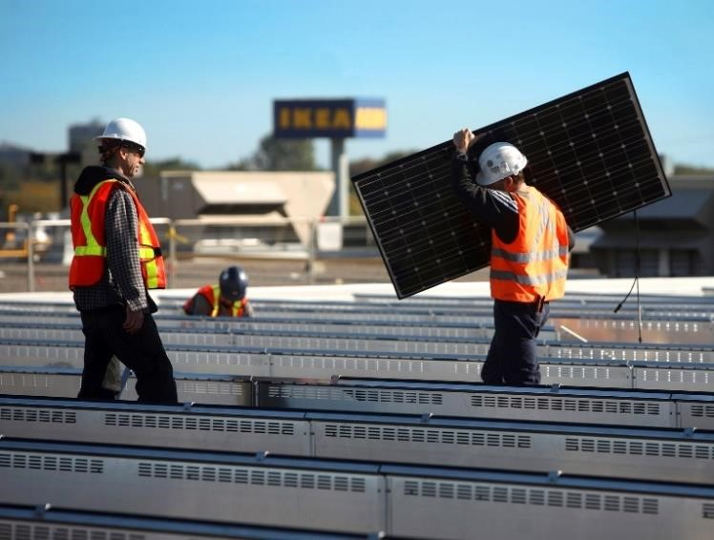Having called Canada home for 44 years, IKEA is the nation’s leading home furnishing retailer, offering a wide range of well-designed, functional, sustainable products at affordable prices that make it accessible for the many. IKEA operates 14 stores, 4 distribution centres, 2 windfarms and 1 call centre in Canada, employing more than 7900 co-workers, including almost 4000 in Ontario. In addition, the IKEA Canada National Service Office is located in Burlington, ON. As a company, we contributed $1.67B in economic output to Canadian households, businesses, and government and $569M in labour income.

Last year, IKEA Canada welcomed almost 30 million visitors to its stores. Many people know IKEA as a furniture retailer through their own in-store customer experience, however our business is much more than that:

* IKEA Canada is a clean energy company. Our windfarms and solar panels on our buildings generate 4 times more renewable energy than we consume nationally.
* IKEA is also a community recycling depot, taking in such items as batteries, lightbulbs and mattresses that do not have an easily accessible municipal collection stream.
* We are a vibrant online retailer, with 178M customer visits to IKEA.ca In addition, IKEA provides access to digital services such as kitchen design and, through the TaskRabbit app, furniture assembly.
* IKEA is a leader in the food service industry and grocery sector, with our restaurants, Swedish Food Market and walk-up Bistro generating $79M.
* We are a logistics and transportation company that moves billions of dollars’ worth of goods from ports, warehouses, stores and to our customers’ homes. In 2019, IKEA opened a new Distribution Centre in Kleinburg, ON.

In everything we do, the purpose of IKEA is to create a better everyday life for the many people and do so in a way that is affordable, sustainable and respects human rights. We are proud to lead our business in a way that meets the needs and expectations of Ontarians.

**Comments on Blue Box Changes**

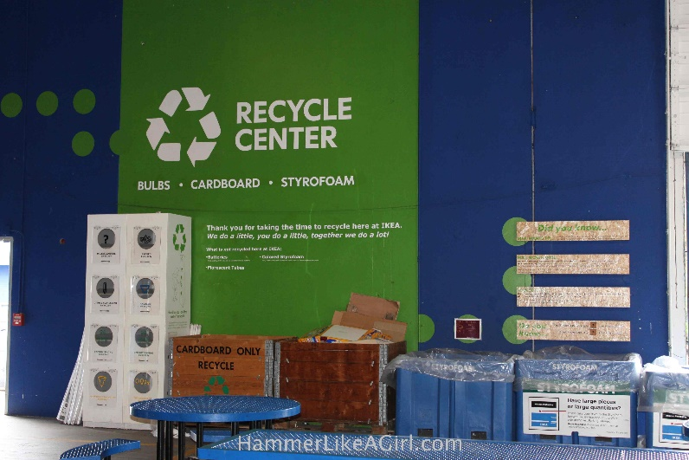IKEA Canada is supportive of Ontario’s goal of diverting waste from landfill, including recyclable items. This includes having producers take an enhanced leadership role in developing sustainable solutions. This position is also shared by the Government of Ontario itself as noted in “[Reducing Litter and Waste in Our Communities: Discussion Paper](https://prod-environmental-registry.s3.amazonaws.com/2019-03/Reducing%20Litter%20and%20Waste%20in%20Our%20Communities%20Discussion%20Paper_0.pdf) “ The document notes:

*“The patchwork of materials collected by Blue Box programs across the province can be confusing, often resulting in reduced recycling rate…We will work closely with businesses and industry to expand beyond the wastes currently covered by existing diversion programs when looking for further opportunities to reduce, reuse, divert and recover resources under the producer responsibility…Materials such as carpets, mattresses, furniture and other bulky items are valuable waste materials that can be recovered and should not go to landfill.”*

The proposed Blue Box regulation, and associated amendments, are narrower in scope than originally outlined in the discussion paper. The current proposal is only specific to the Blue Box and does not incorporate other waste diversion efforts. In addition, the list of eligible materials, while harmonized, is not significantly expanded. There are other household materials, as suggested like furniture, lightbulbs and batteries that warrant increased diversion efforts from landfill. IKEA is doing its part. Presently, we offer community recycling depots in-store that collect items that are not easily taken by municipal collection streams.

The Blue Box program, whether in its original form or the currently proposed changes, is designed to only be one part of Ontario’s overall waste diversion strategy. While increasing recycling rates can achieve provincial waste diversion goals, co-equal focus should be given to recycling, reduction and reuse. Reduction and reuse have the potential to keep items out of the waste management stream altogether, creating efficiencies and reducing costs for all producers.

In 2019 IKEA launched a “sell-back” program to allow customers to return their used IKEA furniture. IKEA repairs and resells these items thereby keeping potential waste out of landfills, but also offering furnishings at lower prices to customers. The reselling of these furniture items, giving them a second life, represents an average revenue stream in Ontario of $8.2M over the last five years. IKEA is just one of many Ontario companies that are building their businesses around sustainability.

More can be done to support, formally recognize, and encouraging businesses that create commercial opportunities that equally focus on reduction, reuse and recycling. Supporting entrepreneurship and growth of businesses that provide new alternatives to recycling, reuse or repair services will help not only ensure that Ontario can grow its waste diversion efforts, but also create new jobs. Furthermore, rather than “throwing out” old or broken products, providing Ontarians with viable consumer options for reuse/repair will help households save money. A formal provincial economic environmental plan, along with direction to encourage businesses to bring more reduction and reuse options to consumers, will help Ontarians meet our shared sustainability goals.

**Conclusion**

IKEA Canada supports Ontario’s vision for a more efficient Blue Box recycling program. IKEA customers want to be part of the solution in making the planet a better place. In moving forward, IKEA Canada urges the government to leverage proposed blue box changes by expanding recycling options beyond the program. In addition, there is an opportunity to further improve diversion efforts through the reuse and reduction of materials before they even enter the waste management stream.

**Contact**

Timothy B. Fuchs

National Public Affairs Manager

IKEA Canada

1065 Plains Road East, Burlington ON L7T 4K1

E-mail: timothy.fuchs@ingka.ikea.com

Web: [www.IKEA.ca](https://na01.safelinks.protection.outlook.com/?url=http%3A%2F%2Fwww.ikea.ca%2F&data=02%7C01%7CSara.Newman%40cision.com%7C733ee7eefd684ddfd59a08d5430c48b9%7C887bf9ee3c824b88bcb280d5e169b99b%7C1%7C0%7C636488642389577713&sdata=WvAqlHyWygIDmNHnKeuDDfWVlsMBcpZtOYA5MrCqygw%3D&reserved=0)