**Appendix 3 to PD-2021-0020**

Proposed 2004 Greenbelt Expansion in Halton Hills

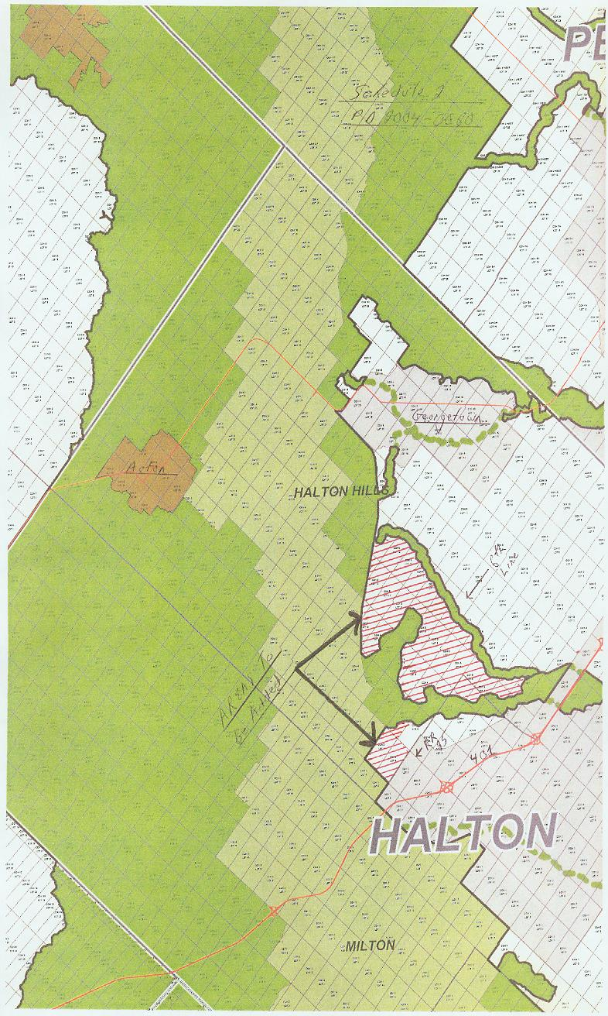

Note: Proposed expansion represented as red hash marked area.