Michele M.B. Braniff, LL.B., MTS, GDip

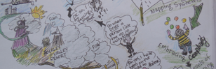

551 Frederick Street

Cambridge, ON,

N3H 2A1

Phone 226 868 2473

Email braniffmichele@gmail.com

April 18, 2021

Dear Members of the Greenbelt Consultation Team,

I appreciate the government’s commitment to grow the Greenbelt, however the study area should also include

* the Paris-Galt moraine as depicted in the Blackport report (2009) ,
* the Grand River watershed, including its headwaters, streams, creeks and wetlands, and
* the land between Brantford and the Hamilton boundary ( land contiguous with the Greenbelt that is part of the Grand River watershed).

DISCUSSION QUESTIONS

**Question 1: What are your thoughts on the initial focus area of the Study Area of the Paris Galt Moraine?**

The City of Cambridge is dependent upon ground water. Brantford and Six Nations and other downstream communities are dependent upon the river. In order to protect the water sources for Brantford and Brant County and people downstream, we need to include

* the entire Paris-Galt moraine as depicted in the Blackport report (2009) ,
* headwaters, streams, creeks and wetlands of the Grand River, including the land between the Brant/Hamilton boundary and Brantford,
* Orangeville Moraine, and
* Waterloo Moraine

**Question 2: What are the considerations in moving from a Study Area to a more defined boundary of the Paris Galt Moraine?**

* Greenbelt the Grand River watershed, including the land between Brantford and the Brant/Hamilton boundary,
* Recognize the dependency of communities up and down the Grand River on groundwater and the Grand River
* Extend protection of the Paris-Galt Moraine into Norfolk County (see mapping in the 2009 Blackport Report commissioned by the Ministry of Environment, Climate and Parks).

**Question 3: What are your thoughts on the initial focus area of adding, expanding and further protecting Urban River Valleys?**

The Grand River watershed is the largest river watershed in southern Ontario, and it has been designated as a Heritage River.

Therefore, it is important to include

* the headwaters, streams, creeks and wetlands of the Grand River in Brantford and Brant County.

**Question 4: Do you have suggestions for other potential areas to grow the Greenbelt?**

Yes

* Greenbelt the areas proposed in the Bluebelt map (Ontario Greenbelt Alliance),
* Include the natural heritage and agricultural systems in these areas.

**Question 5: How should we balance or prioritize any potential Greenbelt expansion with the other provincial priorities mentioned below?**

My suggestions support policies such as

* Ontario’s Biodiversity Strategy,
* Ontario’s Wetland Conservation Strategy,
* Ontario’s Great Lakes Strategy,
* Ontario’s Provincial Policy Statement: protecting prime agricultural land. See map.

**Key Concepts**

**Housing: reduce sprawl development**

The Neptis Foundation (2017) found that there is more than enough land already designated for development to meet future housing needs in the Greater Golden Horseshoe (except Toronto and Peel).

* Build complete communities with current urban settlement boundaries,
* Develop brownfields

**Transportation: Reduce our dependency on cars**

* Promote complete and walkable communities with public transit
* COVID19 has reduced the need to commute, with more people working from home

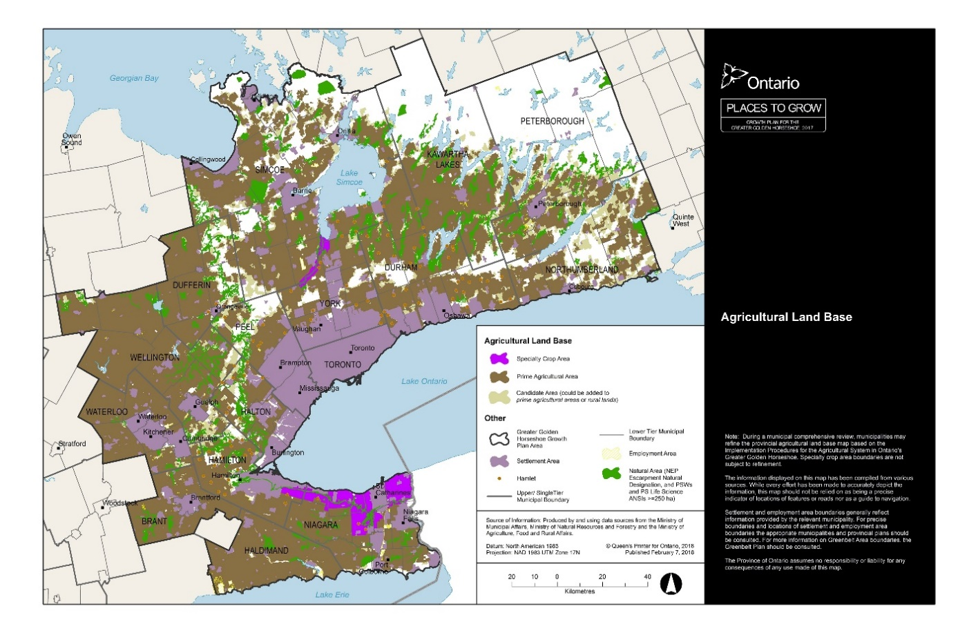

**Minister’s Zoning Orders (MZOs)-protect water, natural heritage and farmland**

* Do not use MZOs to fast-track development on natural areas and farmland. (This is not well aligned with democratic principles)

**Question 6: Are there other priorities that should be considered?**

* **Meaningful consultation** with Six Nations and the Mississauga of the Credit, including the traditional leaders and communities.
* **Also, consultation with Regional Municipalities and cities** I am aware that the City of Cambridge has concerns with the loss of municipal control over gravel licensing etc. Rather than legislation to minimize government oversight, the Green Belt will be protected most optimally with shared oversight by levels of government. It is actually better for business to provide for accessible and clear laws and regulations that reflect the values and concerns of constituents so that business can understand constraints up-front.
* **Climate Change**: Nature-based solutions will help us to lessen and adapt to the risks and impacts of climate change. In 2019, the Grand River watershed experienced severe flooding, particularly in Brantford. Natural features reduce flood damage and financial losses. Expanding the Greenbelt to include the Grand River watershed in Brant County is protect biodiversity, particularly species at risk. The Greenbelt will help to protect wildlife corridors, thus reducing habitat loss.
* **Health and well-being**: The Greenbelt expansion will contribute to
  + clean air and water
  + the local food economy,
  + access to nature, which is particularly important during the COVID19 crisis.

Create incentives for planting native species of flora within urban areas to naturalize small areas for pollinators, to reduce or eliminate grass lawns (zero scaping, waterwise gardens, etc.) This will reduce the carbon emissions from lawn mowing and maintenance.

Sincerely,

MMBraniff

Michele Braniff

Canadian Citizen & Resident of Cambridge, ON

Submission To: <https://ero.ontario.ca/notice/019-3136>