Minister Steve Clark and

the Environmental Registry of Ontario

Ministry of Municipal Affairs and Housing

PDF via greenbeltconsultation@ontario.ca

April 19, 2021



**RE: ERO 019-3136 -- Growing the Size of the Greenbelt**

The Ontario Headwaters Institute and the signatories from Regional Resilience, a project to facilitate participation in this consultation, commend the Province for this initiative to grow the Greenbelt.

As you will be aware, many of the participants in Regional Resilience have already forwarded their support for the recommendations included in our submission. This full submission provides the more fulsome text and the mapping that supports those recommendations, including Appendix B.

Created in 2005, Ontario’s Greenbelt includes the Oak Ridges Moraine Conservation Plan area and the Niagara Escarpment Plan area, as well as the Greenbelt’s protected countryside.

The Greenbelt extends beyond these significant landforms to protect natural heritage systems, water systems and agricultural systems within the Greater Toronto Hamilton Area. A Place to Grow: Growth Plan for the Greater Golden Horseshoe (Growth Plan) directs urbanization to settlement areas and designated greenfield areas, to support managed growth throughout the Greater Golden Horseshoe.

Together, the Greenbelt and Growth Plan provide a framework to support population and employment growth while protecting natural assets essential for sustainable prosperity. The Greenbelt protects valuable ecosystem services including clean water, contributes to the $49B provincial agriculture and agri-food sector, supports nature & biodiversity, and encourages complete communities.

Currently, however, the Greenbelt covers only 21% of the lands in the Greater Golden Horseshoe. Growing the Greenbelt throughout the region will add resilience to the broader region while helping to safeguard ecological integrity, social vitality, and economic prosperity.

While Ontario has a proud history of wise land-use planning and world-class leadership in watershed management, recent reductions in environmental protection are creating uncertainty and skepticism.

**Working to protect Ontario’s Headwaters, Natural Heritage, and Watersheds**

**andrew@ontarioheadwaters.ca ♦ 416 231 9484**

The timing of this initiative, therefore, could not be more appropriate.

**We urge the province to grow the Greenbelt in the following areas:**

* **The Paris-Galt Moraine;**
* **More Urban River Valleys (URVs), including those in Appendix A2, and ensuring the inclusion of the headwaters of all the URVs;**
* **Natural Heritage System across the Greater Golden Horseshoe;**
* **Agricultural System in the Greater Golden Horseshoe;**
* **Lands and waters in the Bluebelt proposal; and,**
* **Key headwater areas not included above.**

We do not consider these recommendations and those below to be aspirational for some distant future: they are needed now.

We urge you to embrace this once-in-a-generation opportunity to safeguard our regional resilience by substantially extending the Greenbelt into the broader area of the Greater Golden Horseshoe.

Sincerely,

***Andrew McCammon***

Executive Director

**Working to protect Ontario’s Headwaters, Natural Heritage, and Watersheds**

**andrew@ontarioheadwaters.ca ♦ 416 231 9484**

**Responses to Questions**

*Question 1: What are your thoughts on the initial focus area of the Study Area of the Paris Galt Moraine?*

The Paris Galt Moraine is an excellent choice for the government to begin growing the Greenbelt.

There are significant recharge areas in and around the Paris Galt Moraine that are under pressure from increasing urbanization and other development in the Grand River Watershed. As more than 800,000 people living in the watershed are dependent on groundwater resources, protecting the Natural Heritage System and hydrological function of the moraine is important for human health and a resilient future.[1]

**We recommend growing the Greenbelt to incorporate the Paris Galt Moraine, including headwater areas as noted in Appendix A.**

*Question 2: What are the considerations in moving from a Study Area to a more defined boundary of the Paris Galt Moraine?*

Efforts to define a boundary for the Paris Galt Moraine should be based upon:

* A thorough, evidence-based understanding of the water resource system including groundwater systems, key hydrological areas, recharge and discharge areas, and well-head protection areas;
* Ensuring all key hydrologic features are captured in the defined boundary;
* The engagement of appropriate Indigenous Peoples in a process that respects and honours Canada’s constitutional and treaty obligations and moves forward in a spirit of reconciliation;
* In-person public consultation throughout the watershed to discuss proposed boundaries once the pandemic has abated; and,
* Clear and easy-to-implement options for properties outside a proposed boundary to be added to the Greenbelt.

**We recommend:**

* **A science-based approach to define the boundary;**
* **Protecting all key hydrologic features and functions;**
* **Engaging meaningfully with Indigenous Peoples;**
* **Conducting in-person consultations once suggested boundaries are identified and the pandemic has subsided; and,**
* **Developing clear and easy-to-implement options for property outside the boundary to be added.**

*Question 3: What are your thoughts on the initial focus area of adding, expanding and further protecting Urban River Valleys?*

Expanding the Greenbelt into Urban River Valleys is an excellent way to increase the area of protected lands and hydrologic features, provide migration corridors for numerous species, and establish direct connections with downstream urban communities. We also suggest that URVs be bookended by ensuring that that the Greenbelt includes headwater areas.

Additional benefits of establishing more Urban River Valleys include:

* Maintaining green infrastructure such as wetlands, floodplains, and riparian edge;
* Enhancing habitat and biodiversity;
* Supporting a regional trail system;
* Protecting downstream areas from flooding, erosion, and excessive sedimentation;
* Providing healthy outdoor recreation opportunities; and,
* Protecting cultural heritage sites.

**We recommend the expansion of URVs to incorporate connections to the Paris Galt Moraine through the Speed and Eramosa Rivers in urban areas as indicated on the maps in the appendices below. We further recommend adding the following as Urban River Valleys:**

* **Lake Simcoe recharge areas including the Severn Sound and Carden Alvar, Waverly Upland, Clearview Township, Holland River;**
* **Lake Iroquois shoreline areas; and,**
* **The Nottawasaga watershed.**

***Question 4: Do you have suggestions for other potential areas to grow the Greenbelt?***

We suggest that the Province can enhance not only the size but also the biodiversity, connectivity, and functions of natural heritage features, and improve the ecological integrity, social vitality, and economic prosperity of the broader Greater Golden Horseshoe by adding the Natural Heritage System identified in the Growth Plan to the Greenbelt.

Natural Heritage System features throughout the GGH perform essential services as they:

* Provide clean air, water storage and filtration;
* Maintain resilience to climate change, invasive species, flooding and soil erosion;
* Contribute to biodiversity conservation and recovery;
* Sustain the water resource system including groundwater water quality and quantity critical for downstream cities and economic activities; and,
* Support agriculture, recreation, tourism, and rural communities.

Much of the Natural Heritage System is contiguous to the Greenbelt, and where it is not contiguous should not be criteria for excluding it from the Greenbelt.

Indeed, these important natural heritage features should be afforded the same protection for the consistency of long-term planning and inter-generational equity.

Given current population, development, climate, and natural heritage challenges, we believe that a more consistent and connected approach to ecosystem protection is warranted.[2]

**We urge the Province to undertake studies and consultations with a view to adding areas in the GGH Natural Heritage System, areas in the Bluebelt map, and any other headwater areas not captured in that mapping to the Greenbelt.**

*Question 5: How should we balance or prioritize any potential Greenbelt expansion with the other provincial priorities mentioned above?*

Growth Management

The Greenbelt and A Place to Grow Plan are designed to balance each other. The Growth Plan identifies where to grow in the Greater Golden Horseshoe. The Greenbelt Plan identifies where urban growth should not occur to support agriculture, natural resources, and the rural economy for a balanced, sustainable region.

Millions more people are forecast to move into the region in the next 30 years. With residential land selling for over $1 million an acre in the GTA, it is exceedingly difficult to build affordable housing on greenfield land without government subsidies.[3]

Since 2006, growth planning projections for people and jobs have consistently been too high for all regions, excluding Brampton, Mississauga, and the City of Toronto due to the higher rates of growth in these urban areas. Despite this knowledge, provincial policies require municipalities to allocate more land than needed due to changes to the Growth Plan. Meanwhile, research indicates there is more than enough land to meet our housing needs to 2041 and beyond.[4]

These policy contradictions were further entrenched in the 2019 A Place to Grow Plan, in which the province reduced intensification rates and decreased designated greenfield density targets from the 2017 Growth Plan - despite housing trends, transit ridership requirements and demographic data supporting higher rates.

These policy changes encourage land speculation and support sprawl. As noted by a former Environmental Commissioner in *Sprawl is Ontario’s Oil Sands*, this places private interests ahead of the public interest.[5]

Regional governments are busy calculating land needs to 2051. As evident by the Region of York’s report to Council on land needs and growth forecasts no expansions into the Greenbelt are required to 2051 but settlement boundary expansions will pave over valuable and finite class 1 farmland.[6] As York Region has the highest allocation of employment and population growth in the GTHA, this finding is likely indicative of what other Region’s will experience.

Supporting higher levels of intensification within existing cities and higher density targets in designated greenfield areas uses land more efficiently. Urban growth needs services and systems to support it. These urban systems are increasingly expensive and in the case of greenfield growth interfere with the ability to develop affordable housing.

By supporting a 60% intensification and 80 people and jobs per hectare density rate for designated growth areas (the rate needed to support regular bus service) and an expansion of the Greenbelt, more affordable urban growth could be achieved, and costly urban boundary expansions could likely be avoided beyond 2051.

To our perspective, the removal of environmental and social considerations in the 2019 Growth Plan has upset the historic balances between natural heritage and development, and between private and public interests. Growing the Greenbelt presents an opportunity to restore the equilibriums and build a more resilient Greater Golden Horseshoe.

**We recommend the province address the issues in the Growth Plan noted above and prioritize growing the Greenbelt to reduce land speculation, limit extending expensive urban services into the countryside, avoid increased municipal debt loads, and reduce challenges to affordable housing.**

Transportation and Infrastructure

Several transportation and infrastructure projects are undermining the Greenbelt’s protected countryside by fragmenting agricultural systems and impacting natural heritage systems, including the GTA West highway, Bradford Bypass, and the Niagara Mid-Peninsula Highway.

If built, these highways will affect environmental health, increase climate change emissions, negatively impact the Natural Heritage and Agricultural Systems in the Greater Golden Horseshoe area, and do little to reduce congestion.[7]

Sprawling low density development on the edge of the Greenbelt, supposedly linked to these highways, is not only contrary to the intent of Growth Plan policies that encourage transit supportive complete communities, it encourages more people to drive, thereby exacerbating road congestion, gridlock, and greenhouse gas emissions.

Studies also demonstrate that highways such as these, through whitebelt areas, spur land speculation and may lead to prematurely opening up lands for low density greenfield development before existing urban areas are built to higher densities.

Policies in the Greenbelt Plan allow infrastructure but fail to consider cumulative impacts of infrastructure and neglect to capture land value as suburban, industrial, and commercial development is not permitted within the protected countryside.

We are encouraged by policies in the Growth Plan that prioritize transit as a transportation option for moving people but consider it inefficient and fiscally imprudent to locate transit stations in the protected countryside, such as Gormley Station. A density of 150 people and jobs per hectare is required to support GO train service. Transit stations should be directed to existing built up settlement areas where intensification may occur.

In addition, COVID-19 has shifted employment models with more people working from home, reducing highway congestion.[8] These changing patterns need to be incorporated into revised GGH transportation models.

**As the province considers growing the Greenbelt, we recommend the that it prioritize the alignment of mobility infrastructure with existing built up urban areas and rescind projects that encourage urban growth in the protected countryside and prime agricultural areas including:**

* **Cancelling the GTA West, Bradford Bypass, Niagara Mid-Peninsula Highways;**
* **Rescinding plans to build transit stations in the Greenbelt; and,**
* **Updating transportation models with Post-COVID commuting data.**

Natural Heritage System

The Natural Heritage System includes interconnected features and functions including but not limited to:

* Wetlands;
* Fish habitat;
* Significant woodlands;
* Alvars, savannahs and meadows;
* Endangered and threatened species habitat;
* Areas of Natural and Scientific Interest; and,
* Valley and stream corridors as well as the shorelines of lakes.

The Natural Heritage System supports clean water systems required for farming and the rural economy. Over a million people in towns across the region rely on groundwater systems.

By growing the Greenbelt along the Natural Heritage System, the Province can enhance not only the size, but the biodiversity, connectivity and functions of natural heritage features and functions, and improve the environmental health, social vitality, and economic prosperity of the region.

Using best practices in ecological land classification, we urge the Province to undertake studies and consultations to identify linkages to improve connectivity between features in headwater areas to improve the function of the NHS. Adding both key headwater areas and wetland features to the Greenbelt is essential for regional resilience. Candidate areas are captured in the Bluebelt map in Appendix A.

**As noted in Question 4, we recommend growing the Greenbelt by incorporating lands and key hydrologic features identified in the GGH Natural Heritage System, including headwater areas and areas identified by Conservation Authorities and municipal mapping.**

**In addition, while municipalities across the region have variations in their natural heritage and agricultural policies, and while the Greenbelt Plan requires municipal plans to conform to it, we urge the provincial government to allow for regional variations and, where there are conflicts between municipal and provincial policies regarding water and natural heritage policies, the more restrictive or protective policy should apply.**

Agriculture

Balancing provincial priorities to support a robust agricultural sector is consistent with Growing the Greenbelt across the Greater Golden Horseshoe. Prime agricultural land is a finite resource. The agri-food sector in Ontario contributes $47 billion to GDP and employs over 800,000 people. [9] Growing the Greenbelt through the Agricultural system will help to address:

* Farmland loss;
* Fragmentation of agriculture lands;
* Food security;
* Long term viability of farming and the agri-food sector;
* Support rural economic development; and,
* Sustainable agriculture and soil health.

**We support the submission made by the Ontario Farmland Trust to grow the Greenbelt across the GGH Agricultural system.[10]**

*Question 6: Are there other priorities that should be considered?*

We encourage the province to consider the following priorities as it undertakes to Grow the Greenbelt. It is critical to embrace a multi-faceted approach to regional resilience, building a decision-making framework to ensure inter-generational ecological integrity, social wellbeing, and economic prosperity.

Health and Wellbeing

Research indicates 20 to 30 minutes in nature leads to better health, including better management of blood pressure, diabetes, mental health, stress, and improved immune response. People sleep better, concentration and sense of well-being are improved. [11]

In addition, the current experience with COVID has underlined how vital the natural environment is for public health, wellness, and recreational purposes. Increased thousands of people have walked trails and visited open parks over the last year. The connection between nature and mental health has never been more evident.

These emerging realities are a wake-up call for planning and government to prioritize access to nature.[12] Building a Greenbelt trail system fills the renewed prescription for accessible recreational spaces in nature.

**Growing the Greenbelt along natural heritage systems is a cost-effective way to address mental and physical wellbeing.**

Climate Change and Biodiversity

Expanding Ontario’s Greenbelt into the GGH is key to a more resilient region.

Across the world, climate change and climate related disasters are an increasing reality, from severe floods to devastating fires as experienced in Australia and California. Climate change is also a threat multiplier, and experts are documenting the links between climate change, invasive species, the loss of biodiversity, and the on-set of a sixth mass extinction.

In the face of these pressures, the Greenbelt’s natural heritage system provides an extensive reservoir of free natural infrastructure. Forests, rivers, and wetlands filter the water and air, decrease temperatures, prevent floods, reduce soil erosion, support biodiversity, and absorb carbon. Urban river valleys provide an important area where city dwellers can beat the heat free of charge.

**Growing the Greenbelt via the Paris Galt Moraine, URVs, the Bluebelt, and through the GGH’s Natural Heritage and Agricultural Systems will build the regional resilience needed to mitigate the changing climate and challenges to biodiversity.**

Regional Prosperity

Overall, we are deeply concerned about the narrow focus of this consultation on the size of the Greenbelt and the general prohibition of policy considerations.

Since 2018, an enormous number of policy changes have been made that benefit private interests, such as streamlining the Environmental Assessment Act and weakening the Growth Plan, the Species At Risk Act, the Provincial Policy Statement (PPS), and the mandate of conservation authorities. More recently, the government has increased the use of MZOs and seeks, in Bill 257, to exempt MZOs from the PPS, although not in the Greenbelt. This makes extending the Greenbelt into the GGH all the more imperative.

Without this extension, we expect our long-term regional resilience to decline, including terrestrial and aquatic habitat, water quality, the viability of farming, and the rural economy. In order to restore balance in the region and support well-being and prosperity, we encourage the province to grow the Greenbelt into the GGH.

**We recommend that the Province consider the health and sustainable prosperity of the broader GGH as it consults on Growing the Greenbelt, thereby extending resilience and policy consistency to the entire region.**

**In addition, we encourage the government to pursue a wide-ranging set of new policies to embrace a fair and green recovery and secure regional resilience, thereby protecting ecological integrity, social vitality, and economic prosperity.**

Aggregates

While new aggregate extraction in the Greenbelt is not permitted in significant wetlands, the habitat of endangered species, and significant woodlands, future aggregate operations may be permitted in key natural heritage features and prime agricultural areas.

Over the past four decades, and following numerous background studies and policy reviews, the provincial interest in aggregate resource management has remained strong.[13] There is a provincial mandate to ensure that aggregate resources are protected for long-term use, and the province has declared a provincial interest in maintaining close-to-market supply.

Cumulative environmental concerns, however, led the Environmental Commissioner of Ontario called on the province in 2017 to decrease aggregate demand, strengthen the province’s powers to protect the environment, and improve rehabilitation rates through better enforcement.

Instead, the province continued to prioritize aggregate production over natural heritage policies.

According to the Canadian Environmental Law Association, in 2019 the province reduced the regulatory burden by providing preferential treatment to the aggregate industry rather than support good planning by balancing public and private interests.[14] And in 2020 changes to the PPS enhanced policies to protect existing and planned aggregate industrial uses.

Aggregate extraction imposes cost on society, it affects our health, increases GHGs, puts the clean water resources of Ontario communities at risk and damages natural heritage systems.

**We support comments by Greenbelt stakeholders to prohibit new aggregate extraction throughout the Natural Heritage System within and outside the Greenbelt.**

**Appendix A: Available maps posted in the draft submission of March 31**

**A.1 Growing the Greenbelt throughout the Natural Heritage System**

By growing the Greenbelt throughout the Natural Heritage System in the Growth Plan area, the province would support regional resilience for future generations.

To support local variations among municipalities we urge the government to allow more restrictive NHS policies at the local level and that, in instances of conflict between provincial and local policies, the more protective policy apply, including for aggregate extraction.

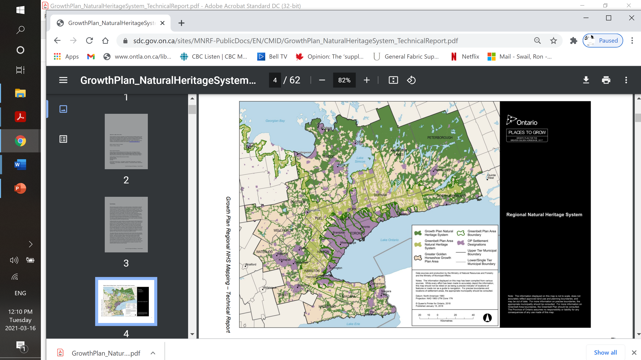

**A.2 Urban River Valleys and Headwaters**

Water systems do not differentiate between urban and rural areas. River systems and valleys provide drinking water resources, water crops, provide recreational space, and flow through our communities.

Forested river systems provide important cooling effects necessary for sustaining fish habitat and cool crops and communities during hot weather, while wetlands and flood plains absorb and minimize flood waters.

While URVs provide a connection for urban populations that may be distant from the sources of their water in the Greenbelt sources, the province should consider ensuring the protection of their headwaters and publicizing this as a more specific connection to the Greenbelt.

The connectivity of headwater areas to the larger Greenbelt and their URVs would heighten public understanding of the Greenbelt and the ecosystem context for regional resilience.

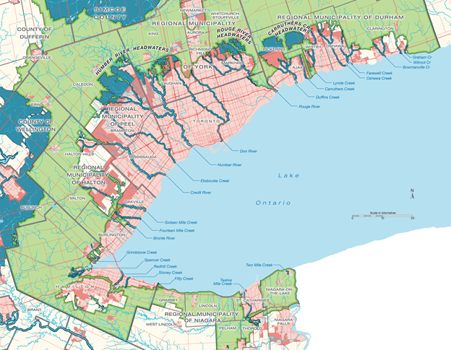

**A.3 The Bluebelt**

We support the proposal from the Oak Ridges Moraine Coalition [15] to add the Bluebelt to the Greenbelt. Key additions include but are not limited to:

* The headwaters of the Humber, Don and Rouge rivers;
* Duffins and Carruthers Creeks;
* The south slope of the Oak Ridges Moraine and the Iroquois Shoreline along Lake Ontario in Northumberland County;
* The Luther Marsh;
* The entirety of the Waterloo and Orangeville moraines in Wellington County;
* Grand River watershed in Brant County; and,
* The remainder of the Lake Simcoe basin as well as vulnerable water resources in the rest of Simcoe County.

Adding these areas to the Greenbelt would help safeguard critical water supplies, natural areas, and prime farmland. Such protection is vital to community health and resilience in the face of increasing population, development, and pressures from climate change and to biodiversity, and limit the impact of future flooding and drought.

Growing the Greenbelt into these areas would also conserve and connect significant wildlife habitats that support many at-risk species such as [redside dace](https://www.ontario.ca/page/redside-dace), [rapids clubtail](https://www.ontario.ca/page/rapids-clubtail) dragonfly and [wood turtle](https://www.ontarionature.org/protect/species/reptiles_and_amphibians/wood_turtle.php). It would help address the ongoing destruction and degradation of stream, river, and shoreline habitats which are key threats to these species.

**A.4 Paris Galt Moraine \***

The Paris Galt Moraine provides drinking water to over 800,000 people in the Grand River Watershed. By 2041 the population of the area is expected to grow to 1,386,000 - all reliant on groundwater. It is essential that the groundwater system is protected from the cumulative impacts of development in the watershed.

The Natural Heritage System throughout the area, including river valleys, headwaters, wetlands, intermittent streams, and recharge and discharge areas must be protected for watershed resilience. As the Paris Galt Moraine is an area with high value aggregates, provision needs to be made to restrict aggregate taking below the water table within the moraine area. All lands within the agricultural system connected to the hydrological system of the Paris Galt should be included in the Greenbelt.

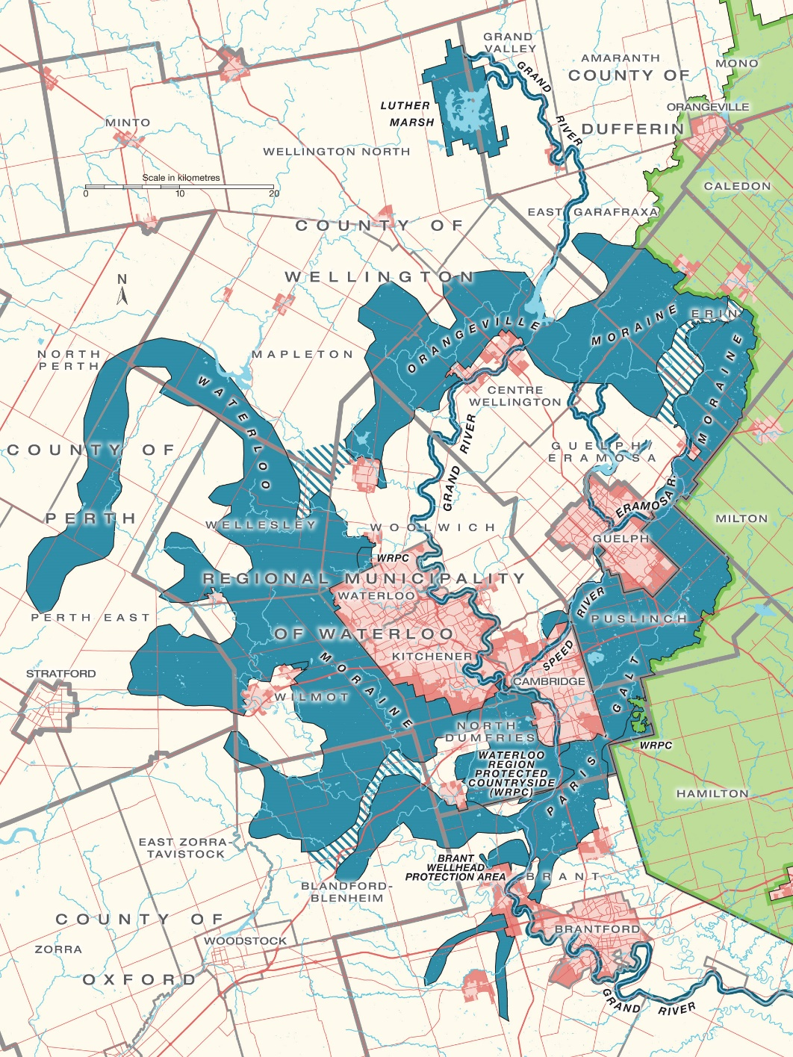

*Draft map that may be updated.

**Appendix B Maps available to us after March 31, to be posted in the sub of April 19**

Additional maps will be added to this submission following March 31 and will be included in the final document to be sent to the government by April 19

1. <https://guelph.ca/wp-content/uploads/Presentation-Paris-Galt-Moraine-Hydrogeology.pdf>
2. <https://ontarionature.org/wp-content/uploads/2018/03/EBR-013-1014-Proposed-Natural-Heritage-System-for-the-GGH.pdf>
3. <https://www.nytimes.com/2019/07/09/business/affordable-housing-luxury-development-gentrification.html>
4. <https://neptis.org/publications/update-total-land-supply-even-more-land-available-homes-and-jobs-greater-golden>
5. <https://saxefacts.com/urban-sprawl-ontarios-oil-sands/>
6. <https://yorkpublishing.escribemeetings.com/FileStream.ashx?DocumentId=20138>
7. <https://d36rd3gki5z3d3.cloudfront.net/wp-content/uploads/2021/02/2021-02-03-GTA-West-EA-request.pdf>
8. https://ehq-production-canada.s3.ca-central-1.amazonaws.com/4e07dcba9779bacc253239d90ac2bc64f6ce7355/original/1611071955/Final-COVID-Paper_NL_PF_1Jan2021.pdf_9ce8ad13d3bf711b8bda0e336172fefe?X-Amz-Algorithm=AWS4-HMAC-SHA256&X-Amz-Credential=AKIAIBJCUKKD4ZO4WUUA%2F20210326%2Fca-central-1%2Fs3%2Faws4_request&X-Amz-Date=20210326T204055Z&X-Amz-Expires=300&X-Amz-SignedHeaders=host&X-Amz-Signature=56f334eae8eef96273858df50efc7d7a37fa46db7064bae13597be79d22e2abb
9. <https://ofa.on.ca/newsroom/ofa-delivers-state-of-ontarios-agri-food-sector-at-queens-park/>
10. <https://ontariofarmlandtrust.ca/wp-content/uploads/2020/12/OntarioFarmlandTrust_ERO-019-3136.pdf>
11. <https://www.thestar.com/news/gta/2021/02/22/ontario-doctors-set-to-turn-over-a-new-leaf-with-program-that-lets-them-prescribe-nature-to-ailing-patients.html>
12. <https://www.utoronto.ca/news/walk-park-how-spending-time-nature-can-boost-mental-health>
13. <https://www.ossga.com/coordinated_provincial_plan_review_summary/spotlight.go?spotlight_id=421&component_type=text_block&scope=global&q=greenbelt#cid1842id421row421>
14. <https://cela.ca/tag/provincial-policy-statement/>
15. <https://ontarionature.good.do/bluebelt/sign/>