Dear Ford Government,

Current government and business holdings increased from 2018 to 2020. Yet the Government of Ontario holds the least amount of vacant land compared to all the other provinces.¹ Destroying conserved land to build 50,000 unaffordable homes results in a small impact in the 1.5 million homes needed to improve the housing crisis in Ontario.
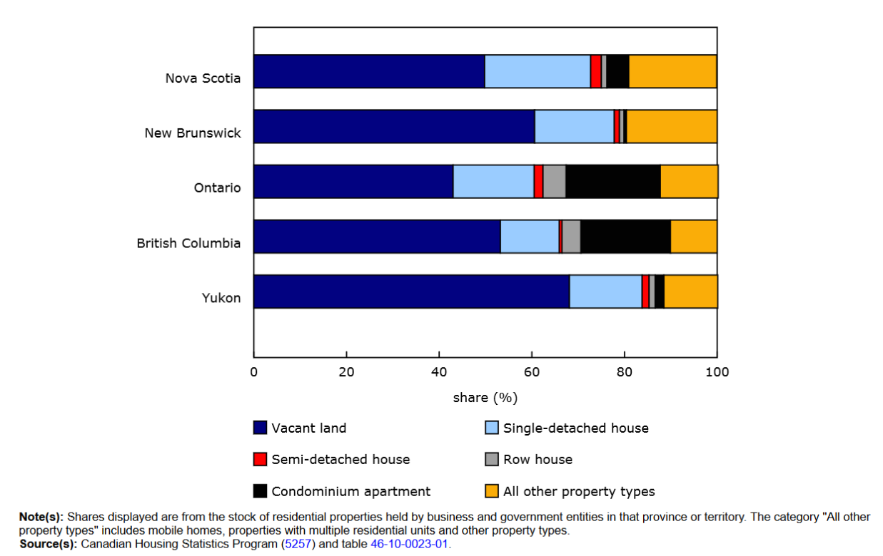
It is understood that Ontario has a higher percent population compared to all other provinces, but population growth is lower than BC (5.8% compared to 7.6%). The population of Ontario has an average household income of $51,300.² The proposed plan by the Ontario government to reduce the cost of housing by $75,000 will not offset the $100,000 increase in extra costs also outlined in the CD-Howe report cited in the More Homes Built Faster plan.³ This plan will not help the Ontarians entering this province who cannot afford new homes being constructed.
The Ford Government should help the small percentage of sole proprietorship property type owners who have decreased by 1.4% from 2018 while government and corporation ownership have increased by a combined 1.5% in the same period.⁴
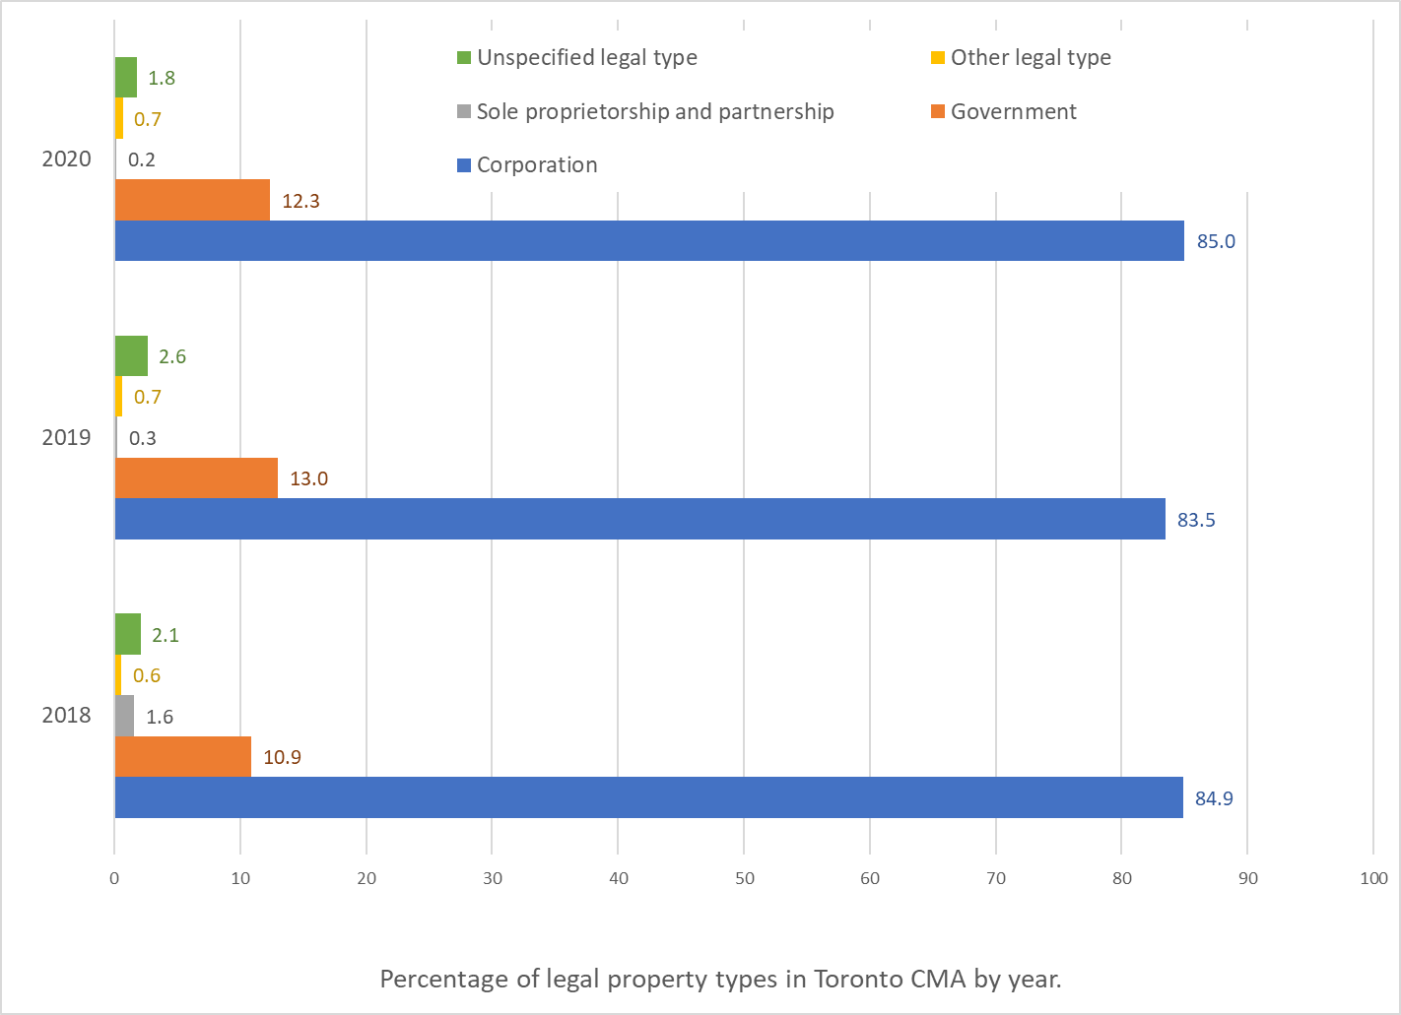
The Ford Government should not listen to the growing Real estate industry which has driven our economy further to housing financialization – this does not equate to more Ontarians being able to attain housing.⁵
The re-allocation of government and corporate properties in lieu of building only 50,000 more homes will jump-start a shift in relation to home ownership in Ontario and reduce the financialization of the housing market. Governments should be accountable for their human rights obligations before those of their investors. What happened to the Premier’s promise to leave the Greenbelt untouched?⁶
References
- Canadian Housing Statistics Program, 2019 and 2020. https://www150.statcan.gc.ca/n1/daily-quotidien/221110/dq221110c-eng.pdf. (Accessed: 11/14/22).
- Income of individuals by age group, sex and income source, Canada, provinces and selected census metropolitan areas. https://doi.org/10.25318/1110023901-eng. (Accessed: 11/14/22).
- Through the Roof: The High Cost of Barriers to Build New Housing in Canadian Municipalities. https://www.cdhowe.org/sites/default/files/2021-12/Friday%20Commentary_513.pdf. (Accessed: 11/14/22).
- Business and government ownership of residential properties, by legal type and industry. https://doi.org/10.25318/4610002301-eng. (Accessed: 11/14/22).
- Ontarians must commit to affordable housing for all, not attainable housing. https://euc.yorku.ca/research-spotlight/ontario-must-commit-to-affordable-housing-for-all-not-attainable-housing/. (Accessed: 11/14/22).
- Ford in 2018: ‘We won’t touch the Greenbelt’. https://www.ctvnews.ca/video?clipId=2557879. (Accessed: 11/14/22).

