Proposed Amendments to the Greenbelt Area Boundary Regulation

The greenbelt portion of land on 4818 King Street should be added to the proposed greenbelt amendment. Approximately 8 of the 31.5 acres I own is designated as greenbelt land. It is a small, narrow and oddly shaped strip of land which splits my property. Its position is inconsistent with other greenbelt zoning as it is within the urban area. This anomaly has negatively impacted urban development ability of this area. See Figure 1.

It appears that the greenbelt was possibly drawn in error. There’s nothing else like it. In Lincoln, the vast majority of the greenbelt land is north of King Street and south of Fly Road. The green belt anomaly on my property is south of King Street in the corner of an urban area. It doesn't extend to Aberdeen Road or Hillside Drive, but it blocks the final piece of potential development land in that corner. This is inconsistent with other green belt zoning and seems arbitrarily placed. The greenbelt land in question is highlighted in red in Figure 2.

According to the policy for removal of lands from the Greenbelt, we meet the criteria.

* It is negotiable
* It has a potential for homes to be built in the near future
* It is near existing green belt boundaries, but completely out of place
* It is adjacent to an existing urban area
* It is near readily serviceable land.

4818 King Street is partly zoned as residential but interrupted by the greenbelt land on my property. We have evergreen trees in the greenbelt land and the adjacent residential zoned area. Of the greenbelt land that runs through the property, less than half is evergreen trees (approx. 3 out of 8 acres), and the rest is ravine (approx. 5 of the 8 acres). See Figure 3.

To boost supply of housing, it would be in the best interest of the province to negotiate/remove the arbitrary positioning of the green belt in this quadrant and open up the Aberdeen/Hillside corner.

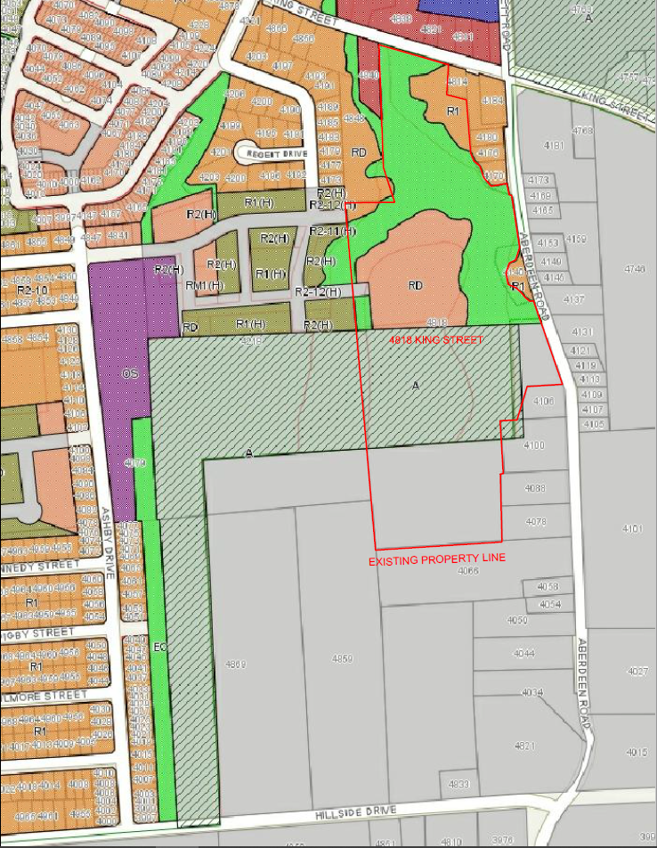

Figure 1

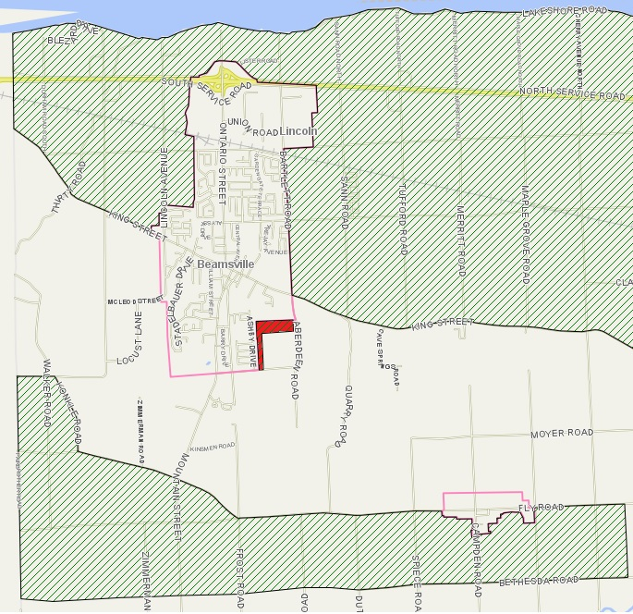

Figure 2

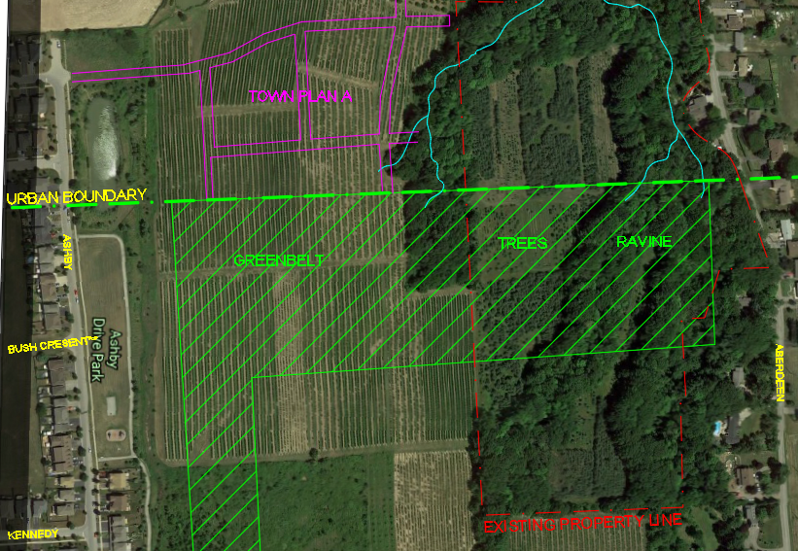

Figure 3