`December 4, 2022

Ministry of Municipal Affairs and Housing

Office of the Minister

777 Bay Street, 17th Floor

Toronto, ON, M7A 2J3

Attn: Honourable Steve Clark, Minister of Municipal Affairs and Housing

Dear Minister Clark,

**Re: Kaneff Group Comments on proposed amendments to the Greenbelt Plan (ERO No. 019-6217)**

On behalf of the Kaneff Group, we would like to first commend your efforts in ensuring that over the next decade, the 1.5 million newcomers to our Province, 70% of which will settle in the GTA and surrounding areas, will have decent and affordable housing options. We support your vision and leadership in promoting reasonable policies to engender that plan; specifically, your government’s decision to remove an immaterial portion (less than 1%) of developable lands from the Greenbelt. By doing so, you will be allowing responsible companies like ours – a long-established developer and builder of purpose-built rental housing – to create shelter so desperately sought and needed for Ontarians.

Accordingly, we ask that you consider the removal of the following lands from the Greenbelt for 3 main reasons: (1) the lands are within the urban boundary or adjacent to urban areas (2) the lands are close to major transport routes; (3) the lands have services & amenities nearby.

Thank you for taking the time to review our concerns. We hope that our perspective provides insight on your decision-making process. We appreciate the opportunity to provide comments on the proposed changes to the Greenbelt, and we look forward to your consideration.

Sincerely,

The Kaneff Group

1. **Carlisle Golf Club, 523 Carlisle Road, Carlisle (Hamilton)**

Firstly: PT LT 1, CON 9 EAST FLAMBOROUGH , AS IN VM16441 ; PT LTS 2 & 3, CON 9 EAST FLAMBOROUGH, PART 1 , 62R12398 , PT LTS 2 & 3, CON 9 EAST (PIN 17523-0303 (LT))

Secondly: PT LT 2, CON 9 EAST FLAMBOROUGH , PART 4 , 62R8143 ; FLAMBOROUGH CITY OF HAMILTON (17523-0301 (LT-))

The Site is located adjacent to a residential community. Development adjacent to existing urban areas with sufficient infrastructure is appropriate. West of the Site is a Rail corridor, and community infrastructure in Carlisle such as parks, schools, and recreational facilities that may support the subject lands to be exempt from protected countryside policies. Frontage on Carlisle Road (approximately 20 acres) was contemplated for housing development in 1997, prior to the Greenbelt Plan coming into effect.

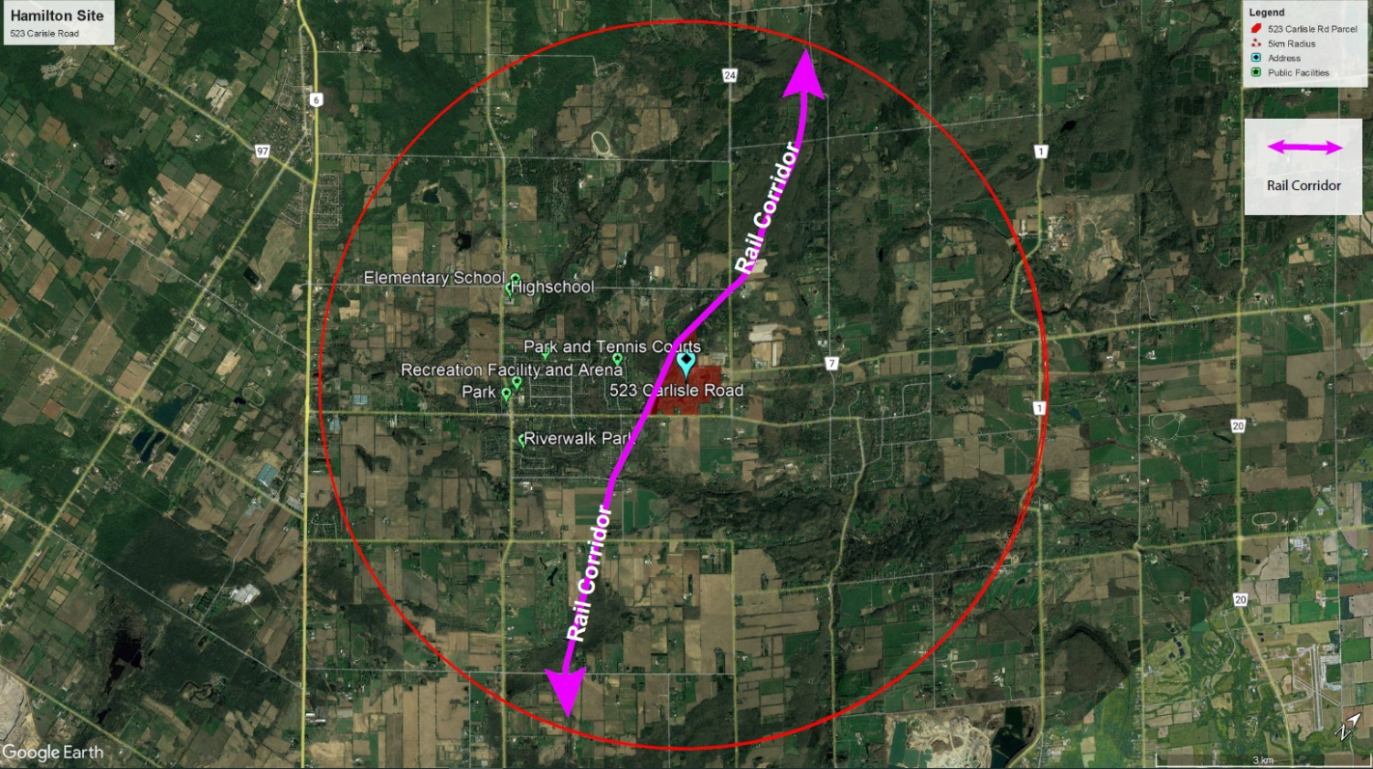

1. **Century Pines Golf Club, 592 Westover Road, Hamilton**

PT LT 31 CON 3 BEVERLY AS IN VM176588 LYING N OF SODOM RD EXCEPT: CD276677, PT 1 ON 62R8545 & PT 1 ON 62R15581; SAVE AND EXCEPT (PIN 17550-0176 (LT))

The subject lands are located adjacent to a highway junction, with access to Highways 5, 8, and 52. Servicing and infrastructure is available by the Site. Public and private services are located within proximity to the Site. To maximize the best use of the land, the lands should be considered to be removed from the Countryside Regulated Area.

1. **311 Butter Road E, Hamilton, ON**

PT LT 45 CON 5 ANC, AS IN CD472275, SAVE & EX PTS 1, 2 & 3 ON WE99032, AND SAVE & EX PT LT 45 CON 5 ANC BEING LANDS LYING TO WEST OF PT 2 ON(PIN 17399-0281 (LT))

In accordance with Kaneff’s letter dated March 27, 2020 to Minister Clark, part of Site is located within the Greenbelt and should be considered to be removed. Surrounding parcels of the Site are not regulated by the Greenbelt Plan. The subject lands could support and grow Hamilton International Airport's economic potential.

