The Honourable George Pirie
Minister of Mines
Whitney Block, 99 Wellesley St. West
Toronto, ON M7A 1W3

March 28, 2023

Re: ERO 019-6692

Dear Minister Pirie:

Thank you for posting the draft Hobby Mineral Collecting Guide on the Environmental Registry for public review and comment. The draft Hobby Mineral Collecting Guide is well written and, generally, easy to understand.

The more than 2,500 members of CCFMS clubs were very happy to learn that it has reached this stage – as, too, are the thousands more rockhounders from within Ontario and the Great Lakes region.

Both many collectors and the CCFMS were, however, disappointed and frustrated to note that some critical provisions, which were included in the version reviewed by the CCFMS in 2014, are missing from the current draft. Instead, they seemed to have been explicitly overturned and/or ignored.

These critical provisions were the fundamental reason that the original Mineral Collecting Guide was updated. We feel quite strongly that these omissions from the current version are unacceptable; and therefore, we would like to provide specific comments. These matters are addressed in the attachment to this letter.

The CCFMS is keen to see the Guide finalized as quickly as possible, and we would be happy to provide any assistance to the Ministry in this matter. Once again, we offer your Ministry the help of one of our CCFMS board directors, who is based in Sudbury, and who is very familiar with this file in finalizing it expeditiously.

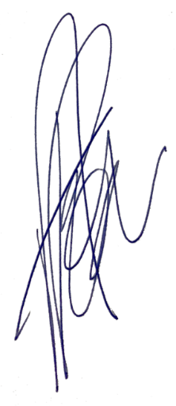
Thank you again for your support in completing this essential initiative.

Yours truly,

Ashley Pollock, B.A., M.Ed.
President
CCFMS Central Canadian Federation of Mineralogical Societies
FSMCC Fédération des sociétés de minéralogie du centre du Canada

Attachment – “2023-03-28 Attachment – Critical Provisions”

cc: Honourable Neil Lumsden, Member, Hamilton East–Stoney Creek, and Minister, Ministry of Tourism, Culture and Sport
Monique Rolf von den Baumen-Clark, Deputy Minister, Ministry of Mines
Afsana Qureshi, Assistant Deputy Minister, Ministry of Mines
Trina Rawn, Director, Mineral Development Branch, Ministry of Mines
Carol Smith, Director, Information and Lands Branch, Ministry of Mines
Donald J. Bennett, Legal Director (Acting), Legal Services Branch, Ministry of Mines
Sophie Fortin, Initiatives Coordinator (Acting), Information and Lands Branch, Ministry of Mines
MPPS:
Ric Bresee, Member, Hastings–Lennox and Addington
Honourable Steve Clark, Member, Leeds–Grenville–Thousand Islands and Rideau Lakes, and Minister of Municipal Affairs and Housing
Vic Fedeli, Member, Nipissing
Wayne Gates, Member, Niagara Falls
Honourable Monte McNaughton, Member, Lambton–Kent–Middlesex, and Minister, Ministry of Labour, Immigration, Training and Skills Development
Peggy Sattler, Member, London West
Laurie Scott, Member, Haliburton–Kawartha Lakes–Brock
Sandy Shaw, Member, Hamilton West–Ancaster–Dundas
Jennie Stevens, Member, St. Catharines
John Vanthof, Member, Timiskaming–Cochrane
Lise Vaugeois, Member, Thunder Bay–Superior North

