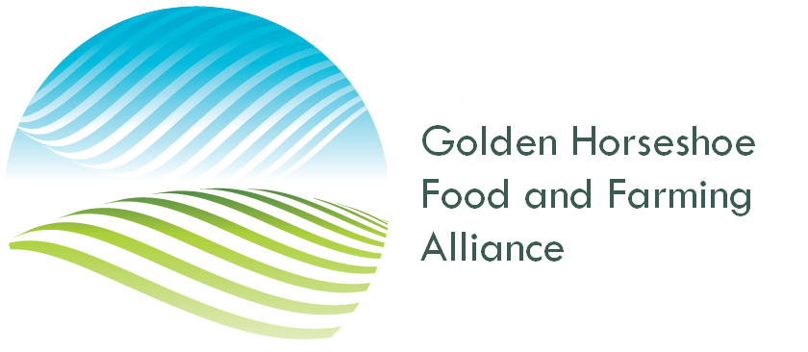
July 8, 2023,

Minister Steve Clark
Ontario Minister of Municipal Affairs and Housing
Minister.mah@ontario.ca

Minister Clark.

Thank you for allowing for the extension of the consultation for proposed changes to the Provincial Policy Statement and Bill 97. This extra time has allowed for the farm community and municipalities to understand the issues more fully and some of the long-term ramifications of changes contained within those documents.

The members of the Golden Horseshoe Food and Farming Alliance understand and support the intent of changes to increase Ontario’s housing supply by streamlining policies, granting greater authority to municipalities and providing flexibility to create more housing.

Overall, the Alliance is supportive of the general move to combine the two Provincial planning documents into a single document and the streamlining of the planning framework.

The Alliance also supports the concept to allow more residential units on the current farm site. This allows farm families to provide more permanent, quality and affordable housing for multi-generational farm families and farm labour. To prevent severance and fragmentation of the land base, we would support “clustering” of these additional units and sharing of common services – ie. Wells, septic systems and driveways to avoid future attempts to sever these units from the farm. In this way, intergenerational farm succession and labour requirements can be supported without fragmentation of the farm parcel.

Given that there are some positive aspects to the proposals, we do however, have some concerns about some of the proposed changes that we wish to share.

Relaxation of policies for settlement area boundary expansions
The allowance for municipalities to expand their boundaries outside the MCR processes and with increased amounts of land promotes growth on an ad hoc basis and promotes sprawl on agricultural lands. In addition to taking agricultural land out of production, this policy increases dependance on the automobile and higher servicing infrastructure, transit and emergency services costs for the municipalities. For the long term, the protection of agricultural lands and need for additional housing should be balanced and not tipped solely in favour of creation of housing.

Lot Creation on Agricultural Lands
The proposal for severances on agricultural lands will have grave and negative future impacts on agricultural industry and food processing in rural Ontario.
In the agricultural community, we have seen the negative effects of the PPS policies that existed in the 1990’s where “retirement lots” were allowed for “bonafide farmers”.
While some of the lots were used by retiring farmers, eventually, the lots moved into the hands of non-agricultural owners. A drive in any Ontario countryside will show these residential lots scattered along roadsides and abutting agricultural fields.

The new PPS would suggest that three residential lots would be created by Section 4.3.3.

This single policy will have the result of significant fragmentation of the current agricultural landbase, moving the use from agricultural to residential. Agricultural land is not “land that is yet to be developed” but it is a finite resource that must be protected and preserved for present and future food production.

The potential for agricultural lands to be severed into 3 additional lots, while giving some farmers a short-term gain, will be a detriment to food production in the future. Dramatic increases of lots in a concession block will only mean introducing additional incompatibility issues with expansion, trespassing, equipment movement, nutrient application, odor, sound and sight complaints for current and future farm operations, presenting even more challenges to carry out normal farm practices.

Currently, 50% of agricultural lands in production in the Golden Horseshoe, are held by farmers and 50% are lands held by non-farm investors. The increasing cost of land in the GGH makes it almost impossible for farmers to buy all the land they need to farm and rental lands make it possible to scale their operations. While there may be significant pressure by the non-farm investors to capitalize in the short term with the creation of extra lots, the farm families who farm the land will be more inclined to protect the land base for production now and in the future.

We request that the new policies for the provision of the creation of residential lots on agricultural lands be removed.

Specialty Crop Areas
As Specialty Crop Areas in the Golden Horseshoe are able to grow the highest value fruits and vegetables in the province, we must continue to ensure the lands in the Holland Marsh and Niagara Specialty crop areas receive the highest priority of protection. In addition, these lands should not be allowed for settlement area boundary expansions. The proposed changes to the PPS are silent on this issue and we require assurance that those Specialty Crop areas will continue to be protected.

Specialty crop areas help Ontario to export 50% of what is grown and processed in Ontario to help our balance of trade and ensure a level of self-sufficiency in food production of some crops. Incompatible residential uses on those lands do neither.

The Golden Horseshoe Food and Farming Alliance suggests that municipalities work with the Province to designate additional Specialty Crop areas where there are factors such as soil conditions and microclimates that allow production of high value crops – ie. Essex County for tomato production and Norfolk County for fruits and vegetables. This would allow additional protection for those highly productive lands.

Agricultural Systems Mapping
The Provincial Agricultural Systems mapping has been an excellent tool for municipalities to identify their most productive agricultural lands and the businesses supporting the agriculture industry based on consistent criteria and methodology. The Golden Horseshoe Food and Farming Alliance supports the extension of the Agriculture Systems Mapping and approach to be required across the province rather than “encouraged” as per 4.3.1.1.

The removal of Provincial Agricultural Systems policies and mapping creates an open season for developers on agricultural and natural heritage lands. Unchecked development on these lands will create extra burden on aquifers and natural areas with a significant increase in extra wells, septic systems and fill. How will this cumulative impact be calculated and checked when too much burden is placed on the groundwater resource?

It does not make sense that at a time the Ontario government is spending $9.5 million dollars to increase the health of soils while at the same time allowing those soils to become residential lots and rural subdivisions.

MDS

The current Minimum Distance Separation calculations provides protection for existing farm livestock operations. The proposed addition of residential lots on farmland will further restrict expansion of current operations and establishment of new livestock operations. MDS will become even more challenging to implement in the future given the residential lot creation potential.
New operations will be pushed farther into the properties requiring extensive laneways, hydro and water infrastructure, further degrading and infringing on the agricultural lands. Is the intent to force out our livestock industry in Ontario? The unintended consequence will affect not only the livestock farms but the many meat processing jobs and industry in Ontario.

Density
The A Place to Growth Plan 2020 gave density targets to municipalities for housing and employment. We are concerned that the strong policies of the 2020 Growth Plan, directing the majority of residential growth to fully serviced urban areas, is being weakened and replaced with unsustainable sprawl and rural subdivisions on cheaper agricultural lands. Growth should be directed to serviced settlement areas to help sustain expensive road, water and sewer systems that service those areas. Placing significant numbers of additional wells and sewers on aquafers and ecosystems that are fragile is a recipe for disaster in the future.

Natural Heritage Systems
Given the later release of the NHS systems information, at a cursory view, it appears that any changes will not have a significant impact on agricultural lands. Implementation of any new policies must balance the increased need for housing with the preservation of the environment, farmland, natural resources and cultural heritage.

In addition, there are many other questions that arise with the proposed PPS:
- Are surplus farm dwelling severances in addition or within the permitted 3 lots to be considered?
- Can municipalities set minimum parcel size for farms or utilize other tools to ensure that prime agricultural soils and future livestock farming is protected?
- Clarification is required on whether additional lot creation policies would apply to previously sterilized lands due to the severance of a surplus farm dwelling.
- Does the new policy allow 3 new lots or a total of 3 including the existing farm parcel?
- With new accessary residential units being allowed, are these units eligible for severance in the future?

As presented, Bill 97 and the Proposed Provincial Planning Statement have some unintended long-term consequences for Rural Ontario. Most specifically to the agricultural lands, the food grown on those lands and the jobs created by the farms and food processing industry in Ontario. Unchecked growth on rural concessions, diminishes the growth in our towns and rural hamlets where that development can be supported with servicing. Municipalities can afford growth in those targeted areas but are less able to support sprawling growth on relatively inexpensive farmland.

We urge the government to think carefully before making these changes. In Rural Ontario, the additional lots will not lead to affordable housing but rather unaffordable, unsustainable, sprawling growth. We look forward to a continued conversation on these matters in order to “get it right”.

Sincerely,
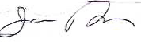
Jamie Reaume
Vice-Chair
Golden Horseshoe Food and Farming Alliance

