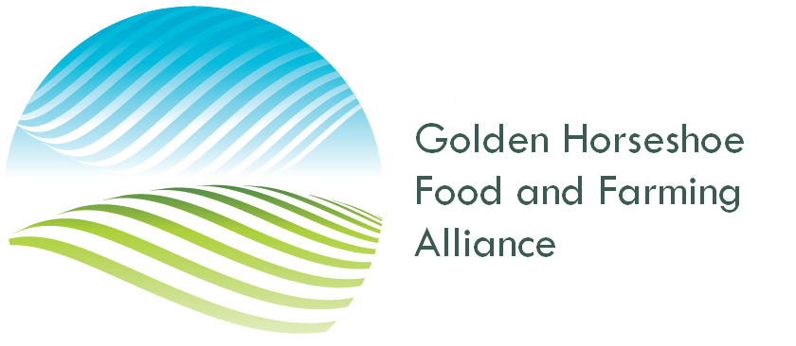
November 27, 2023,

Minister Paul Calandra
Ontario Minister of Municipal Affairs and Housing
Minister.mah@ontario.ca

Re: ERO 019-7739

Minister Calandra.

Thank you for the opportunity to make input to the consultation for the proposal to introduce legislation that would restore 15 parcels of land to the Greenbelt. Our organization fully supports this move.

The Directors of the Golden Horseshoe Food and Farming Alliance understand and support the intent to increase Ontario’s housing supply by streamlining policies, granting greater authority to municipalities and providing flexibility to create more housing. At the same time, we must strike a balance between the protection of agricultural and natural heritage features that will serve us for the long term and the immediate need to find solutions to the housing shortage.

Ontario’s Greenbelt, like many other Greenbelts around the world, are guided by several policy underpinnings – the prevention of urban sprawl, protection of natural areas and the protection of high-quality agricultural lands. The success of any Greenbelt however depends on political commitment and trust, not only to the landowners or would-be landowners involved and to the people of Ontario who value ecosystem services provided by a Greenbelt.

Unfortunately, that trust has been broken over the last year. We must do better.

Democracy can be a messy process. Democracy can take a long time with many diverse opinions heard around the table. Ultimately, a path forward that is transparent should be the outcome of a democratic process that has allowed for adequate consultation. Removing lands from the Greenbelt that had been designated for agricultural use and moved to a development use in December 2022 allowed some players to profit unfairly. Transparency was ignored.

The Greenbelt contains the headwaters of many of the significant rivers in the GTA. Specifically the Oak Ridges Morraine was given the protection in needed to prevent undue pressure on the aquifer . Unchecked development on these lands would create extra burden on groundwater and natural areas with a significant increase in extra wells, septic systems and fill. The quality and quantity of available water would be significantly impacted.

Going forward, we are interested in the process that will be initiated to both remove and add lands to the Greenbelt. That process should be focused on the long term public good and not the interests of developers or individuals seeking to profit in the short term.

Agricultural land is not “land that is yet to be developed” but it is a finite resource that must be protected and preserved for present and future food production.

Thank you for rethinking this process. Our province will be the better for it.

Sincerely,

Albert Witteveen
Golden Horseshoe Food and
Farming Alliance

Regional Councillor Niagara

