To whom it may concern,

This letter is to express concern for the well-being and health of the local community and the potential adverse effects on the Sydenham watershed, should the proposal for the expansion and relocation of the small dormant landfill along with the development of a Regenerative Recycling Facility put forth to the Environmental Registry of Ontario by York1 be approved. I, like many others, am contesting on the grounds of potential degradation of the natural environment, as per Sections 4.1 and 4.2 of the guideline: D-4 Land Use On or Near Landfills and Dumps from the Government of Ontario (<https://www.ontario.ca/page/d-4-land-use-or-near-landfills-and-dumps#section-0>). Furthermore, I am advocating for the ongoing preservation and conservation of biodiversity within the Sydenham watershed.

This letter aims to provide supplementary information and relevant concerns regarding the history of the site, the significance of the watershed, as well as the potential ecological damage that this expansion would impose on the local area and the Sydenham watershed.

## **Site of Proposed Dump Expansion**

York1 Environmental Waste Solutions Ltd plans to expand a defunct 2-acre waste disposal site on 29831 Irish School Road. Historically, this site had been established to dispose of ash from the town’s garbage incinerator, and according to land transfer records, it was sold by ‘Dresden Tile Yard’ to the Town of Dresden in 1979. Subsequently, on November 20, 1980, the town received a license to use the property for waste disposal insofar as 95% of waste product disposed of onsite was ash. It was also previously owned by an individual and was allowed to do some small-scale recycled wood operation.

Under York1’s current proposal, up to 7,000 tons of waste will be disposed of daily, running 24 hours per day, 7 days a week. According to York1’s proposal, up to 700 trucks can be expected to enter the site daily! The noise alone would cause a major detrimental impact for the whole town of Dresden as well as anyone living on or near the roads on which transport trucks would continually travel.

Additionally, this site is less than 2 km from the town of Dresden. Historical evidence in Ontario has shown that the minimum distance within which adverse effects could be experienced while a landfill is operating is up to 3 km (D-4 Land Use guideline). There is cause for concern regarding the proximity of the proposed dump site to the municipality of Dresden, especially concerning the nearby presence of Molly’s Creek and its connection to the Sydenham River. 85% of land nearby and adjacent to the proposed expansion site is used for agricultural purposes. Sensitive land use, such as agricultural land use and pasturing livestock, is not recommended on land adjacent to land use for waste disposal purposes or operating landfills due to health concerns for animals and crops.

## **The Sydenham Watershed**

Please see the website link [www.sydenhamriver.on.ca](http://www.sydenhamriver.on.ca) from which the following facts have been produced.

Also the Sydenham watershed is the traditional territory of the Anishinaabeg, Haudenosaunee, Lunaapeewak, and Attawandaron peoples who have a connection to the Land and water of southwestern Ontario in Time Immemorial.

The St. Clair Region Conservation Authority estimates 40+ Species-at-Risk that rely on the productive waters of the Sydenham River, making the Sydenham River the most biologically diverse river on both provincial and federal scales, and so deserves special protection and concern when considering environmentally detrimental impacts of a new waste processing facility feeding into these waters.

The Sydenham watershed consists of two primary branches: the North and East Sydenham Rivers. Habitat in the North Sydenham River is less diverse and has poorer channel morphology. The Est Sydenham however is well known as a sanctuary for many Species At Risk (SAR). There is a feeder waterway, Molly’s Creek, adjacent to the proposed dump site (see Fig. 1). This spring-fed creek feeds directly into the East Sydenham River and is of utmost concern for the potential facilitation of pollution spread. There are concerns regarding potential pollution caused by, but not limited to ground and surface water contamination by leachate, surface runoff, contaminant discharge from increased vehicular traffic, noise, dust, odour, landfill-generated gases, and other air emissions, and the adverse impacts these would have on the surrounding terrestrial and aquatic ecosystems.

On March 1st, 2024 at the Dresden Town Hall Meeting, a York1 hydrologist shared site plans regarding storm water management. It was revealed that there would be a series of holding ponds meant to handle leachates. Due to the multitude of highly concentrated water substances, landfill leachate is one of the most difficult waste waters to handle or treat. This plan is based on a “1 in 100 years” flood regime which, under the current climatic conditions, is no longer an accurate time scale for extreme flood events in Southwestern Ontario. The past few years have seen large-scale flood events on a nearly yearly basis. Flood events will cause these catch basins to overflow, draining leachate directly into the Sydenham River via Molly’s Creek. If this proposal were to be approved, there would as a minimum have to be amendments made to the flood plan to account for more regular flooding contingencies.

The East Sydenham River is diverse in habitat availability and among its inhabitants are 34 species of mussels, acting as filter feeders and keeping these waters healthy, and 80 species of fish that depend on the waters of the Sydenham for feeding and reproduction, not to mention countless birds, snakes, turtles, frogs, and mammals that rely on this ecosystem. Of these, 15 species of mussels, 10 species of fish, 5 species of turtle, and 3 species of snake have been classified as Endangered, Threatened, or of Special Concern by the Committee on the Status of Endangered Wildlife in Canada (COSEWIC). Once widespread throughout the Great Lakes river basins, The Northern Riffleshell mussel, which calls a 91km stretch of the East Sydenham home, has experienced a 95% habitat loss over the last century. The Sydenham River is one of only two watercourses in Canada that still supports this mussel and is home to one of only four reproducing populations in the world. The Northern Riffleshell is classified as Endangered under COSEWIC, SARA, and SARO. The plans proposed by York1 directly threaten the existence of the Northern Riffleshell and many more SAR that rely on the Sydenham River.

**Species at Risk in the Sydenham**

The Sydenham River supports an amazing diversity of aquatic life, it is home to at least 34 mussel species and 80 fish species. More than 20 fish and mussels in the Sydenham are Species at Risk (SAR). The watershed also supports many other semi-aquatic SAR including amphibians, turtles, snakes, and dragonflies. Some of these species are found nowhere else in Canada or remain in only a few locations globally. The Sydenham watershed is of global conservation concern for the very existence of these species. **To learn more about the species at risk that call the Sydenham River home, refer to:** [www.sydenhamriver.on.ca](http://www.sydenhamriver.on.ca)

**Below is an excerpt from the**[2018 Sydenham Action Plan](https://www.sydenhamriver.on.ca/wp-content/uploads/2021/09/2018-Action-Plan-for-the-Sydenham-River.pdf)**:**

*“Some of these species, such as Rayed Bean, occur in only one other location in Canada and persist in only a few locations in North America. The Salamander Mussel is found nowhere else in Canada and is considered globally vulnerable. The Northern Riffleshell population in the Sydenham River is one of only three remaining relatively healthy and reproducing populations globally. Consequently, the Sydenham River is of global significance to the conservation of these species.”*

The federal Species at Risk Act (SARA) and the Ontario Endangered Species Act, 2007 (ESA) automatically protect species classified as extirpated, endangered or threatened as well as their habitat. Through the 1996 Accord for the Protection of Species at Risk, the federal, provincial, and territorial governments agreed to develop complementary legislation and programs to effectively protect SAR throughout Canada.

For species listed as threatened, endangered or extirpated, **it is illegal** to:

* kill, harm, harass, capture, or take an individual
* possess, collect, buy, sell or trade an individual
* ***damage*** or ***destroy*** the habitat

**Conclusion**

I whole heartedly advocate against the adverse environmental impacts the proposed dump site expansion put forth by York1 would have on the most biologically rich watercourse in Canada. The environmental and ecological degradation that threatens the Sydenham watershed would be severely exacerbated by this proposed facility, especially under modern unpredictable rainfall and flood regimes.

I oppose the dump plans for many reasons but especially on behalf of the Sydenham River and surrounding watersheds, believing that this watercourse deserves special attention and consideration prior to wreaking ecological havoc on an ecosystem home to so many Species-at-Risk. As a vital source of life, recreation, and enjoyment for so many creatures, human and non-human alike, I and many, many others want to see the Sydenham River happy, healthy, and thriving. Since she does not have a voice of her own, we speak on her behalf to raise concerns about the threats to her rich biodiversity and unique ecosystems.

Thank you for your time and consideration upon hearing our concern. I ask that you review our letter and act to the best of your ability to take into consideration the needs of the local community.

## 

*Figure 1.* Map of Proposed Site (Yellow Pin) in relation to the town of Dresden and Molly’s Creek.

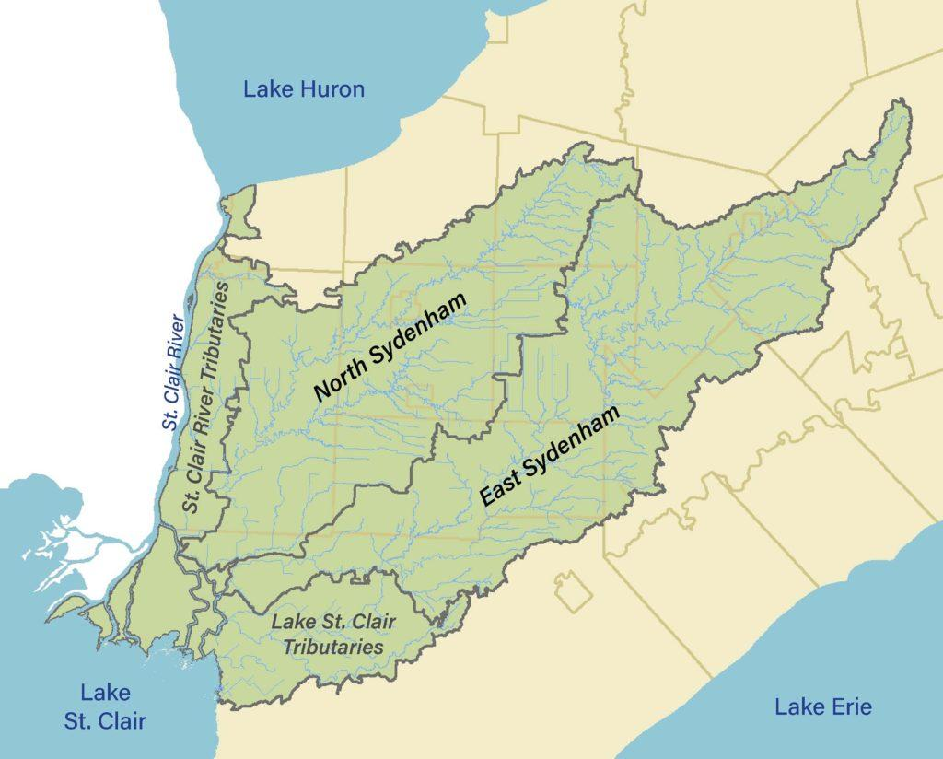

*Figure 2.* Map of North and East branches of the Sydenham River.